

**Diploma in**

Electronics Computer and Communication Engineering

**Final Year Project Report**

**Project title:**

Development of   
an Intelligent Assessment & Advisory  
E-learning System for Physics using LabVIEW

**Project Supervisor:**

Mr. Cheong Chee Keng

**Project Student:**

Yan Bingtao (137160X)

Pang Jun Qing (131882K)

# Acknowledgement

We would like to express the deepest appreciation to my supervisor, Mr Cheong Chee Keng, for his support and guidance throughout the 12 weeks while doing our final year project. He gave us clear guidelines on what the project is about and what we have to do using LabVIEW development system. He also gave us many suggestions of improvement of the project.

In addition, we would also like to take this opportunity to thank our week 6 and 12 presentation assessor, Mr Loh Kock Keong, for his time, patience and advice for our presentation and project.

We would also like to thank Yang Wenting to prepare a very informative report, so that we can understand the project well and catch up very fast.

# Abstract

This report outlines the design and development of an e-learning system for the O-level Physics syllabus. The application was written in G, using LabVIEW (short for Laboratory Virtual Instrumentation Engineering Workbench) development system, to run under Windows operating system. Microsoft Access is used to store the application’s data

E-learning is a tool that enhances and supports the traditional learning system and it is becoming an integral part of the learning tools used by many educational institutions. The goal of this project is to create an intelligent E-Learning assessment system for O-level Physics. In this project, assessment questions are set for each topic in the O-level Science Physics Guide [1].

After doing the assessment, users are able to review the questions, see their results and the correct answers to each question.

**Content**

**Acknowledgement**

**Abstract**

# Table of Contents

**1 Introduction**

1.1 Background Information

1.2 About LabVIEW

**2 Project Scope**

2.1 Project Objectives

2.2 Deliverables

2.3 Project Specifications

2.4 Program Flow

2.5 VI Hierarchy

**3 Software Development**

3.1 LabVIEW

3.2 Microsoft Access (Database)

3.3 Sharing of database with multiple users

**4 Main Functions Used**

4.1 SubVI

4.2 Refnum Controls

4.3 Property Node

4.4 Local Variable

4.5 Global Variable

4.6 Start Asynchronous Call

4.7 Call by Reference

4.8 Database

**5 SubVIs Created**

5.1 Connection String

5.2 Get Login Information

5.3 Randomize MCQ options

5.4 Update Marks to Database

5.5 Update Answer to Database

5.6 Update Choice to Database

5.7 Update Question to Database

5.8 Update Why to Database

5.9 Storing File Names

5.10 Store VI References

5.11 Build Image Path

5.12 Save VI Front Panel Image

5.13 Get Result from Database

5.14 Button Control for Review Questions, view Correct Answers and Results

**6 Program**

6.1 Login page

6.2 Signup page

6.3 Tree Control

6.4 Questions

6.4.1 Multiple Choice Questions (MCQs)

6.4.2 Structured Questions

6.5 RunQuestions

6.5.1 Paper1

6.5.2 Paper2

6.6 Review Questions, view Correct Answers and Results

6.6.1 Paper1

6.6.2 Paper2

6.7 Administration Panel

6.7.1 See Login/Logout History

6.7.2 Set Number of question running

6.7.3 Set Number of Attempts

6.7.4 Add more attempts

**7 Building the Executable (Application)**

**8 Building the Installer**

**9 Problems Encountered**

9.1 Database (writing SQL statements)

9.2 Open and execute subVIs can on the same page

9.3 Interactively control which subVI to show on the subpanel and the behaviour of subVI

9.4 Structures questions

9.5 Select Topics to Work on

9.6 Error Running Executable on Other Computers without LabVIEW

9.7 Relinking the .udl file was needed every time the application is distributed to other computers

9.8 SubVI cannot Pop-up when click it

9.9 Mismatching VI Reference Type

**10 Future Enhancement**

10.1 Provide Analyses of Mastery Level of Each Topic

10.2 Provide Personalized Tracking of Results

10.3 Timer

10.4 Teaching Guides

10.5 Web Enabling this Application

**11 Conclusion**

**12 Gantt Chart**

**13 References**

**Tutorial Section**

# 1 Introduction

## 1.1 Background Information

E-Learning is “all forms of electronic supported learning and teaching, which are procedural in character and aim to effect the construction of knowledge with reference to individual experience, practice and knowledge of the learner. Information and communication systems, whether networked or not, serve as specific media to implement the learning process” [2]. It allows users to be able to access learning materials not just within the classroom, but anywhere. E-Learning also reinforces concepts taught in classroom so that users can have a better understanding of the concepts. It enhances and supports the traditional learning system. The goal of this project is to let the users gauge the level of understanding they have on each topic of the O-level Physics syllabus.

## 1.2 About LabVIEW

LabVIEW, short for Laboratory Virtual Instrumentation Engineering Workbench, is a graphical programming tool based on the dataflow language G. It was created by National Instruments. It is a “highly productive development environment for creating custom applications that interact with real-world data or signals in fields such as science and engineering” [3]. Instead of using text-based languages, such as C# or Java, for coding, Labview uses graphical symbols (icons).

# 2 Project Scope

## 2.1 Project Objectives

The objectives of this project are to develop an application of an intelligent assessment & advisory e-learning system for Physics using LabVIEW development system. Assessment questions are created for various topics of the O-level Physics syllabus. At the same time, the order of the questions is randomised to minimise the chances of students copying the answers from one another.

In addition, user-friendly interface is created so that users are able to navigate to the materials, assessment questions or teaching materials easily. Users are able to choose to access the materials on any topics and they can choose to focus only on the topics they are weaker in.

Last but not the least, administration panel has been created to let administrators to see the login/logout history, set number of question running for each paper, set number of attempts for a specific student and add more attempts for a student.

## 2.2 Deliverables

* Multiple Choice Questions (MCQs) and Structured Questions;
* Login Page;
* Login as Admin:
  + Show Student’s Login/Logout History;
  + Set Number of Questions Running;
  + Set Number of Attempts;
  + Add More Attempts;
* Sign Up Page ;
  + Upload User’s Information;
* Tree Control;
  + Auto-Create Question Table for Paper1;
  + Auto-Fill in Question Table for Paper1;
  + Auto-Create Question Table for Paper2;
  + Auto-Fill in Question Table for Paper2;
* Randomise Questions;
* Run Question;
* Update Essential Data;
  + Update A,B,C &D;
  + Update Questions;
  + Update Answer;
  + Update Why;
  + Update Choice;
  + Update Image Path;
* Review all questions and see the explanations to each question after submission;
* See the results after attempting the questions.

## 2.3 Project Specifications

LabVIEW (short for Laboratory Virtual Instrumentation Engineering Workbench) development system is used to develop this application and Microsoft Access is used to store the application’s data.

## 2.4 Program Flow

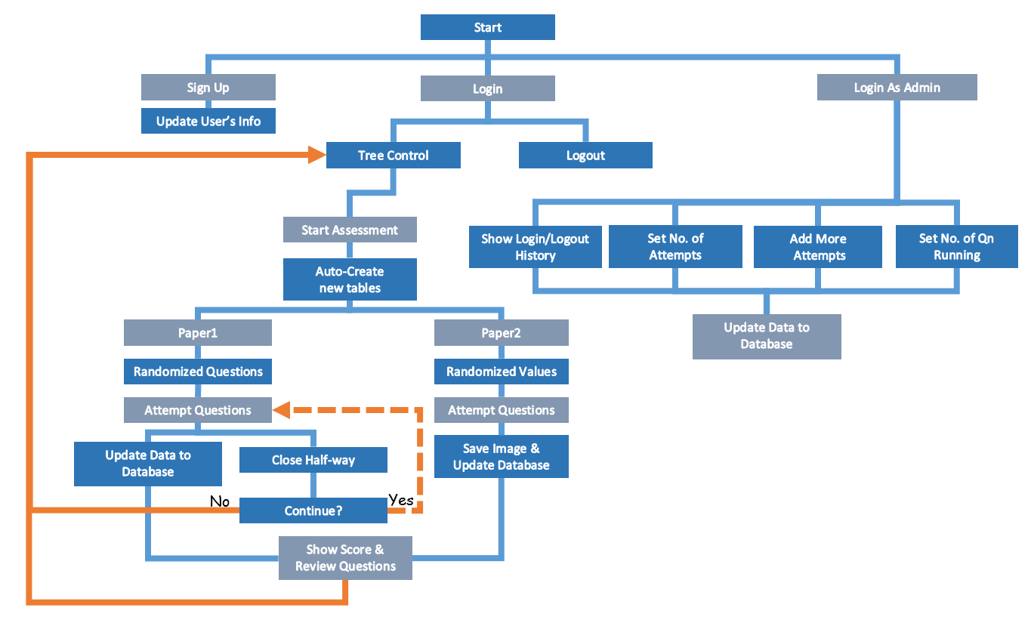

Figure 2.4 Program Flow

## 2.5 VI Hierarchy

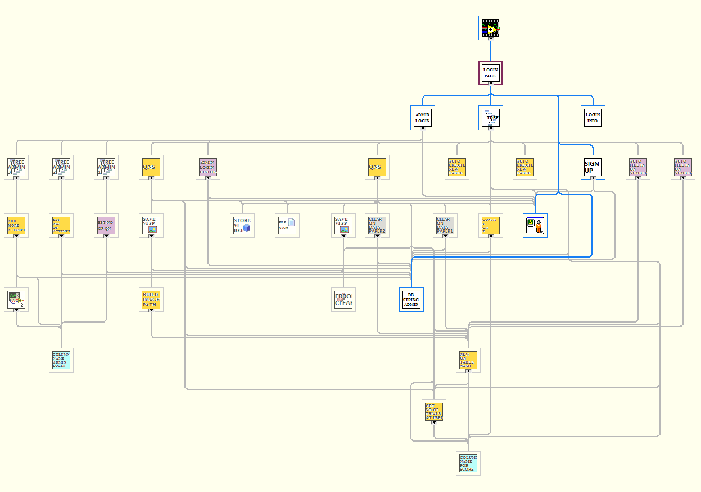

Figure 2.5 VI Hierarchy

# 3 Software Development

## 3.1 LabVIEW

(Click [here](http://www.ni.com/pdf/manuals/373427c.pdf) to find out more details about getting started with LabVIEW)

1. Open LabVIEW and click on “Blank VI”

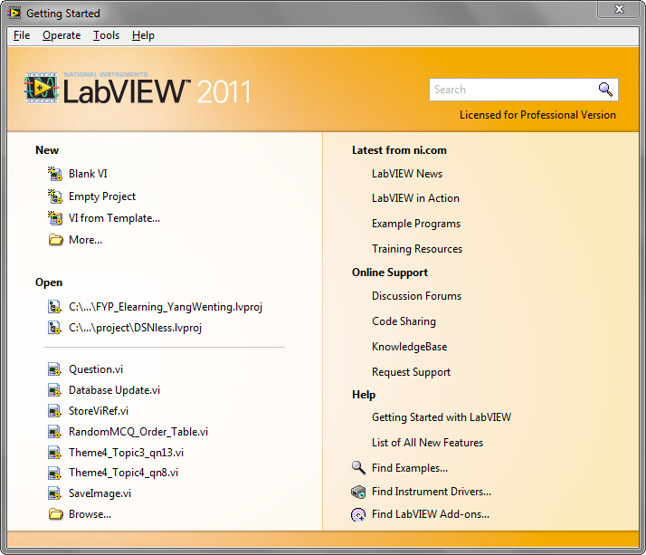

Figure 3.1.1 Getting Started Window

1. The “Front Panel” and “Block Diagram” windows appear.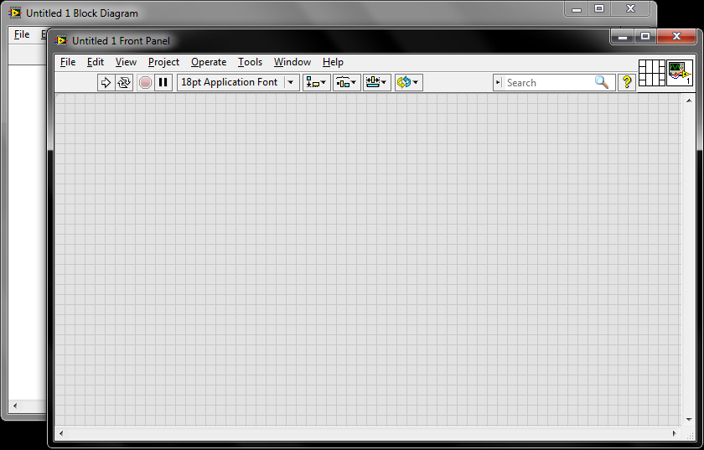

Figure 3.1.2 Front Panel and Block Diagram windows

1. Double Click anywhere in the front diagram or front panel to insert a text.

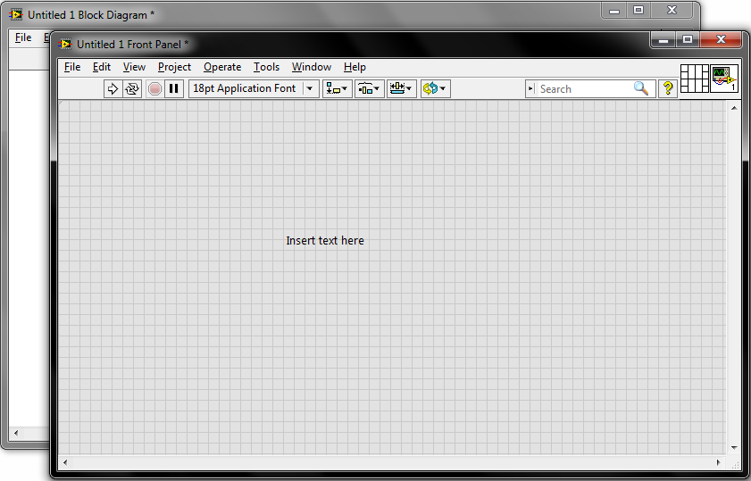

Figure 3.1.3 Insert text

1. Right Click on the front panel to show the control palette. Move your cursor to “Buttons” and choose “OK button”.

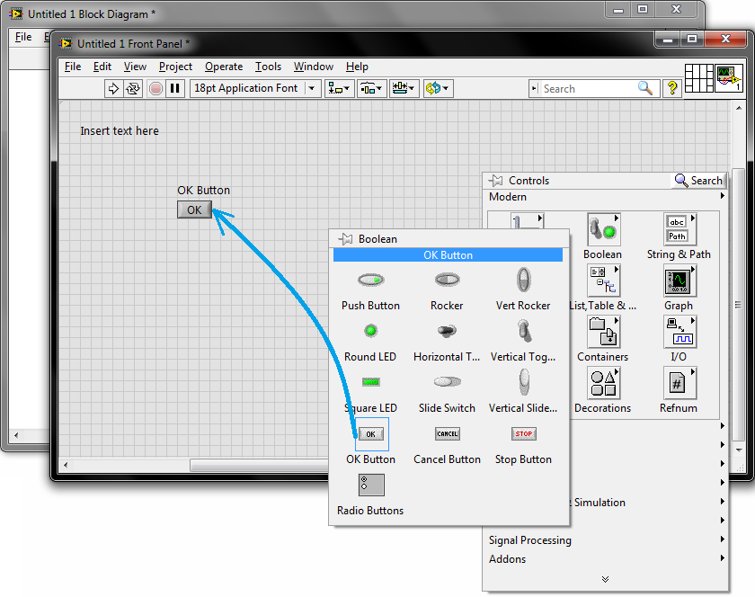

Figure 3.1.4 Adding Control to Front Panel

1. Go to the Block Diagram and create a While loop. After that, wire “OK Button” to the stop terminal ().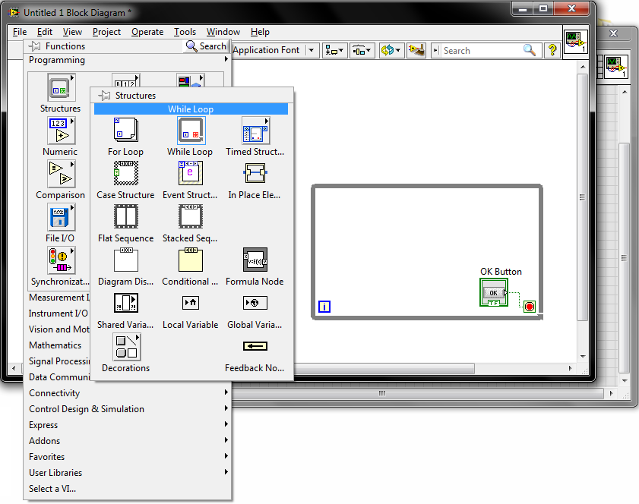

Figure 3.1.5 Creating While Loop

1. Right click the iteration terminal and select “Create Indicator”.

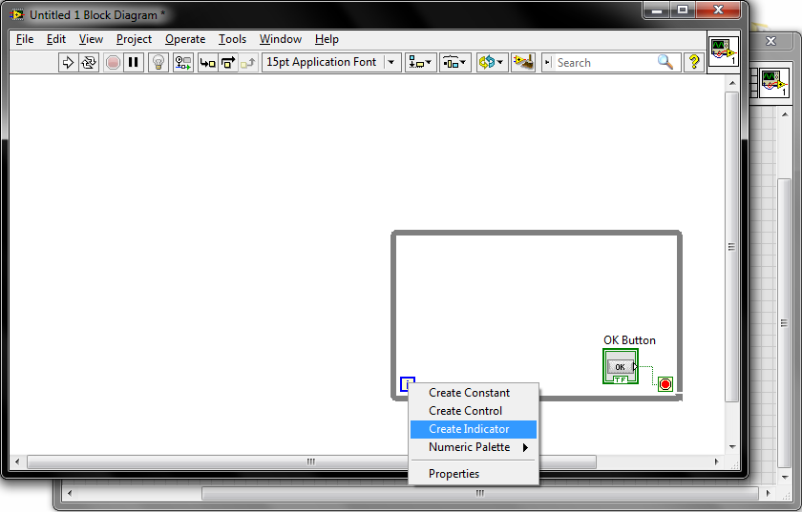

Figure 3.1.6 Creating Indicator

1. Run the program by clicking on the Run icon. You should observe that the value of the numeric indicator keep increasing until you press the OK button.

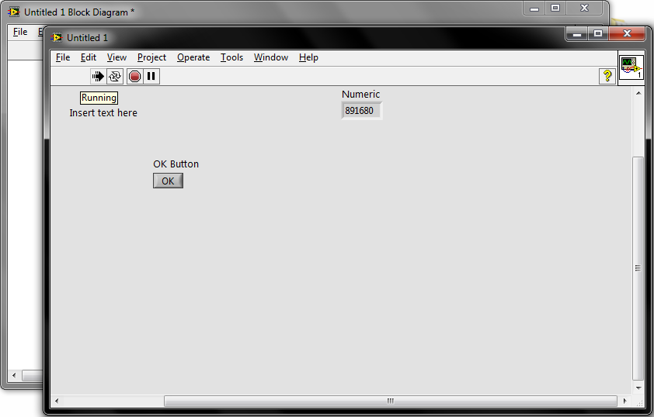

Figure 3.1.7 Running the VI

## 3.2 Microsoft Access (Database)

1. Open Microsoft Access from Window Toolbars. Browse to the directory you want to save the database to and rename it. Click “Create”. It has to be in .mdb file.

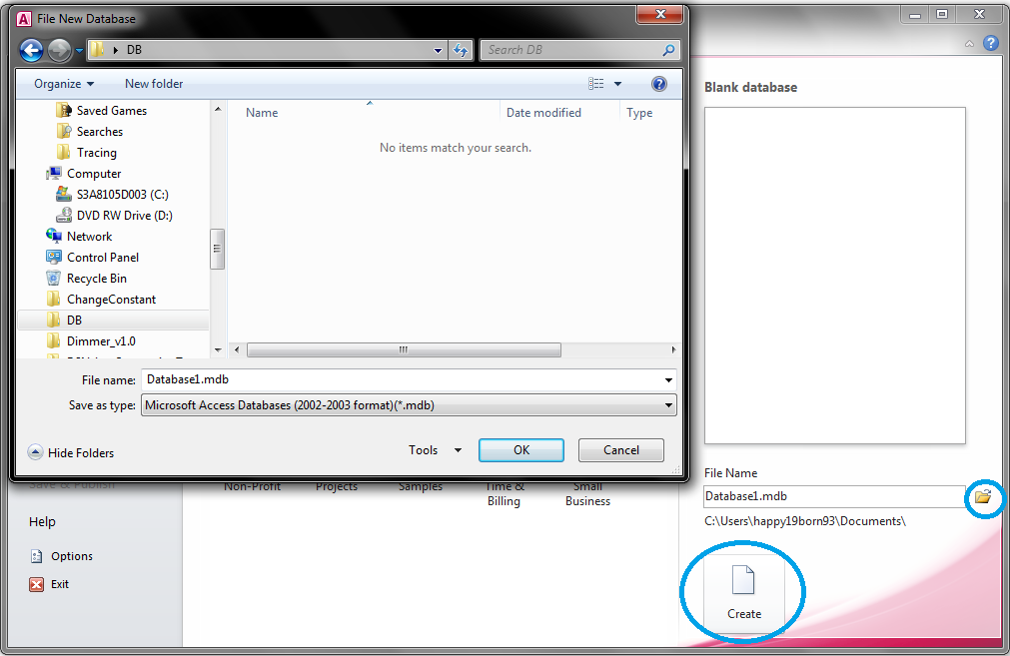

Figure 3.2.1 Create a database

1. Save the database and rename the table.

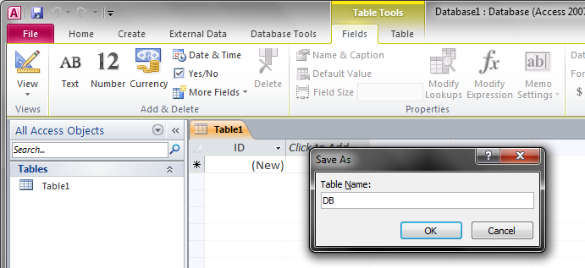

Figure 3.2.2 Save and Rename Table

1. Click file, options and current database Change document window options to

Overlapping windows. 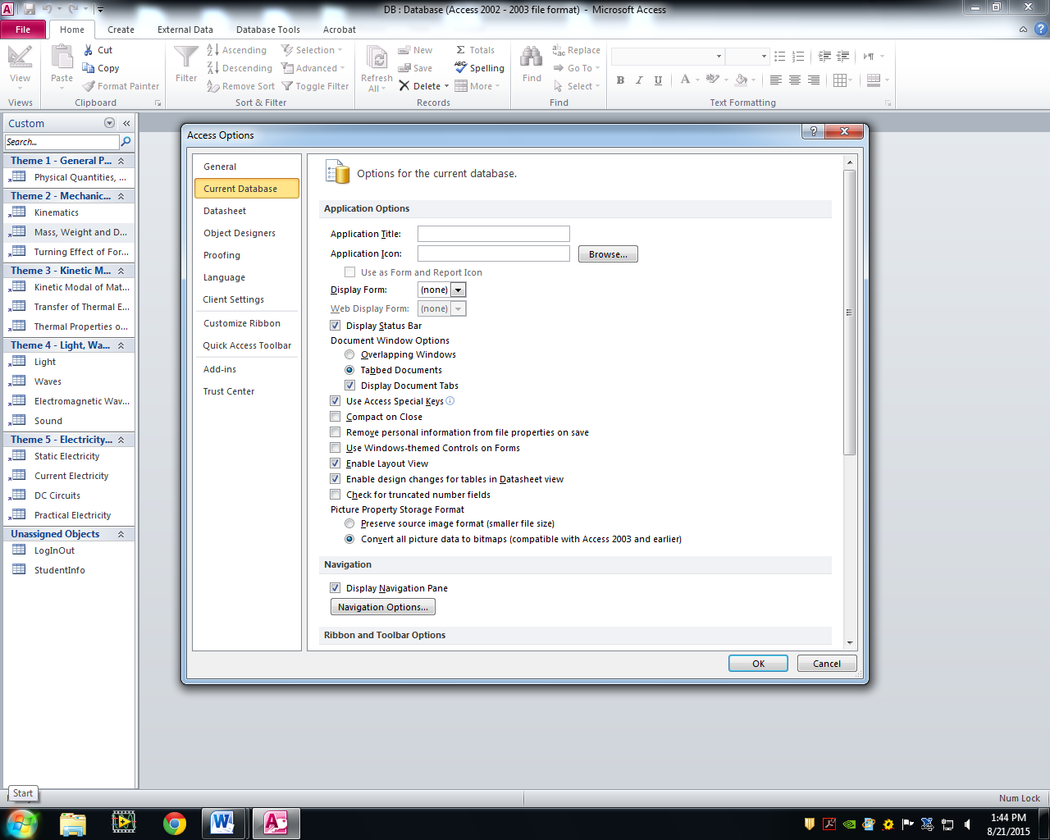

Figure 3.2.3 Database

1. You can change the field name and data type by clicking design view at the bottom right of panel.

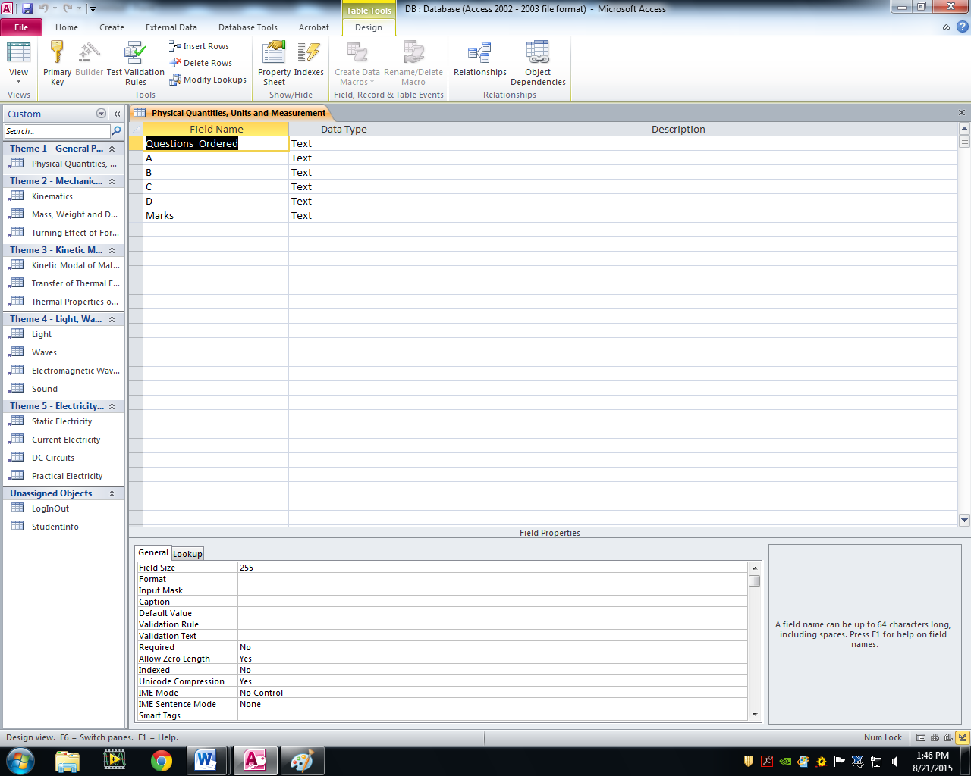

Figure 3.2.4 Database

For more information regarding database, please refer to Access 2010: the missing manual by Matthew Macdonald and Access 2010 Step by step.

## 3.3 Sharing of database with multiple users

1. Share the database with multiple users over the same network. First create a folder for sharing.
2. Put the folder at the local disk.
3. Go to the folder properties and click share.

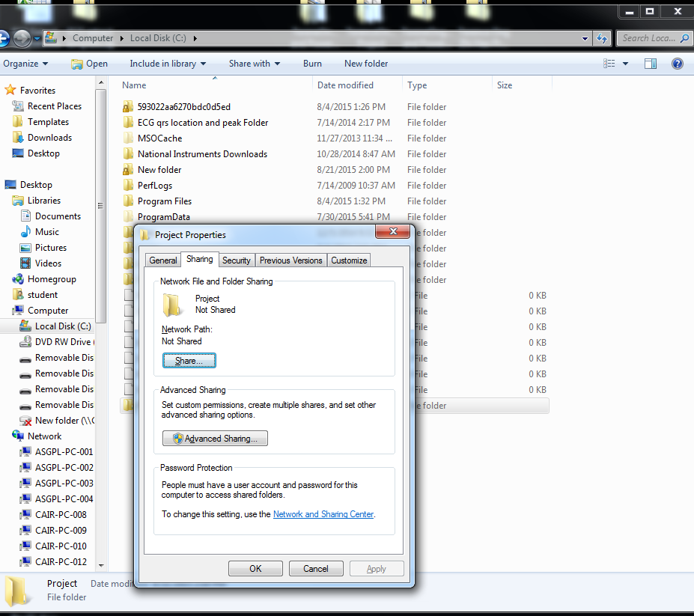

Figure 4.9.1

1. Choose to share with everyone.

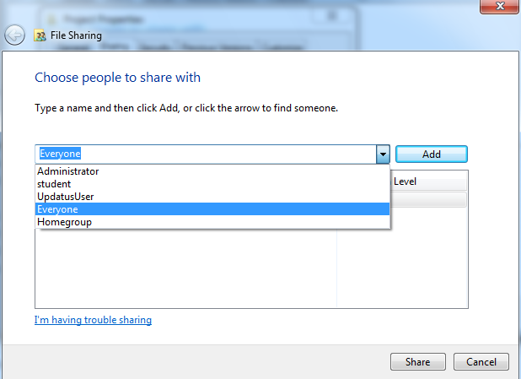

Figure 4.9.2

1. Click share and remember the directory of the folder. Your folder is shared.
2. Refer to the directory stated on the window. You will be able to share the files in the folder among multiple users.
3. The database will update the record whenever there is a user attempted the quiz even if the database does not locate in the master computer.

# 4 Main Functions Used

## 4.1 SubVI

A subVI is similar to a subroutine or a function in other languages such as C# of Java. It is *“a stand VI that can be called by other VI.” “Using SubVI is an efficient programming skill in that it allows you to use the same code in different situations, and make your main VI program clear and compact.* [4]*”*

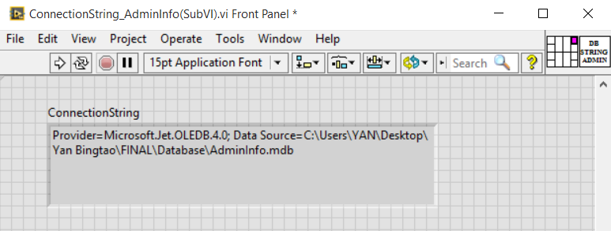  
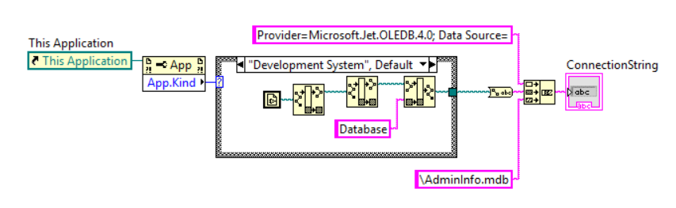

Figure 4.1.1 Example of SubVI

Figure 4.11 shows one of the subVIs I had created. This function is used to build the connection string whenever there is a need to connect to the database. With this subVI, I do not have to recreate the code every time I need it.

**Steps create a SubVI**

1. Create/Edit the Icon
2. Create the Connector
3. Assign Terminal(s) to control(s) and/or indicator(s)
4. Save the VI
5. Insert the VI into a Top Level VI
6. Create/Edit the Icon

* Double click on the icon pane at the top right corner of the front panel or block diagram.

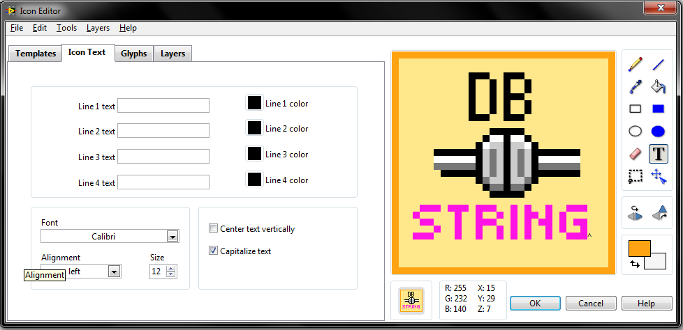

Figure 4.1.1 Icon Editor

1. Create the Connector

* Right click on the connector pane (front panel only) and select a pattern.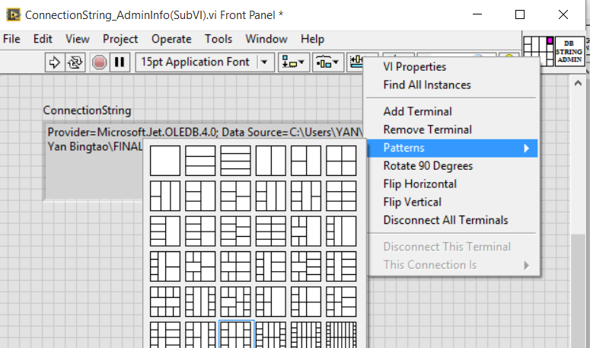

Figure 4.1.2

1. Assign Terminal(s) to control(s) and/or indicator(s)

* Use the wiring tool. Click on the control or indicator and then click on the terminal which you want to assign the control or indicator to.

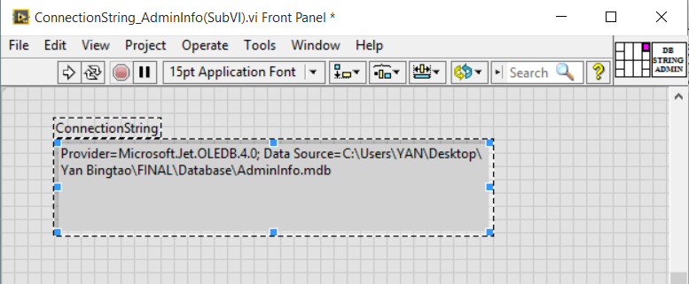

Figure 4.1.3

1. Save the subVI.
2. Insert the VI into a Top Level VI

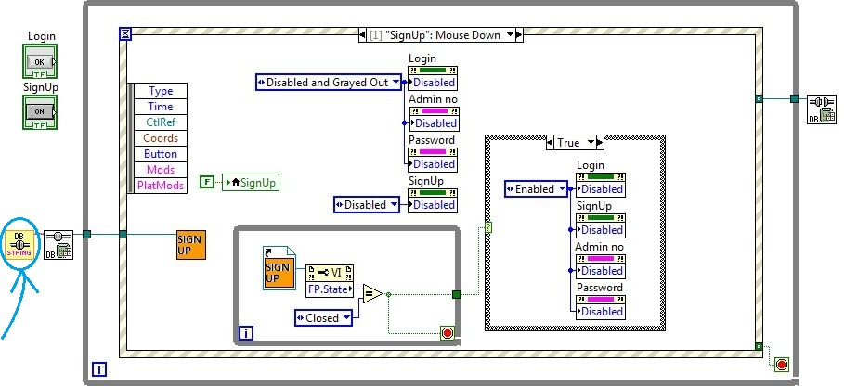

Figure 4.1.5 Block Diagram of “Login1.vi”

## 4.2 Refnum Controls

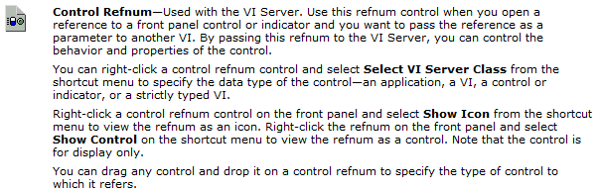

Figure 4.21 “Types of Refnum Controls”, LabVIEW Help, National Instruments

A refnum is a temporary pointer to an open object. It is valid only for the period during which the object is open [6]. Wiring a control reference of a control from the top level VI to a refnum of a subVI allows the top level VI to control the behaviour of the subVI. A control reference can be created by right clicking the control> Create> Reference. In this project, I am using Control Refnums for “Next” and “Previous” buttons, “RefNext” and “RefPrevious” respectively, from “RunQuestions.vi” to control each questions. Whenever there is a need in other VIs for the “Next” and “Previous” buttons in “RunQuestions.vi” to control its behaviour, “RefNext” and “RefPrevious” would be used in conjunction with property nodes *(see section 4.3 Property Node)*.

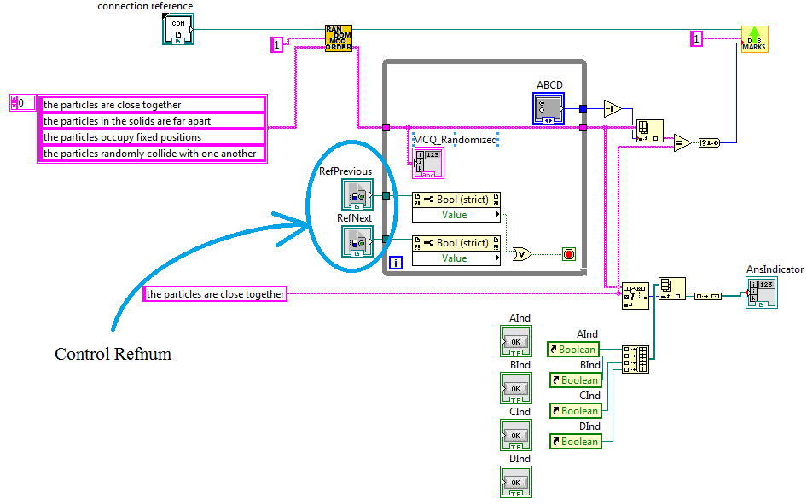Figure 4.2.2 Block Diagram of a Multiple Choice Question

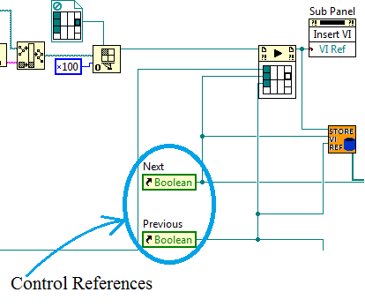

Figure 4.2.3 Sub Diagram of “RunQuestions(SubVI).vi” with Control Reference

Figure 4.22 shows an example of a block diagram of a question where control refnum is used.

Figure 4.23 shows the sub Diagram of “RunQuestions(SubVI).vi” where control references are wired to the control refnums’ terminal of each questions through “Start Asynchronous Call” (*See section* *4.6 Start Asynchronous Call*).

## 4.3 Property Node

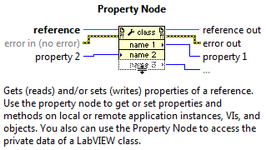

Figure 4.3 “Property Node”, LabVIEW Help, National Instruments

A property node in LabVIEW allows you to programmatically read or write the properties associated with an object such as a control or an indicator. In this program, the property node is very useful whenever there is a need to read or write an object from a top-level VI. It also plays a key role of hiding and showing the answers of each question.

In short, the property node allows the programmer to get any properties of one object, which could be an indicator, a button, a global variable, etc.

## 4.4 Local Variable

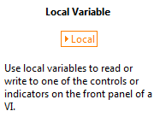

Figure 4.41 “Local Variable”, LabVIEW Help, National Instruments

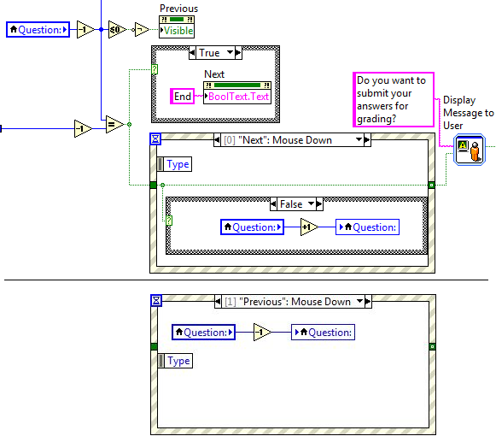

Figure 4.4.3 Sub Diagram of “RunQuestions(SubVI).vi” with Local Variables

Local variable is a reference of an indicator or a control in the front panel. If the programmer assign a valve to the local variable, it is the same as assigning a value to the indicator or the control.

## 4.5 Global Variable

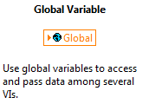

Figure 4.5.1 “Global Variable”, LabVIEW Help, National Instruments

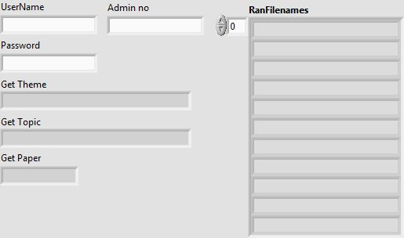

Figure 4.5.2 Front Panel of “FYP_LabviewGlobal.vi”

Figure 4.52 shows the front panel of “FYP_LabviewGlobal(SubVI).vi” where the global variables of this program are stored. The front panel objects are the global variables that need to be stored as they will be used by several VIs.

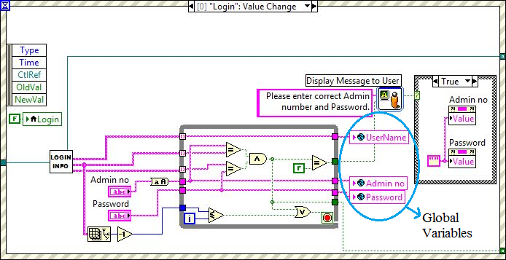

Figure 4.5.3 Sub Diagram of “Login1.vi” with Global Variables

## 4.6 Start Asynchronous Call

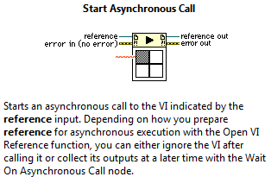

Figure 4.6.1 “Start Asynchronous Call”, LabVIEW Help, National Instruments

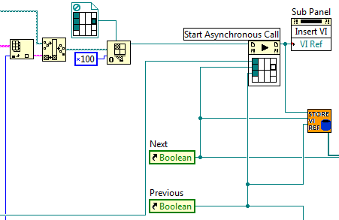

Figure 4.6.2 Sub Diagram of “RunQuestions(SubVI).vi” with Start Asynchronous Call

## 4.7 Call By Reference

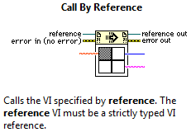

Figure 4.7.1 “Call By Reference”, LabVIEW Help, National Instruments

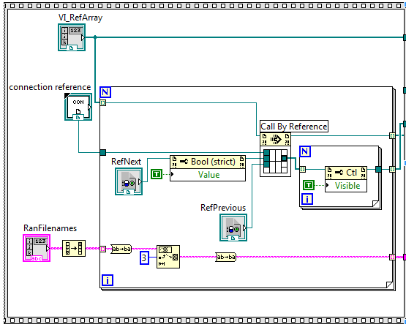

Figure 4.7.2 Sub Diagram of “SaveImage(SubVI).vi” with Call By Reference

## 4.8 Database

*“The NI LabVIEW Database Connectivity Toolkit is a set of easy-to-use tools you can use to quickly connect to local and remote databases and implement many common database operations without having to perform structured query language (SQL) programming. It readily connects to popular databases, such as Microsoft Access, SQL Server, and Oracle. If you need advanced database functionality and flexibility, the LabVIEW Database Connectivity Toolkit also offers complete SQL capabilities.* [12]”

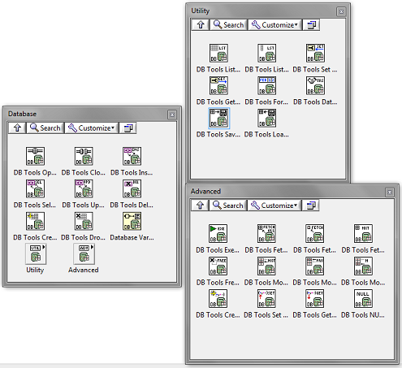

Figure 4.8.1 Database Connectivity Toolkit

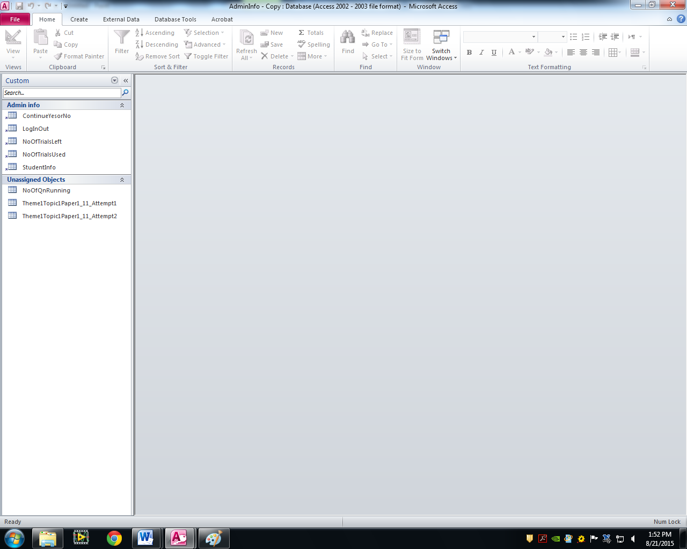

Figure 4.8.2

In the database for this program, there is a table for student info, login/logout history and etc. The “StudentInfo” table stores all the admin number, username and password. “LogInOut” table stores the date and time of the user login in and out. When a student attempt a topic, a new table will be automatically created and store the questions and answers into the column as shown in figure 4.83

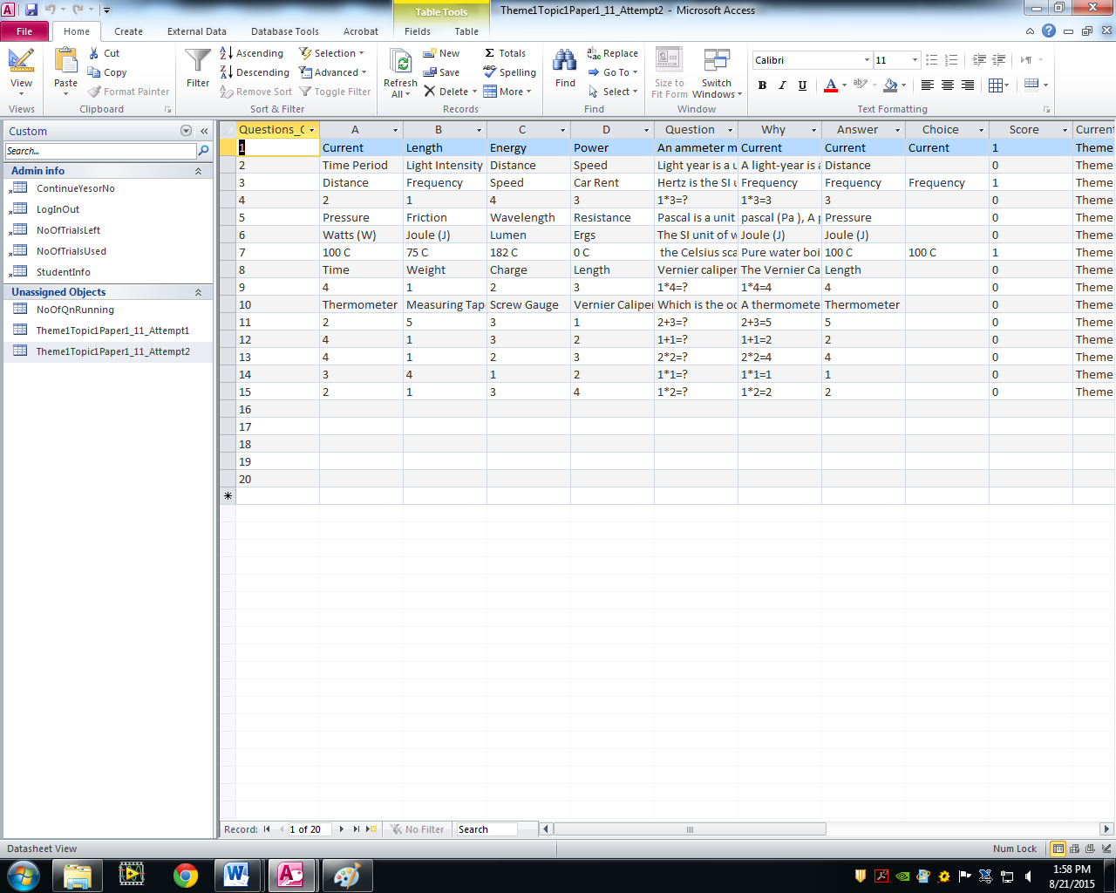

Figure 4.8.3

# 5 SubVIs Created

## 5.1 Connection String

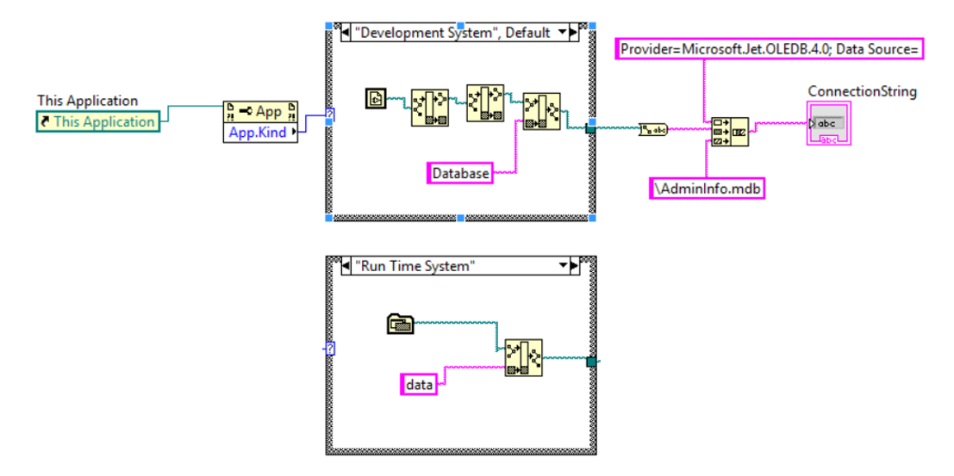

Figure 5.1.1 Block Diagram of “ConnectionString(SubVI).vi”

This subVI is used to create connection string for database connection. The rectangle is a “Case Structure”. It is similar to the traditional programming “if else” and “case” method. The case to execute depends on the case condition wire to the green boxed “?”. The part before the case structure is to determine if the subVI is running in the development environment or running as part of the application (after building to .exe format). This is necessary because the path of the database changes when it is running as part of the application.

The first case structure shows how the database’s path was built when running in the development environment whereas the case structure below shows how the database’s path was built when running as part of an application.

## 5.2 Get Login Information

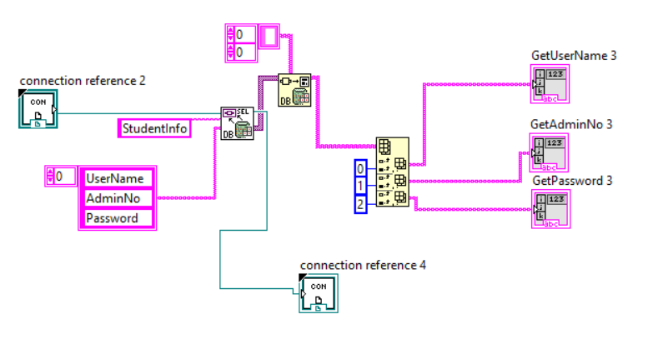

Figure 5.2.1 Block Diagram of “LoginInfo(SubVI).vi”

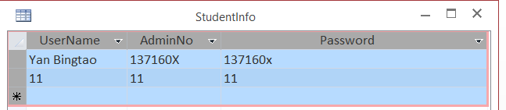

Figure 5.2.2 Database table “StudentInfo”

The function of this subVI is to read the Username, Admin no. and Password from the database. And save these 3 values inside “GetUserName 3”,”GetAdminNo 3” and “GetPassword 3”. These 3 indicators are 3 outputs for this function.

## 5.3 Randomize MCQ options

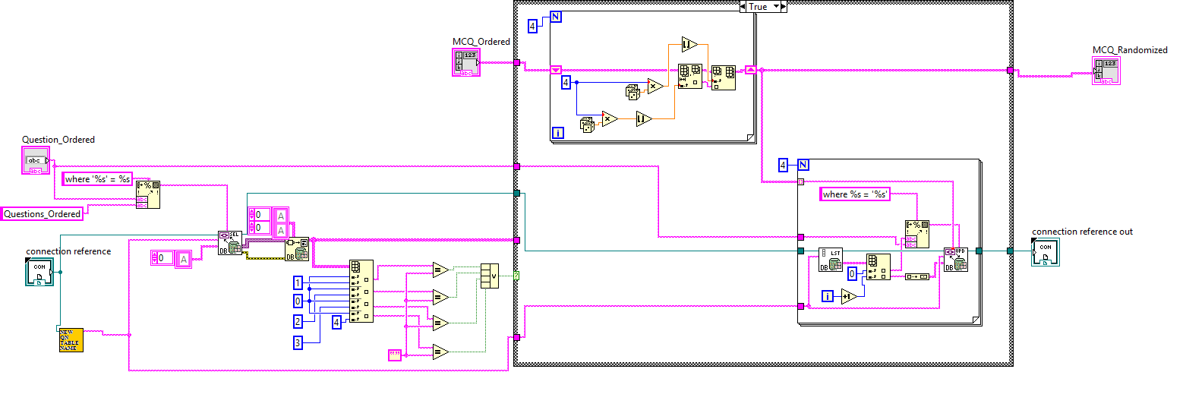

Figure 5.3.1 Block Diagram of “RandomMCQ_Options(SubVI).vi”

This subVI is used by the MCQs in the program. The two rectangles in the case structure are the “For Loops”. The function of this subVI is to randomize the order of MCQ options to make it more difficult for students to copy the answer from one another. After the order of MCQ options are randomized, the randomized MCQ options are updated to the database, and then passed out of this subVI to its calling VI. After the user complete the questions and the results are reviewed, these values will be deleted from the database. Next, I will split Figure 5.31 into two parts, Figure 5.32 and Figure 5.33, to give more detailed explanations.

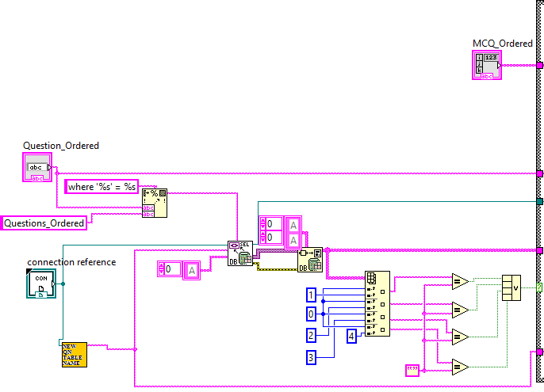

Figure 5.3.2 Part 1 of Block Diagram of “RandomMCQ_Options(SubVI).vi”

The first part of the block diagram *(see Figure 5.32)* is to determine if the order of options of the particular running MCQ has already been randomized before. This is because the order of options has to stay unchanged if the user clicks the “Previous” button.

This is done by checking the database if there is any value stored for MCQ options, columns A, B, C and D of the database *(see Figure 5.34 below)*. If any of the four columns is empty, case is true and the order of MCQ options will be randomized. The database will be updated with the randomized options. Otherwise, case is false and the order of MCQ options will correspond with the respective values in the database *(see Figure 5.33)*.

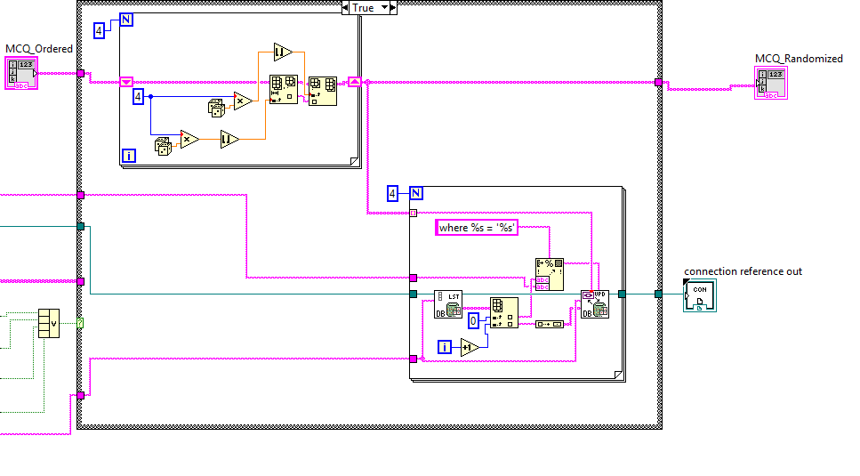

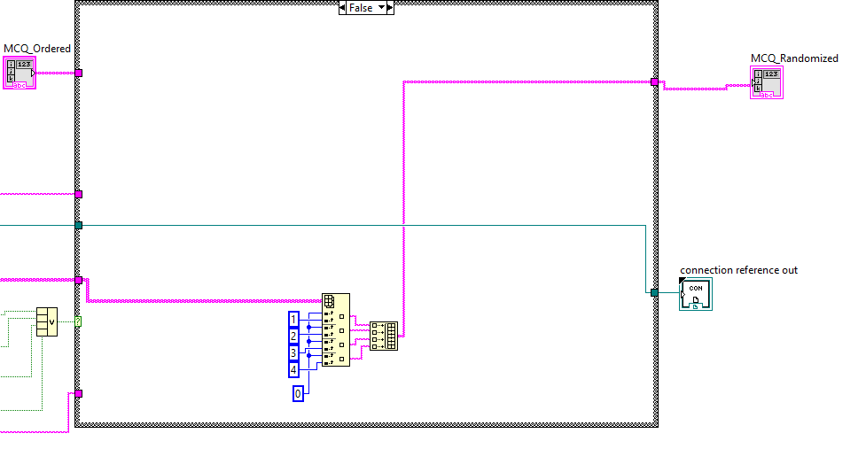

Figure 5.3.3

Part 2 of Block Diagram of “RandomMCQ_Options(SubVI).vi”

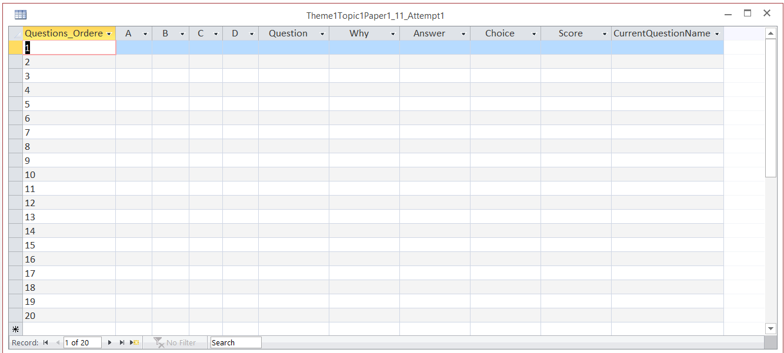

Figure 5.3.4 Database

## 5.4 Update Marks to Database

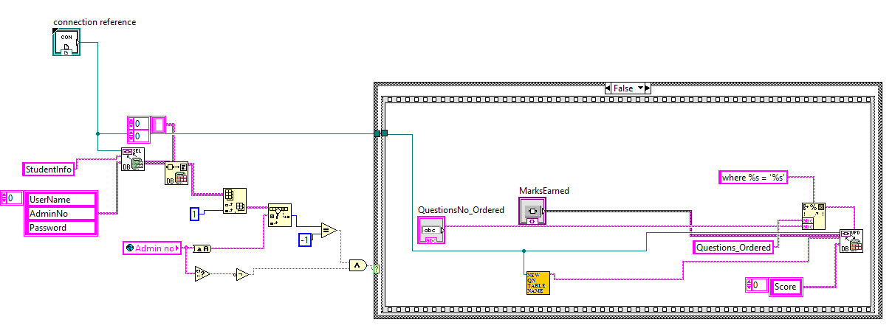

Figure 5.4.1 Block Diagram of “UpdateMarks(SubVI).vi”

This subVI is used in every question subvi. After the user proceeds to the next question, the marks will be updated to the database under the “Marks” column. From figure 5.41, note that “QuestionNo_Ordered” and SubVI, “NewQuestionTableName(SubVI).vi”, is used as a parameter of the database. “QuestionNo_Ordered” determines which row of the database table to update and “NewQuestionTableName(SubVI).vi” determines the table to update. The amount of marks will be determined by the value wired to the “MarksEarned” terminal, which will be either “1” or “0” for MCQs and “x/y” where “x” is the marks scored and “y” is the total marks for that particular question.

## 5.5 Update Answer to Database

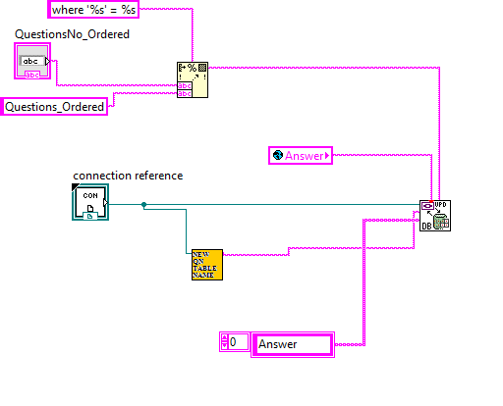

Figure 5.4.1 Block Diagram of “UpdateMarks(SubVI).vi”

3

This subVI is used in every question. After the user proceeds to the next question, the answer of this question will be updated to the database under the “Answer” column. From figure 5.41, note that “QuestionNo_Ordered” and SubVI, “NewQuestionTableName(SubVI).vi”, is used as a parameter of the database. “QuestionNo_Ordered” determines which row of the database table to update and “NewQuestionTableName(SubVI).vi” determines the table to update.

## 5.6 Update Choice to Database

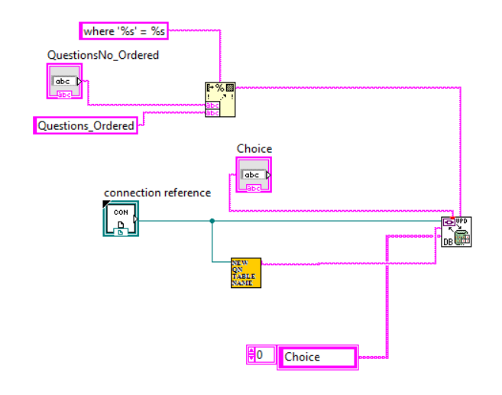

Figure 5.6.1

This subVI is used in every question. After the user proceeds to the next question, the Choice the user chose of this question will be updated to the database under the “Choice” column. From figure 5.41, note that “QuestionNo_Ordered” and SubVI, “NewQuestionTableName(SubVI).vi”, is used as a parameter of the database. “QuestionNo_Ordered” determines which row of the database table to update and “NewQuestionTableName(SubVI).vi” determines the table to update.

## 5.7 Update Question to Database

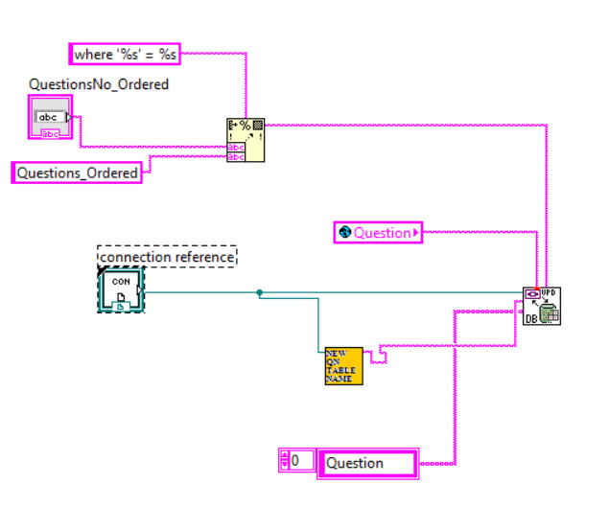

Figure 5.7.1

This subVI is used in every question. After the user proceeds to the next question, the question of this question will be updated to the database under the “Question” column. From figure 5.41, note that “QuestionNo_Ordered” and SubVI, “NewQuestionTableName(SubVI).vi”, is used as a parameter of the database. “QuestionNo_Ordered” determines which row of the database table to update and “NewQuestionTableName(SubVI).vi” determines the table to update.

## 5.8 Update Why to Database

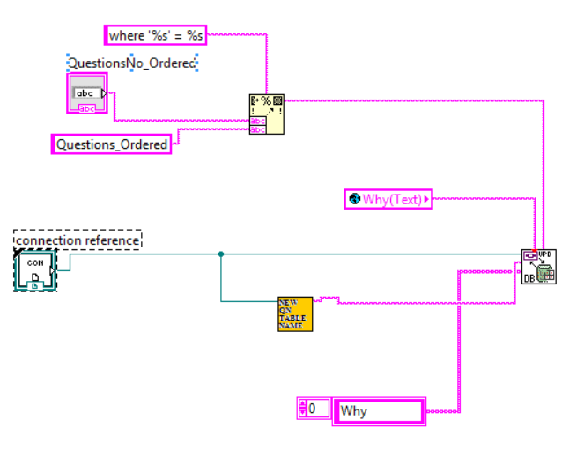

Figure 5.8.1

This subVI is used in every question. After the user proceeds to the next question, the explanation of this question will be updated to the database under the “Why” column. From figure 5.41, note that “QuestionNo_Ordered” and SubVI, “NewQuestionTableName(SubVI).vi”, is used as a parameter of the database. “QuestionNo_Ordered” determines which row of the database table to update and “NewQuestionTableName(SubVI).vi” determines the table to update.

## 5.9 Storing File Names

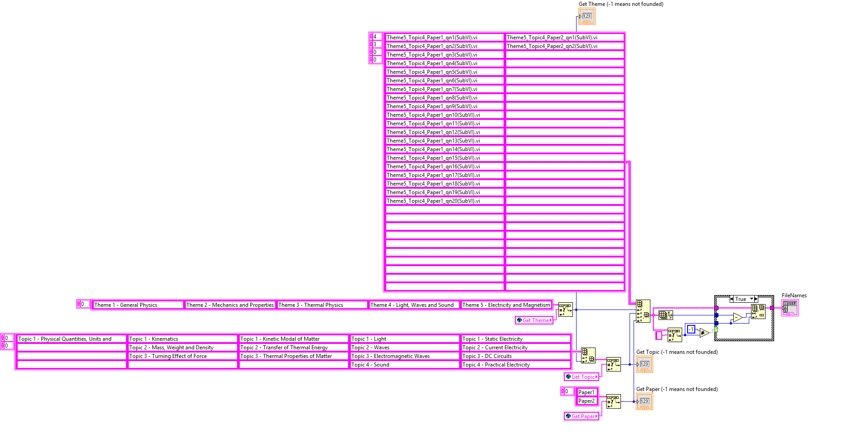

Figure 5.9.1 Block Diagram of “QnFileNames(SubVI).vi”

This subVI is used to organize store the file names of all the questions. In this subVI, multi-dimensional arrays are used. The top array is a 4D array. The four dimensions are volume, page, row and column, representing the theme, topic, question and paper respectively. The output, “FileNames”, is the file names of the set of questions user chose. This is determined by the global variables “Get Theme”, “Get Topic” and “Get Paper” which were stored when user double clicks “Start Assessment” from the tree control *(see section 6.3 Tree Control).*

## 5.10 Store VI References

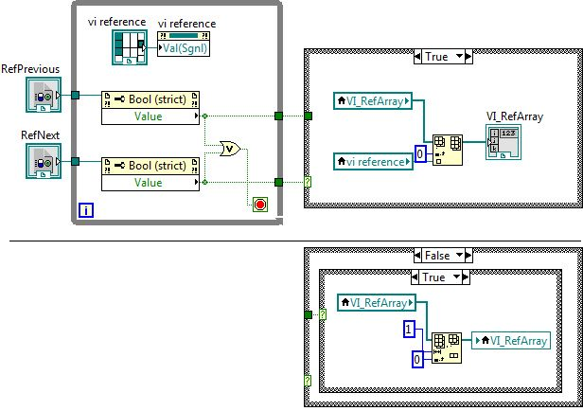

Figure 5.10.1 Block diagram of “StoreViRef(SubVI).vi”

This subVI is used in “RunQuestions(SubVI).vi” where each questions are executed. The function of this subVI is to store the VI references of each question that has been executed. The output of this subVI, “VI_RefArray”, which is an array of VI references, will be used by another subVI, “SaveImage(SubVI).vi”, which captures and saves the front panel images of questions. These images will be used in “ReviewQns(SubVI).vi” where questions are reviewed, results and answers are shown.

The reason for creating this subVI is because “SaveImage(SubVI).vi” makes the answers of each question visible first, before capturing and saving the questions front panel image. This means that when the user is answering the questions and clicks the “Previous” button, the answers will be there and user can change their answers accordingly. To solve this problem, this subVI is created to store the VI references of each question that the user had done, so that “SaveImage(SubVI).vi” can execute only after the user finishes doing the questions and clicks “End” button.

This VI works by inserting the VI reference to the first element of an array, “VI_RefArray”, before proceeding to the next question whenever the user click “Next”. However, when the user click “Previous”, the first element of “VI_RefArray” will be deleted. The vi reference is wired to value (signalling) property node in the while loop so that value changes in the VI reference could be detected *(see Figure 5.62)*

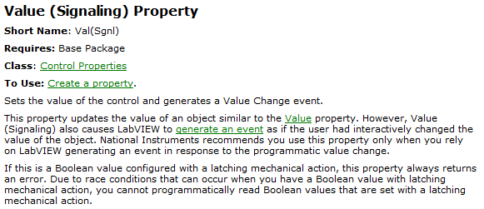

Figure 5.10.2 “Value (signalling)”, LabVIEW Help, National Instruments

## 5.11 Build Image Path

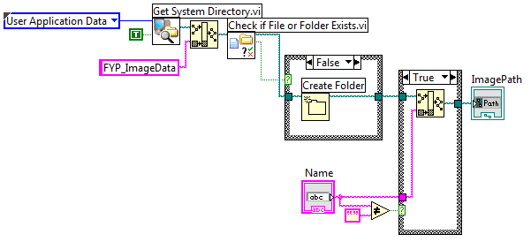

Figure 5.11.1 Block Diagram of “ImagePath(SubVI).vi”

This subVI is used in “SaveImage(SubVI).vi”, “ReviewQns(SubVI).vi” and “RunQuestions(SubVI).vi”. The function is to build the path were the front panel images of every question to be/are saved. The path will eventually points to “FYP_ImageData” folder under the user application data directory.

This subVI works by determining the directory of the user application data using the “Get System Directory VI” *(see Figure 5.72 below)*. Under this directory, it will check if the folder “FYP_ImageData” exists using “Check if File or Folder Exists VI” *(see Figure 5.73 below)*.

The filenames of those front panel images will be determined by the values wired to “Name” terminal.

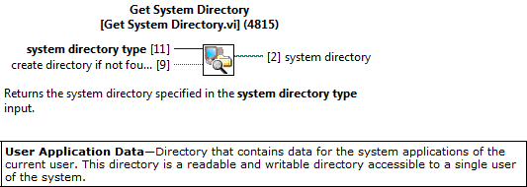

Figure 5.11.2 “Get System Directory VI”, LabVIEW Help, National Instruments

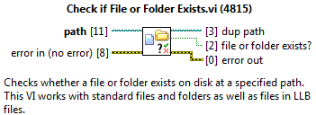

Figure 5.11.3 “Check if File or Folder Exists VI”, LabVIEW Help, National Instruments

## 5.12 Save VI Front Panel Image

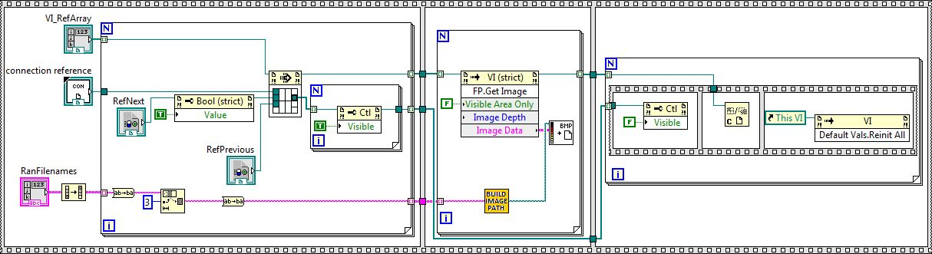

Figure 5.12.1 Block Diagram of “SaveImage(SubVI).vi”

This subVI is used in “RunQuestions(SubVI).vi”. The function of this subVI is to show the answers, then capture and save the front panel image of the questions user had done. These images will be used in “ReviewQns(SubVI).vi” where questions are reviewed, results and answers are shown.

The “frame” of the block diagram is the “Flat Sequence Structure”. It executes the block diagram from left right frame.

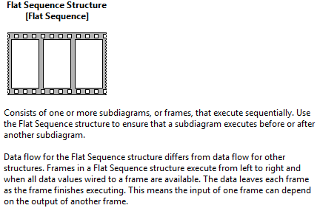

Figure 5.12.2 “Flat Sequence Structure”, LabVIEW Help, National Instruments

Next, I will split the block diagram *(Figure 5.81))* into three parts *(see Figure 5.83, 5.84 and 5.85)* for more detailed explanation. 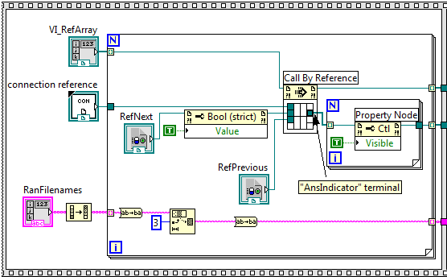

Figure 5.12.3 Part 1 Block Diagram of “SaveImage(SubVI).vi”

Figure 5.83 shows the first frame of the sequence structure. The function of this frame is to show the answers to each question. In every question, there will be a set of answer indicators that shows the correct answers. These answer indicators are invisible to the users when they are doing the questions *(see section 6.4 Questions).* This frame shows the answers to each question by making those sets of answers visible, before capturing the front panel images of the questions. This was done by wiring the “AnsIndicator” terminal of each question through “Call By Reference” to “Visible” property node in the smaller for loop.

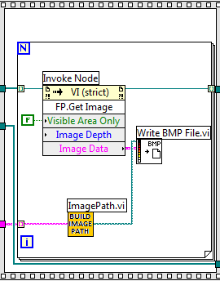

Figure 5.12.4 Part 2 Block Diagram of “SaveImage(SubVI).vi”

Figure 5.84 shows the second frame of the sequence structure. The function of this frame is to capture and saves the front panel image of each question. The “AnsIndicator” terminal from the first frame is wired to “Front Panel: Get Image” invoke node which captures the image data of the front panel of each question. The “Image Data” is then wired to “Write BMP File.vi” which creates the image files and saves it to the output path of “ImagePath.vi”.

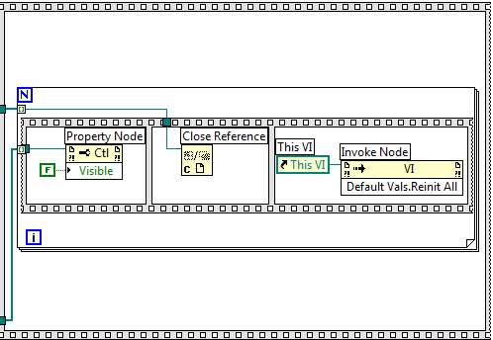

Figure 5.12.5 Part 3 Block Diagram of “SaveImage(SubVI).vi”

Figure 5.85 shows the third frame of the sequence structure. Within this frame, there is a for loop that contains another flat sequence structure. The first frame of the smaller sequence structure hides all the answers in each question so that the next time users redo the questions, the answers are still hidden. The second frame closes the VIs’ references of all the questions’ VIs as the questions’ VIs are no longer needed. By closing the references that are no longer needed, the space in memory where LabVIEW stored the reference source are freed up [17].

## 5.13 Get Result from Database

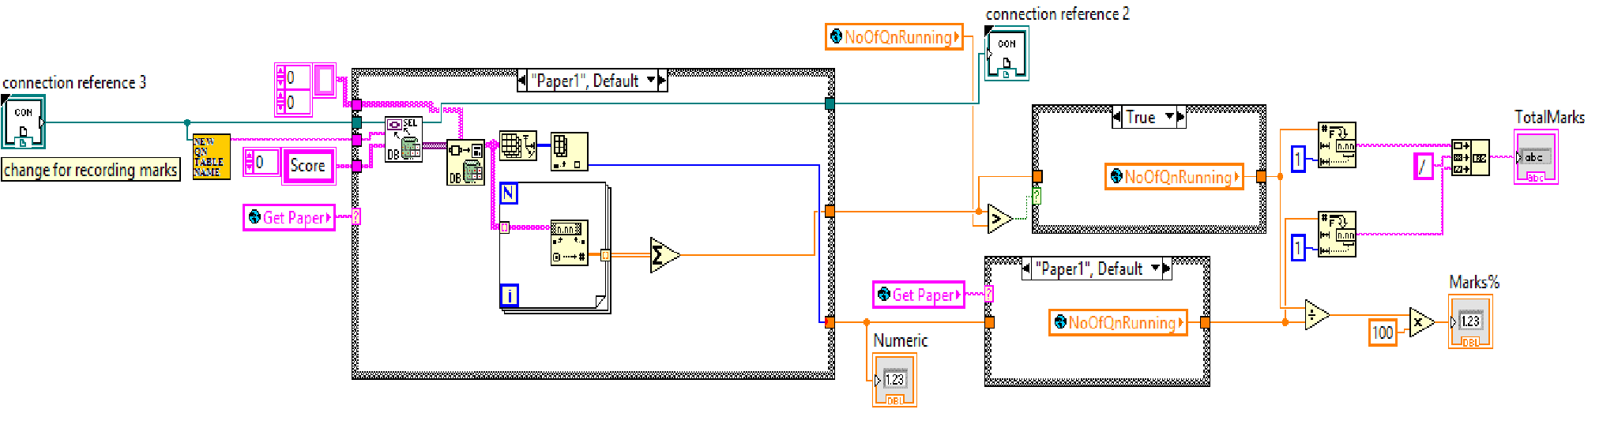

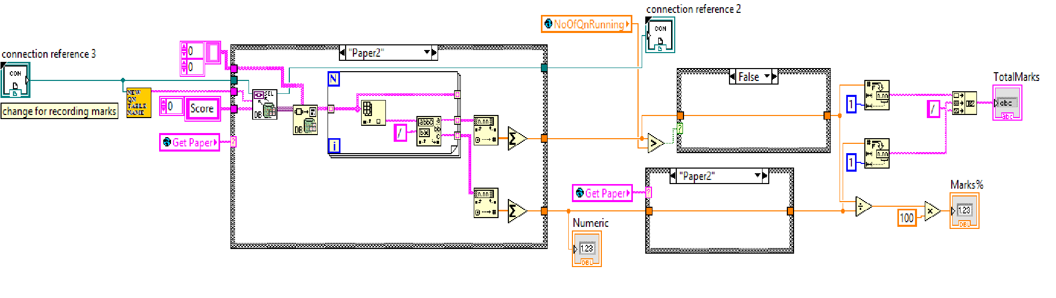

Figure 5.13.1 Block Diagram of “GetMarks(SubVI).vi”

This subVI is used in “ReviewQns(SubVI).vi” where questions are reviewed, results and answers are shown. The function of this subVI is to retrieve the results from the database where the number of marks scored for each questions are stored. The global variable “Get Paper” will be determined by whether user chose to do paper 1 or paper 2 questions.

The case on top shows the case when paper 1 questions are chosen. The sum of the values under “Marks” column are added for the number of marks scored. The total mark is determined by the number question running of MCQs in the selected topic. “NewQnTableName SubVI” is to determine the name of the table, so that the correct marks can upload to the table.

The case below shows the case when paper 2 questions is chosen. As the marks updated for structured questions is “x/y”, where “x” is the marks scored and “y” is the total marks for that particular question, “x” and “y” have to be read individually to find the total score and the total marks for all the structured questions. Hence, “Match Pattern Function” is used *(see Figure 5.92 below)*. This function separates the value before and after “/”, so that they could be read separately.

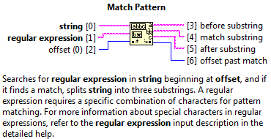

Figure 5.13.2 “Match Pattern Function”, LabVIEW Help, National Instruments

The part after the case structure is used to calculate the result. The program will use the marks scored divide by the total scores, and then pass to “TotalMarks” indicator. And correct percentage will be calculated and pass to “Mark%” indicator as well.

## 5.14 Button Control for Review Questions, view Correct Answers and Results

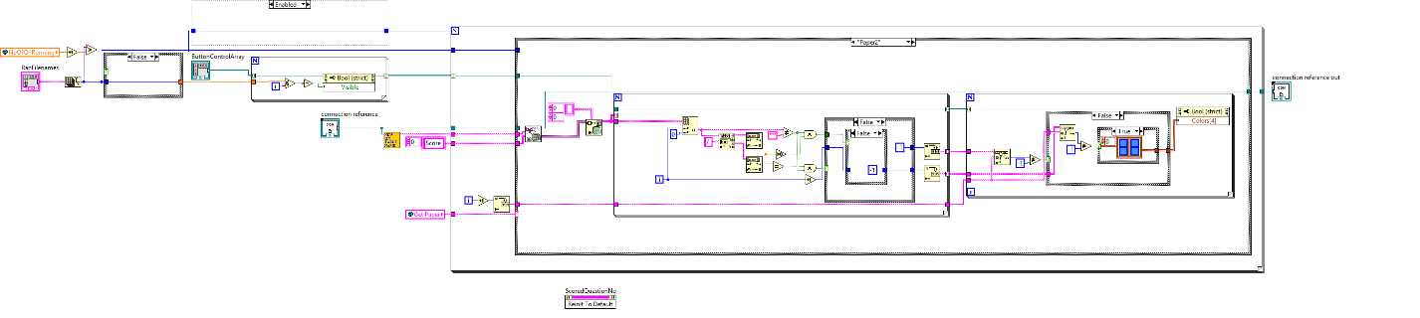

Figure 5.14a Block Diagram of “BtnCtrl_Review(SubVI).vi”

The function of this subVI is to control the buttons in “ReviewQns(SubVI).vi”. The number of buttons that show up will be equal to the number of questions running in the paper of the topic. The colour of each button for MCQs will be either green or red. Green represents correctly answered questions, and red represents wrongly answered questions. The colour of each button for Paper2 questions will be green, red or blue. Green means got the full marks for the question, blue means answer some questions correctly, while red means got 0 marks for the question.

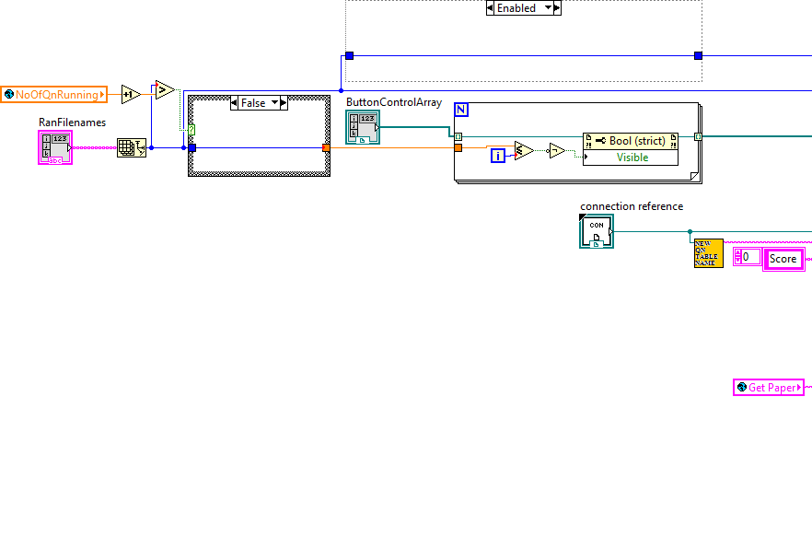

Figure 5.14b Part 1 Block Diagram of “BtnCtrl_Review(SubVI).vi”

Figure 5.10b shows part 1 of the block diagram of “BtnCtrl_Review(SubVI).vi”. The for loop at the top is used to show the buttons in “ReviewQns(SubVI).vi”. The number of buttons shown equals to the number of questions done.

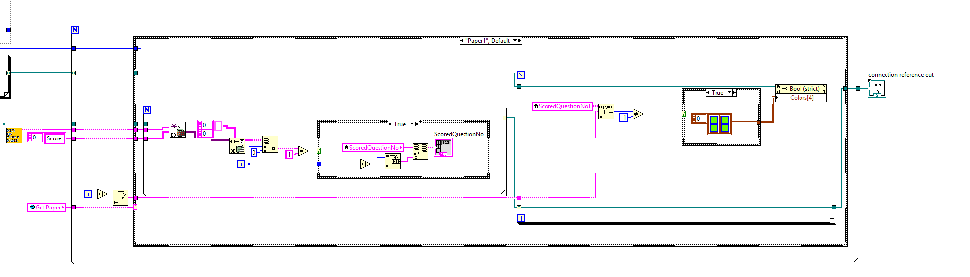

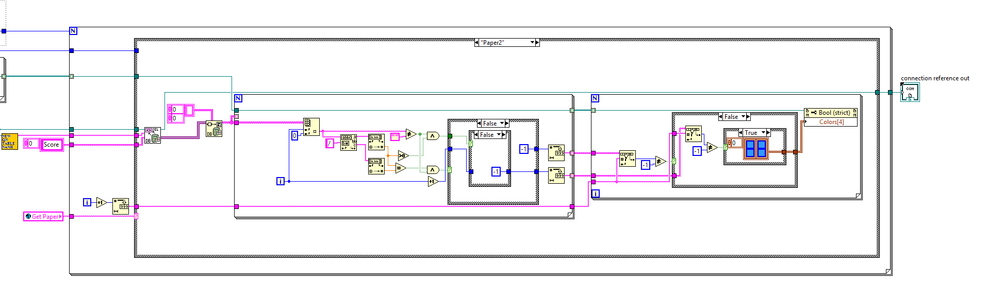

Figure 5.14c Part 2 Block Diagram of “BtnCtrl_Review(SubVI).vi”

Figure 5.10c shows part 2 of the block diagram of “BtnCtrl_Review(SubVI).vi”. The top case is executed if paper 1(MCQs) is chosen and the case below is executed if paper 2(structured questions) is chosen. The function of this part is to determine the colour of the buttons. The colour of each button for MCQs will be either green or red; green if correctly answered or red if wrongly answered. The colour of each button for Paper2 questions will be green, red or blue. It will be blue if the users’ answer is partially correct.

# C:\Users\happy19born93\Pictures\1.jpg

# Figure 5.14d Front Panel of “ReviewQns(SubVI).vi”

# 6. Program

## 6.1 Login page



Figure 6.1.1 Front Panel of “Login(SubVI).vi”

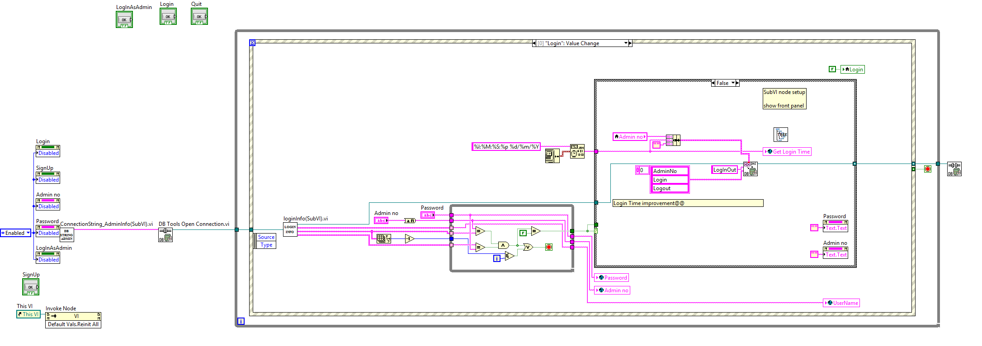

Figure 6.1.2 Block diagram of “Login(SubVI).vi”

The login page is where users login with the correct admin no. and password. If the user does not have an account, he can sign up for one. When user clicks the “Login” button, this VI verifies if the admin no. and password entered is correct. If they are correct, the login attempt will be successful. Otherwise, a message box asking the user to key in the correct admin no. and password will pop-up *(see Figure 6.13)*. If the user chooses to sign up, the front panel controls will be disabled and the sign up will pop-up.

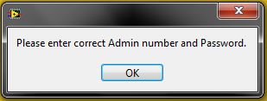

Figure 6.1.3 Message box

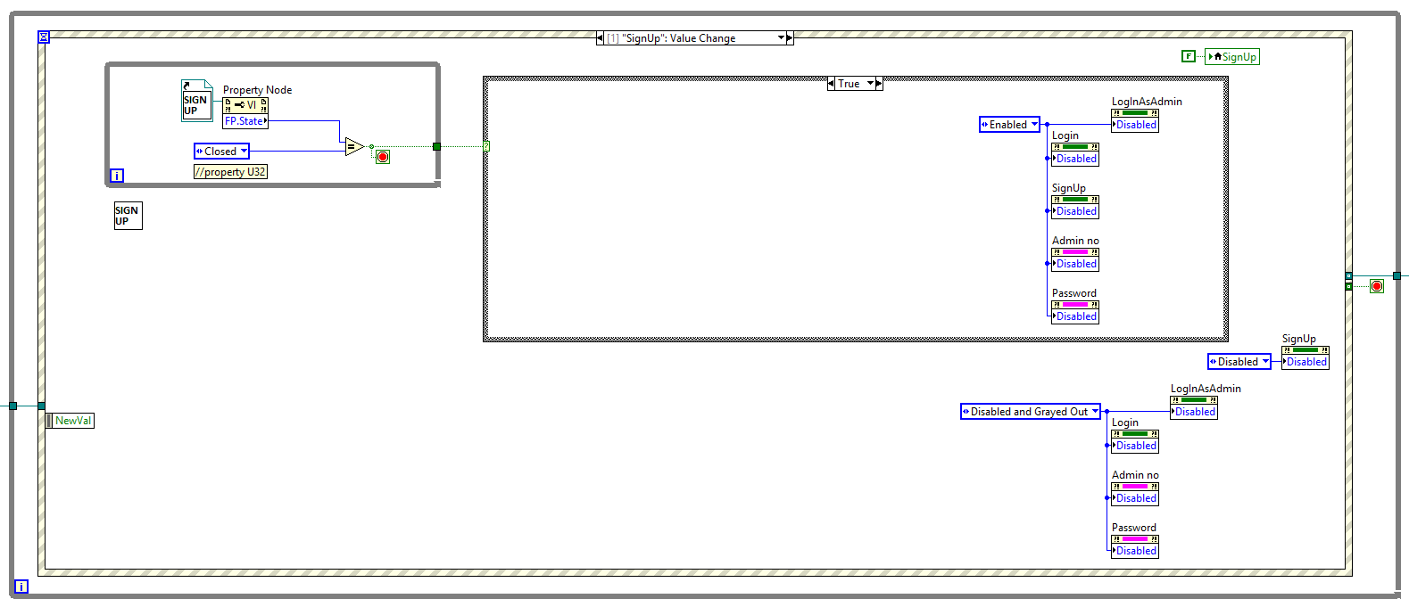

Figure 6.1.4 “Login1.vi” ““SignUp”: Mouse Down” Event case

Figure 6.14 shows the event case that will execute if user chooses to sign up. The front panel controls will be disabled and the sign up page will pop-up. After the sign up page closes, the front panel controls will be enabled so that users can continue to login.

## 6.2 Sign up page

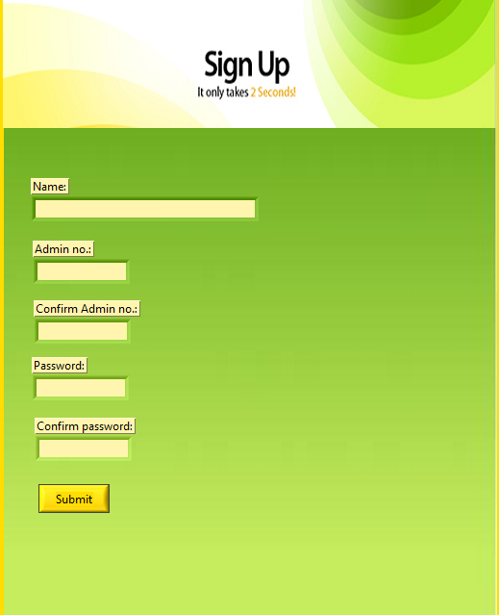

Figure 6.2.1 Front panel of “SignUp(SubVI).vi”

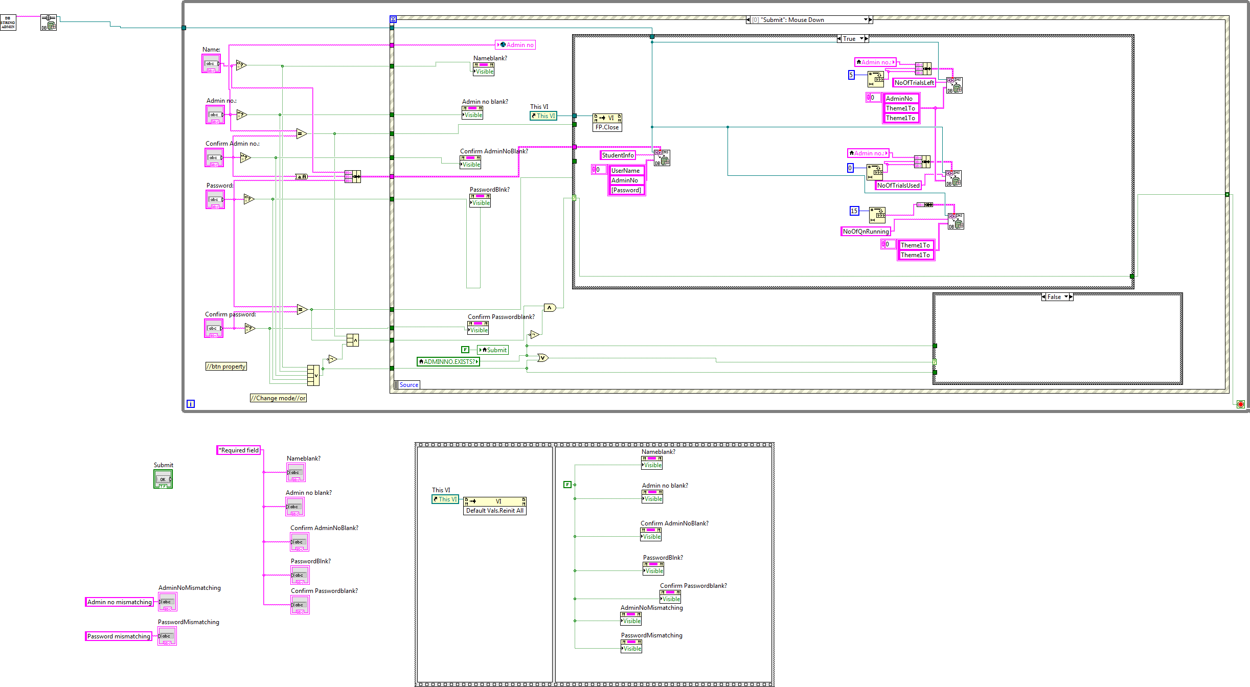

Figure 6.2.2 Block Diagram of “SignUp(SubVI).vi”

This “SignUp”.vi allows users to sign up for a new account if the user does not have one. This VI will verify that the admin no. has not been registered and all the fields are filled up. Otherwise, a message box will pop-up telling the user to choose another admin no. and/or fill in the required fields.

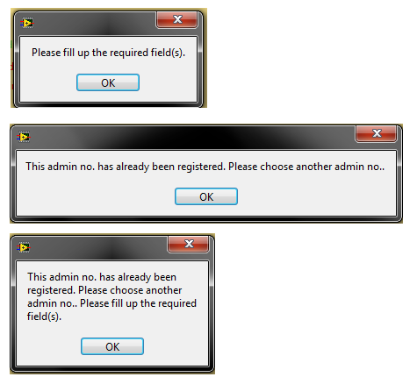

Figure 6.2.3 “SignUp(SubVI).vi” Message Boxes

## 6.3 Tree Control

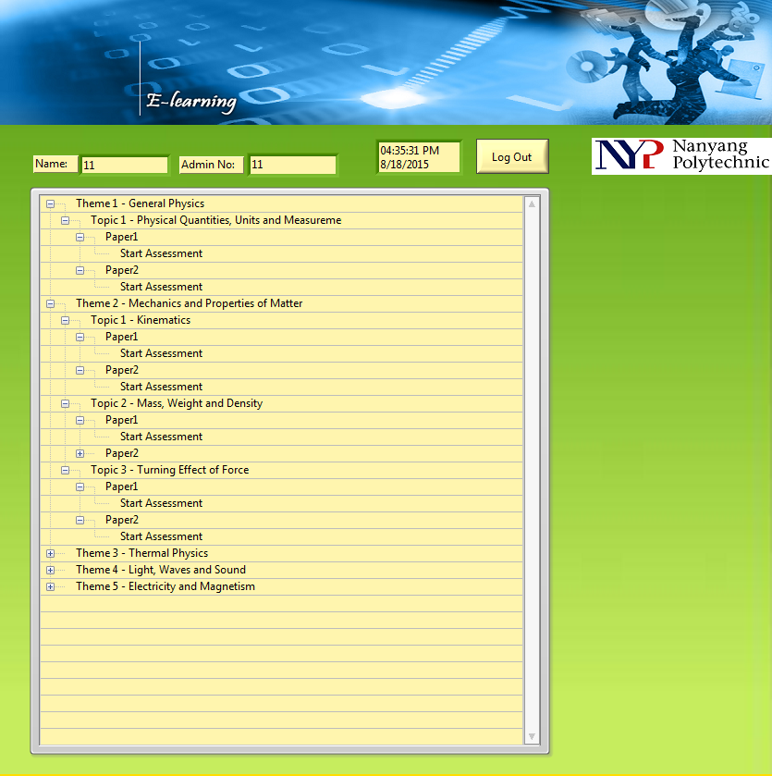

Figure 6.3.1 Front Panel of “Tree(SubVI).vi”

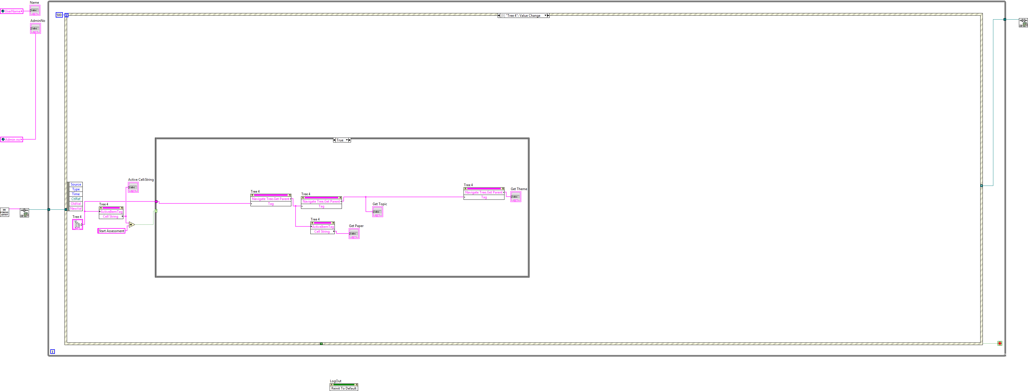

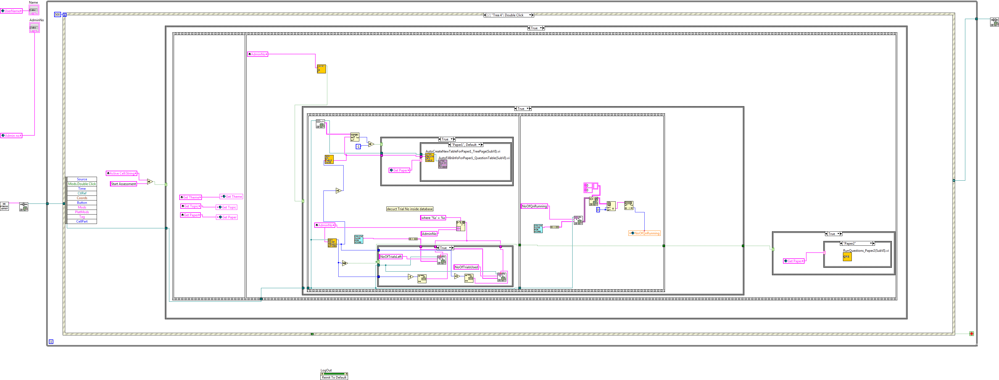

Figure 6.3.2 Block Diagram of “Tree(SubVI).vi”

The function of this VI is to allow users to choose the topics they want to do. The username and admin no. is shown at the top of the front panel. The first event case *(see Figure 6.32)* is used to identify the theme, topic and paper when user clicks on “Start Assessment”. The second event case is used to store the theme, topic and paper to the global variables when user double clicks on “Start Assessment”, as they will be used in other parts of the program later. Moreover, the program will auto create a new table to record all the question data inside the database ad fill in the number of running questions. After that, the front panels “RunQuestions(SubVI).vi” will pop-up.

## 6.4 Questions

## 6.4.1 Multiple choice questions (MCQs)

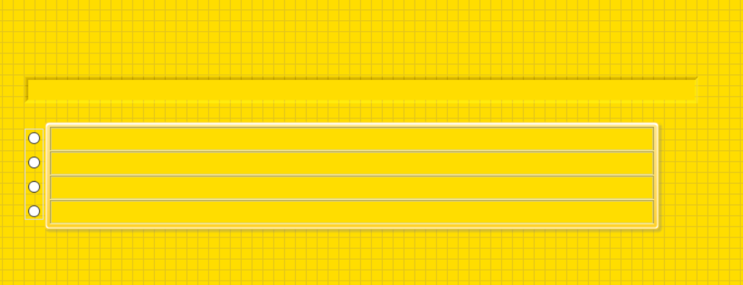

Figure 6.4.1.1 Front Panel of a MCQ VI

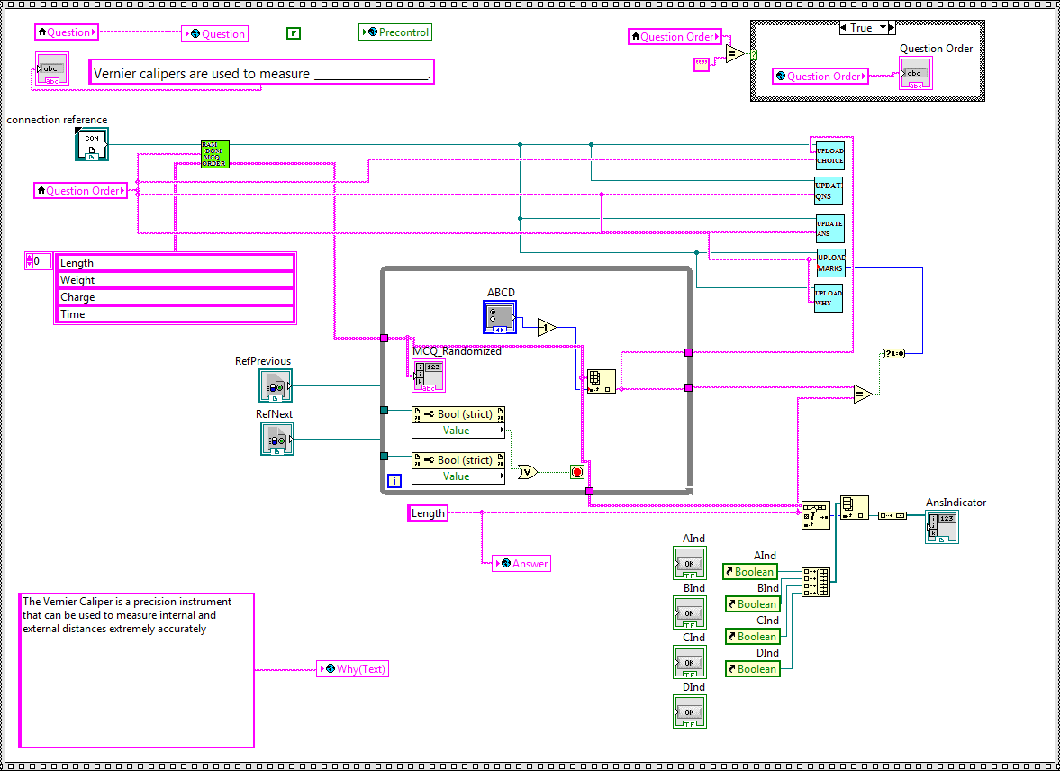

Figure 6.4.1.2 Block Diagram of a question VI

For every MCQ, an array of options is wired to “RandomMCQ_Options(SubVI).vi” where the order of options is randomized. The randomized options are displayed and user can select the answer. The users answer will be compared to the correct answer wired to the “Search 1D Array” function. The “Search 1D Array” function determines which answer is correct. The marks scored will be updated to the database by the SubVI, “UpdateMarks(SubVI).vi”.

## 6.4.2 Structured questions

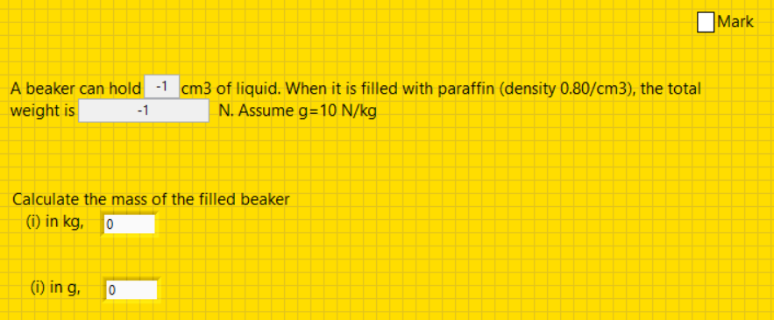

Figure 6.4.2.1 Front Panel of structured question VI

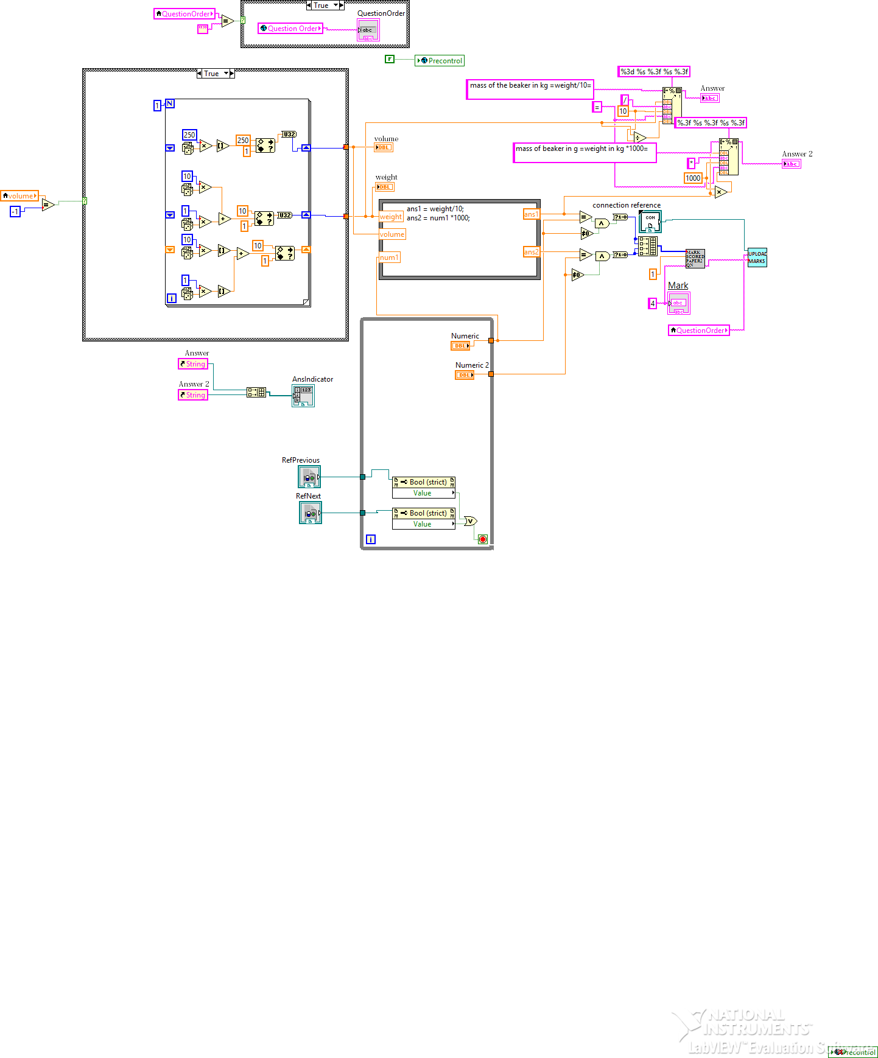

Figure 6.4.2.2 Block Diagram of Structured question VI

For every paper2 question, all the values inside the question will be randomized. Then the program will calculate a correct value as answers. The user can key in their values. The “Equal” function will compare the correct value with the value which the user key in. If these two values are equal. Then marks will be given and updated to the database by the SubVI, “UpdateMarks(SubVI).vi”. Otherwise, “0” marks will update to database. The top right corner is the explanation part. After the user done their attempt, all the explanation will be shown based on the right corner part.

## 6.5 Run Questions

## 6.5.1 Paper 1

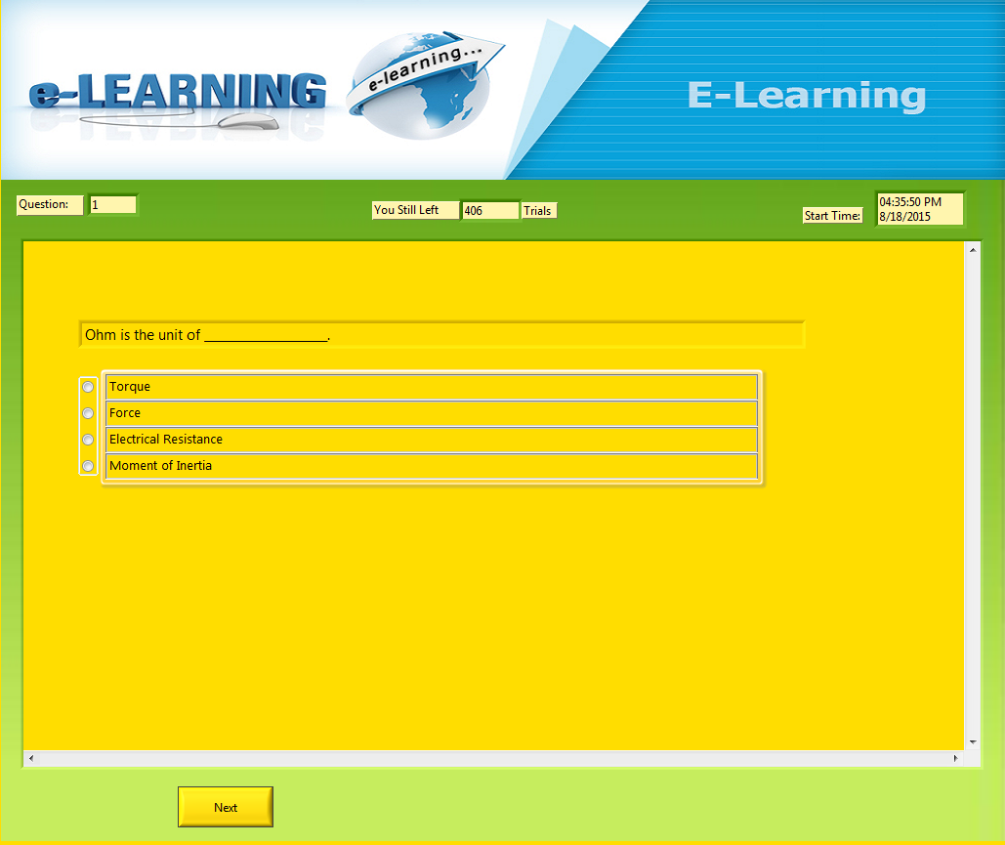

Figure 6.5.1.1 Front Panel of “RunQuestions_Paper1(SubVI).vi”

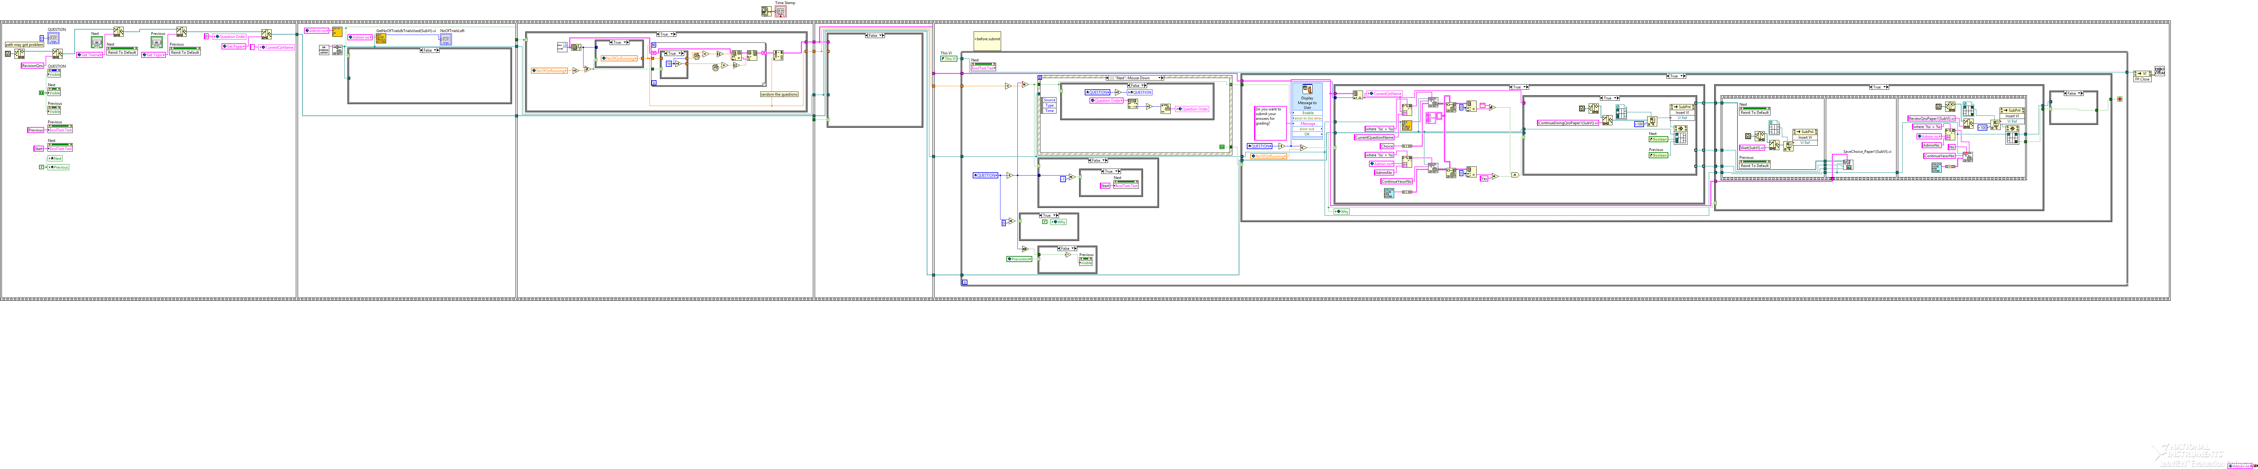

Figure 6.5.1.2 Block Diagram of “RunQuestions_Paper1(SubVI).vi”

The function of this VI is to run the questions. I will split into five parts for more detailed explanation.

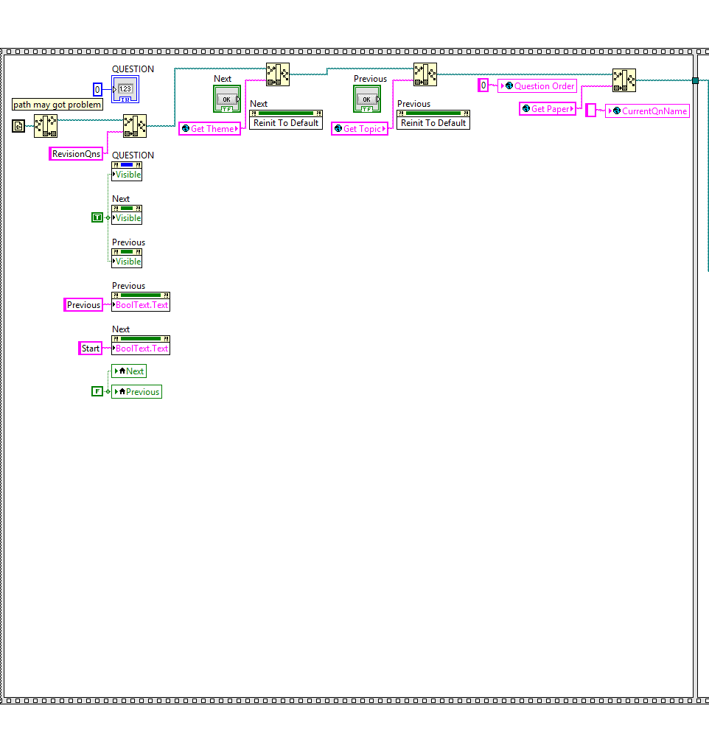

Figure 6.5.1.3 Part 1 Block Diagram of “RunQuestions_Paper1(SubVI).vi”

Figure 6.5.1.3 shows part 1 of the block diagram of “RunQuestions_Paper1(SubVI).vi”. The function of this part is to identify the path of questions to run. This was done by using the global variables to identify the theme, topic, and paper the user selected from the tree control. All the questions are organized in such a way that their respective paths are “…\RevisionQns*Theme X - Name of theme\Name of topic*Paper 1”. The output of the subVI, “QnFileNames(SubVI).vi”, is an array of file names of the questions to be executed.

Moreover, all the buttons and indicators will be initialized in this part.

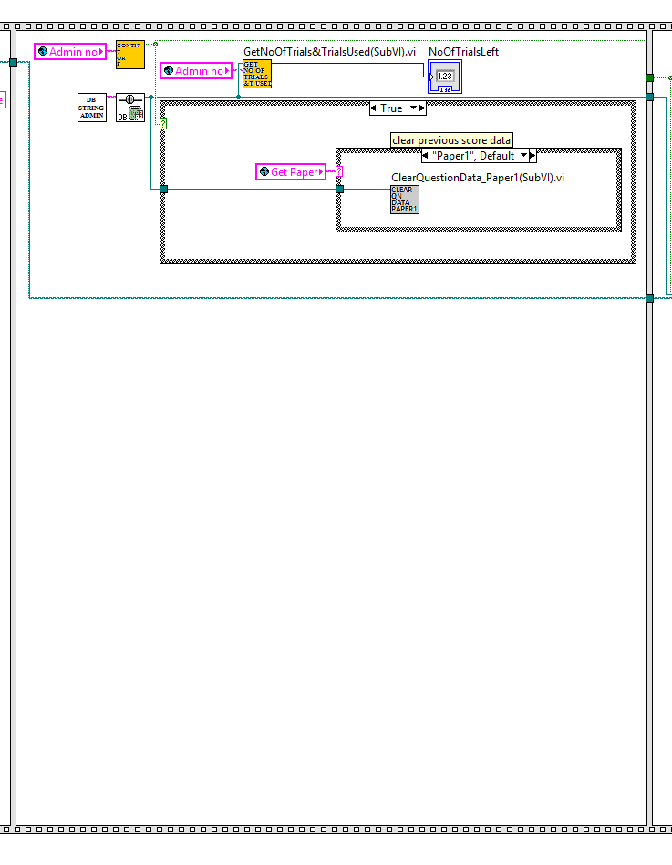

Figure 6.5.1.4 Part 2 Block Diagram of “RunQuestions_Paper1(SubVI).vi”

Figure 6.5.1.4 shows part 2 of the block diagram of “RunQuestions_Paper1(SubVI).vi”. The function for this part is to check whether the user did this paper before and he/she wants to continue doing the paper or not. If it’s the first time he/she doing the paper, then the program will clear the table and prepare for recording all the essential data inside the database while he/she doing the paper. If this is second time he/she doing the paper, and he/she wanted to continue doing the paper, then the program will keep all the data inside the table and let the program load all the data and let he/she continue doing the paper.  
  
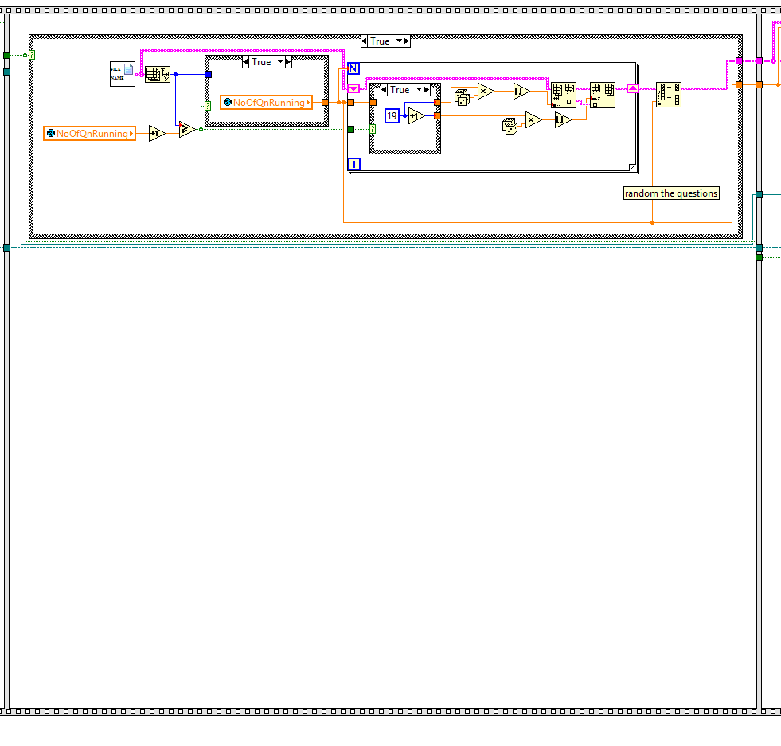

Figure 6.5.1.5 Part 3 Block Diagram of “RunQuestions_Paper1(SubVI).vi”

Figure 6.5.1.5 shows part 3 of the block diagram of “RunQuestions_Paper1(SubVI).vi”. If this is the first time the user doing the paper, then the program will randomize the order of the questions and pass to next stage. However, if the user did this paper before and want to continue doing it, then the program will just read all the questions order from the database “CurrentQuestionName” column, and pass to next stage to run the question based on previous order.  
  
  
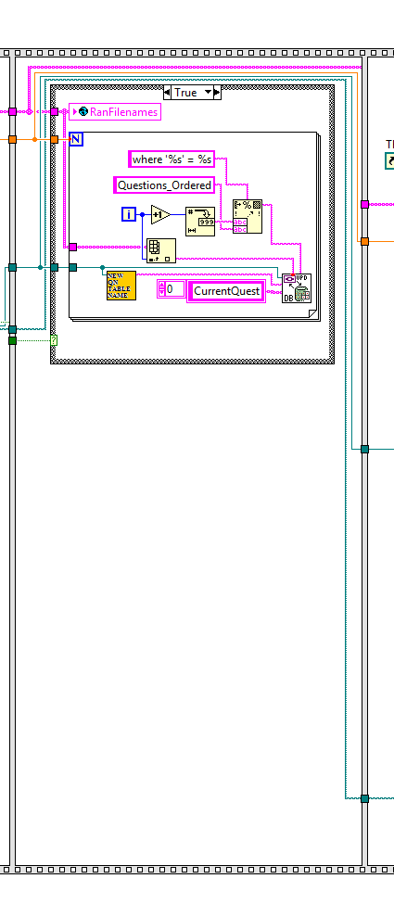

Figure 6.5.1.6 Part 4 Block Diagram of “RunQuestions_Paper1(SubVI).vi”

Figure 6.5.1.6 shows part 4 of the block diagram of “RunQuestions_Paper1(SubVI).vi”. This part is to upload all the question order to “RunFileNames” global variable and database “CurrentQuestionName” column if this is the first time the user doing the paper.  
  
  
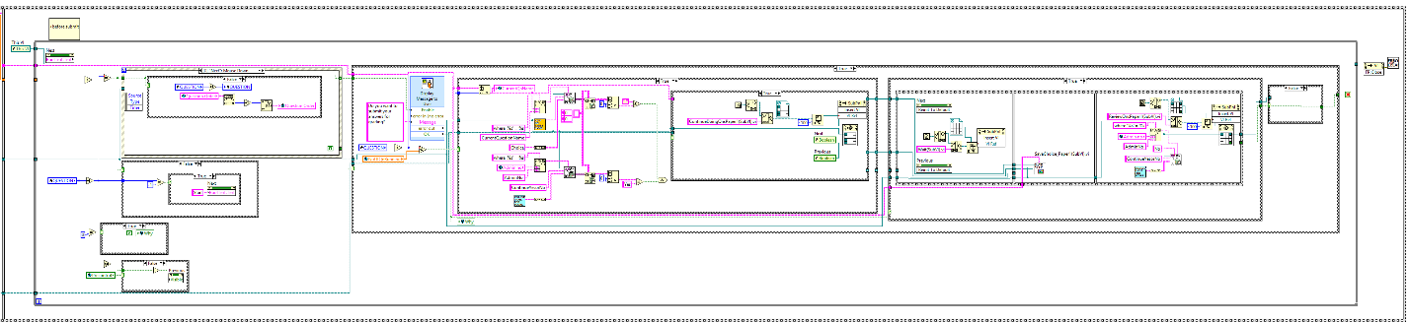

Figure 6.5.1.7 Part 5 Block Diagram of “RunQuestions_Paper1(SubVI).vi”

Figure 6.5.1.7 shows part 4 of the block diagram of “RunQuestions_Paper1(SubVI).vi”. The function of this part is to control the visibility and text of “Previous” button and “Next” button respectively, as well as the question shown on the front panel. If only the user is doing the first question, the “Previous” button will be invisible. If the user reached the last question, the text on the “Next” button becomes “End”. The event structure determines which question to execute if users click on “Next” or “Previous” button. If “Next” is clicked, the next question is shown. Similarly, if “Previous” is clicked, the previous question is shown. After the user clicks “End”, a message box pop-up *(see Figure* 6.5.1.8*).*

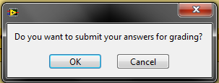

Figure 6.5.1.8Message Box

Moreover, the function of this part is also to display the front panel of each question in the sub panel of this VI as well as storing the VI references of each question. The “Open VI Reference” function is used where the path is the path from part 1 built with the file names in randomized order from part 1, indexed with local variable, “Question”. “Start Asynchronous Call” function is used*.* “StoreViRef.vi” stores the VI references of each question that has been executed. The output of this subVI, “VI_RefArray”, which is an array of VI references, will be used in the part of the block diagram.

After the user clicks “OK” when the message box appears, the program in the case structure executes. The question number will be hidden.

The program will update all the data to database based on the question order before executing “ReviewQns(SubVI).vi”.

The last frame executes “ReviewQns(SubVI).vi”, where questions are reviewed, results and answers are shown, as well as displaying its front panel in the sub panel. “Call By Reference” function is used to call “ReviewQns(SubVI).vi”*.*

After the program execute all the parts above, the program will wait until the user click the “Close” button in the review page. The stop condition of the while loop is wired to the output of the case condition. This means that after the case finishes executing, the while loop stops and the front panel of “RunQuestions(SubVI).vi” will close.

## 6.5.2 Paper 2

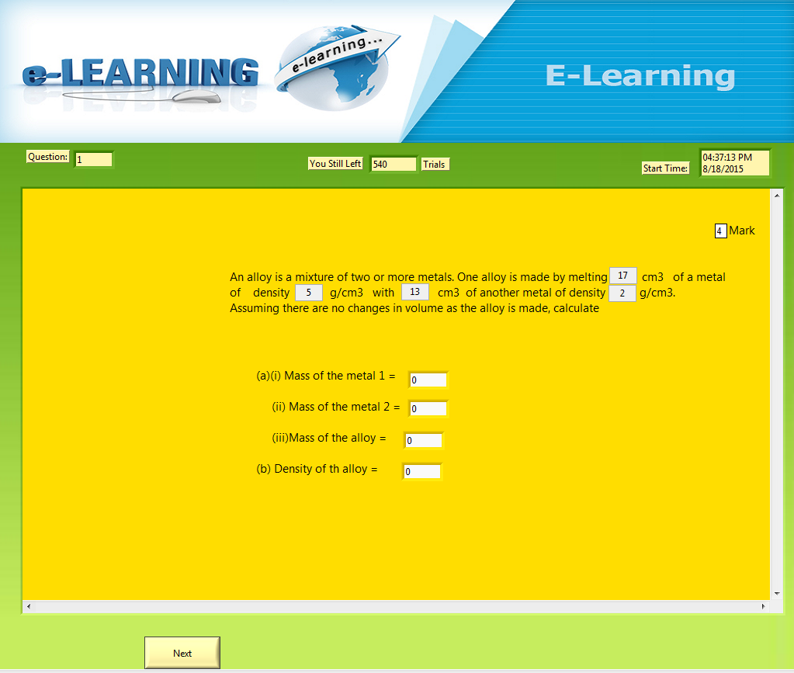

Figure 6.5.2.1 Front Panel of “RunQuestions_Paper2(SubVI).vi”

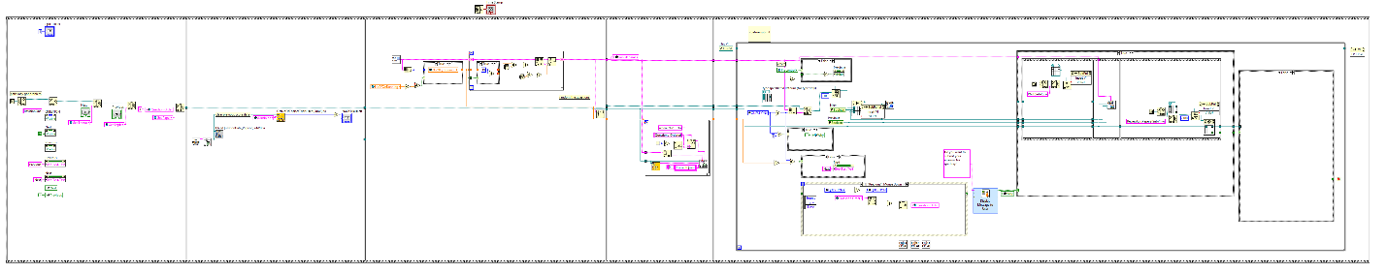

Figure 6.5.2.2 Front Panel of “RunQuestions_Paper2(SubVI).vi”

The function of this VI is to run the questions. I will split into five parts for more detailed explanation.

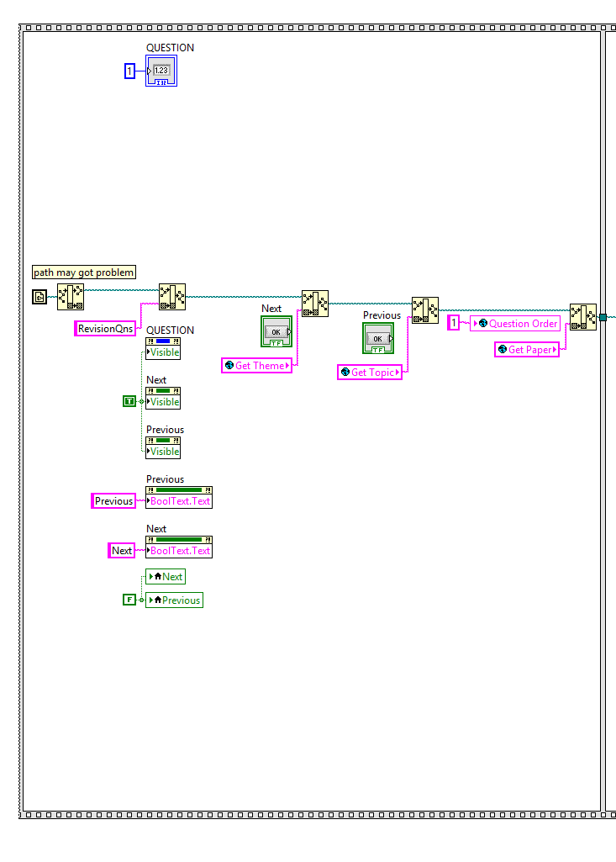

Figure 6.5.2.3 Part 1 Block Diagram of “RunQuestions_Paper2(SubVI).vi”

Figure 6.5.2.3 shows part 1 of the block diagram of “RunQuestions_Paper2(SubVI).vi”. The function of this part is to identify the path of questions to run. This was done by using the global variables to identify the theme, topic, and paper the user selected from the tree control. All the questions are organized in such a way that their respective paths are “…\RevisionQns*Theme X - Name of theme\Name of topic*Paper 2”. The output of the subVI, “QnFileNames(SubVI).vi”, is an array of file names of the questions to be executed.

Moreover, all the buttons and indicators will be initialized in this part.

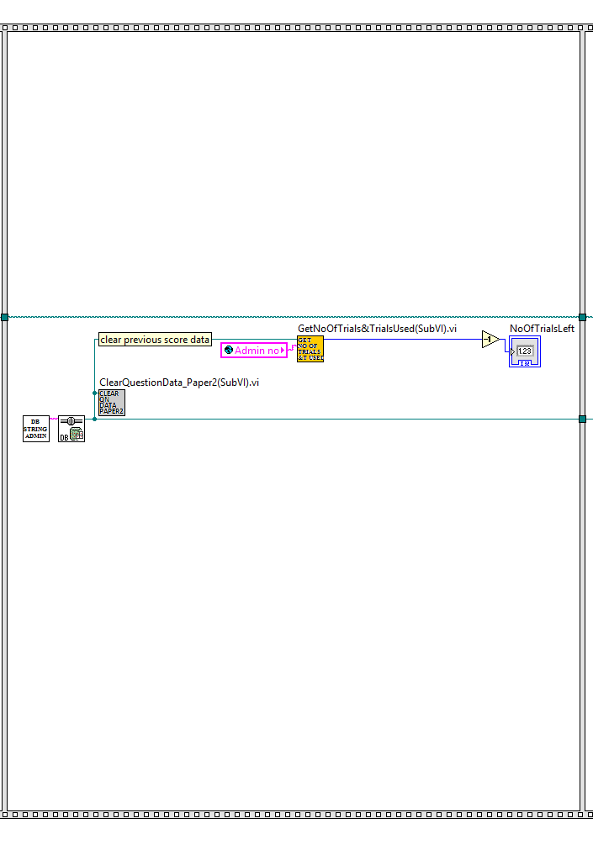

Figure 6.5.2.4 Part 2 Block Diagram of “RunQuestions_Paper2(SubVI).vi”

Figure 6.5.2.4 shows part 2 of the block diagram of “RunQuestions_Paper2(SubVI).vi”. The function for this part is to clear the table and prepare to update all the question data in the while the user is doing the paper.  
  
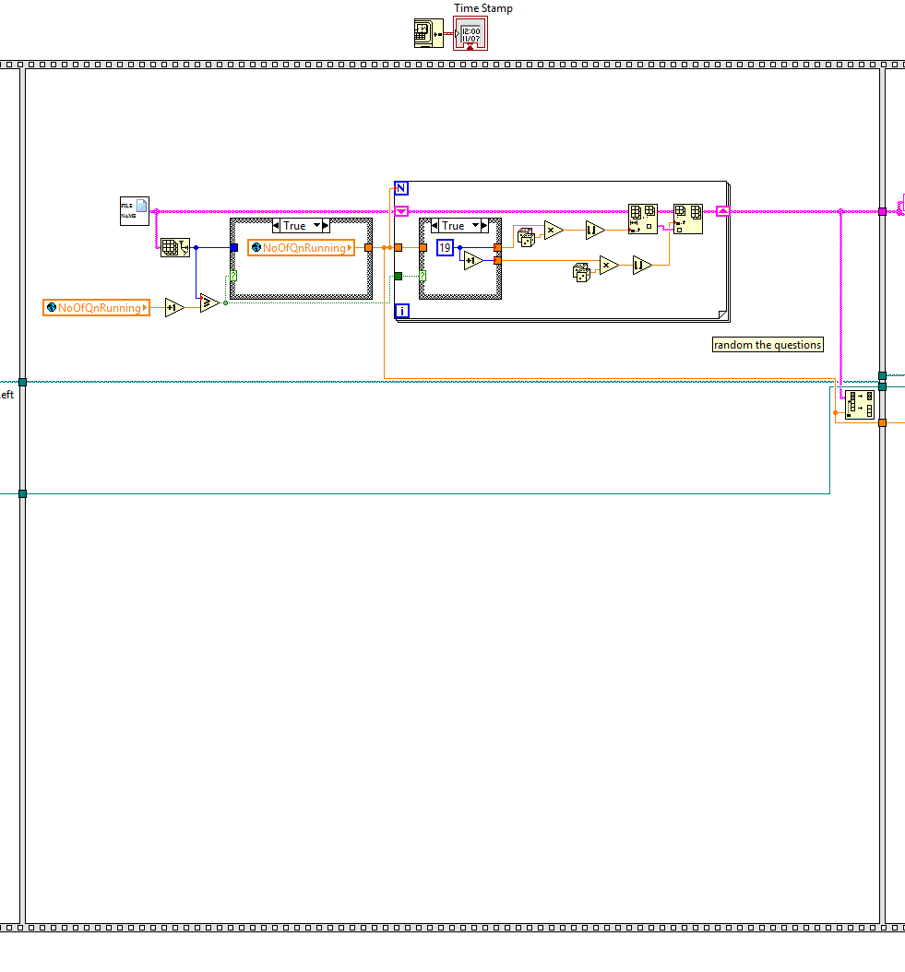

Figure 6.5.2.5 Part 3 Block Diagram of “RunQuestions_Paper2(SubVI).vi”

Figure 6.5.2.5 shows part 3 of the block diagram of “RunQuestions_Paper2(SubVI).vi”. the function for this part is to randomize the order of the questions and pass to next stage.   
  
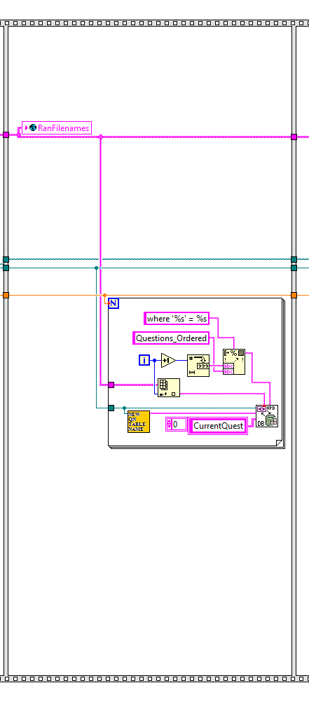

Figure 6.5.2.6 Part 4 Block Diagram of “RunQuestions_Paper2(SubVI).vi”

Figure 6.5.2.6 shows part 4 of the block diagram of “RunQuestions_Paper2(SubVI).vi”. This part is to upload all the question order to “RunFileNames” global variable and database “CurrentQuestionName” column.  
  
  
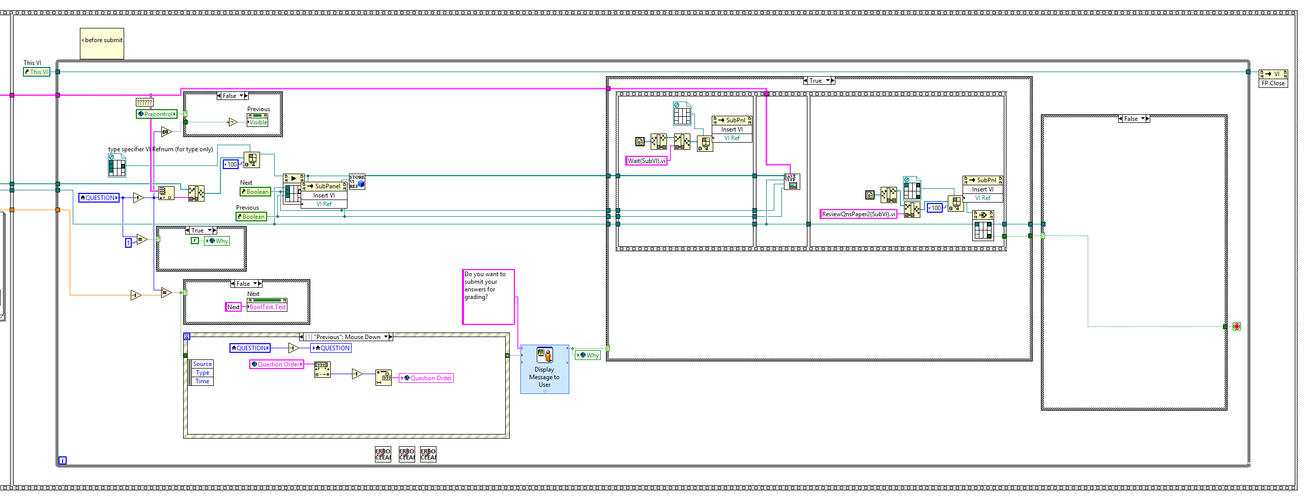   
 Figure 6.5.2.7 Part 5 Block Diagram of “RunQuestions_Paper2(SubVI).vi”

Figure 6.5.2.7 shows part 4 of the block diagram of “RunQuestions_Paper2(SubVI).vi”. The function of this part is to control the visibility and text of “Previous” button and “Next” button respectively, as well as the question shown on the front panel. If only the user is doing the first question, the “Previous” button will be invisible. If the user reached the last question, the text on the “Next” button becomes “End”. The event structure determines which question to execute if users click on “Next” or “Previous” button. If “Next” is clicked, the next question is shown. Similarly, if “Previous” is clicked, the previous question is shown. After the user clicks “End”, a message box pop-up *(see Figure*6.5.2.8*).*



Figure 6.5.2.8 Message Box

Moreover, the function of this part is also to display the front panel of each question in the sub panel of this VI as well as storing the VI references of each question. The “Open VI Reference” function is used where the path is the path from part 1 built with the file names in randomized order from part 1, indexed with local variable, “Question”. “Start Asynchronous Call” function is used*.* “StoreViRef(SubVI).vi” stores the VI references of each question that has been executed. The output of this subVI, “VI_RefArray”, which is an array of VI references, will be used in the part of the block diagram.

After the user clicks “OK” when the message box appears, the program in the case structure executes. The question number will be hidden.

The program will update all the data to database based on the question order before executing “ReviewQns(SubVI).vi”.

The last frame executes “ReviewQns(SubVI).vi”, where questions are reviewed, results and answers are shown, as well as displaying its front panel in the sub panel. “Call By Reference” function is used to call “ReviewQns(SubVI).vi”*.*

After the program execute all the parts above, the program will wait until the user click the “Close” button in the review page. The stop condition of the while loop is wired to the output of the case condition. This means that after the case finishes executing, the while loop stops and the front panel of “RunQuestions(SubVI).vi” will close.

## 6.6 Review Questions, view Correct Answers and Results

## 6.6.1 Paper 1

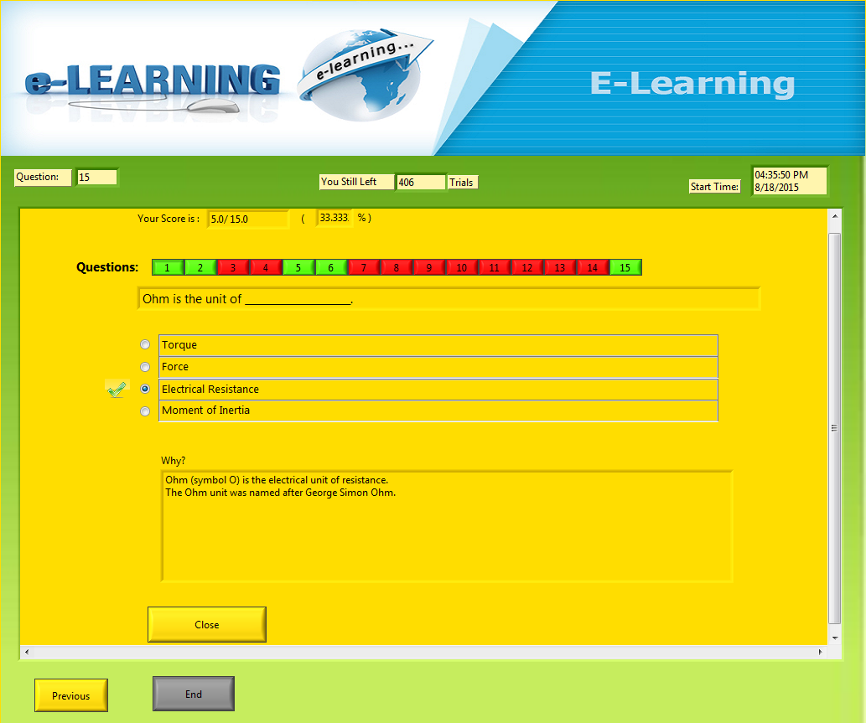

Figure 6.6.1.1 Front Panel of “ReviewQnsPaper1(SubVI).vi”

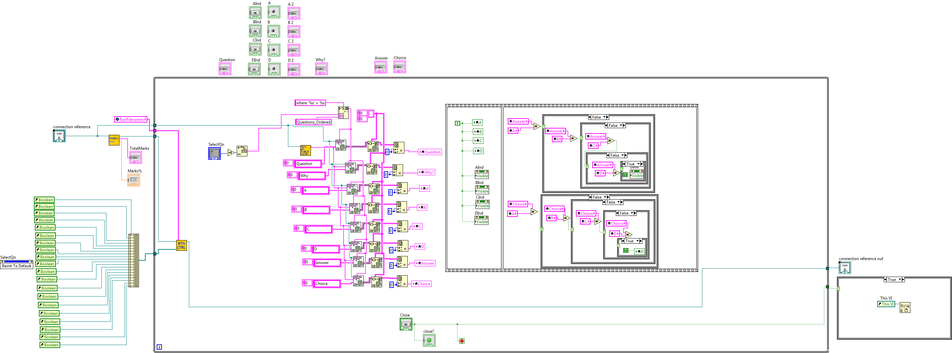

Figure 6.6.1.2 Block diagram of “ReviewQnsPaper1(SubVI).vi”

The function of this VI is to review the questions as well as showing the results, answers and explanations. This VI uses three subVIs; “GetMarks(SubVI).vi”, ‘BtnCtrl_Review(SubVI).vi” and “NewQuestionTableName(SubVI).vi”. All the data will be taken form the database.

## 6.6.2 Paper 2



Figure 6.6.2.1 Front panel of “ReviewQnsPaper2(SubVI).vi”

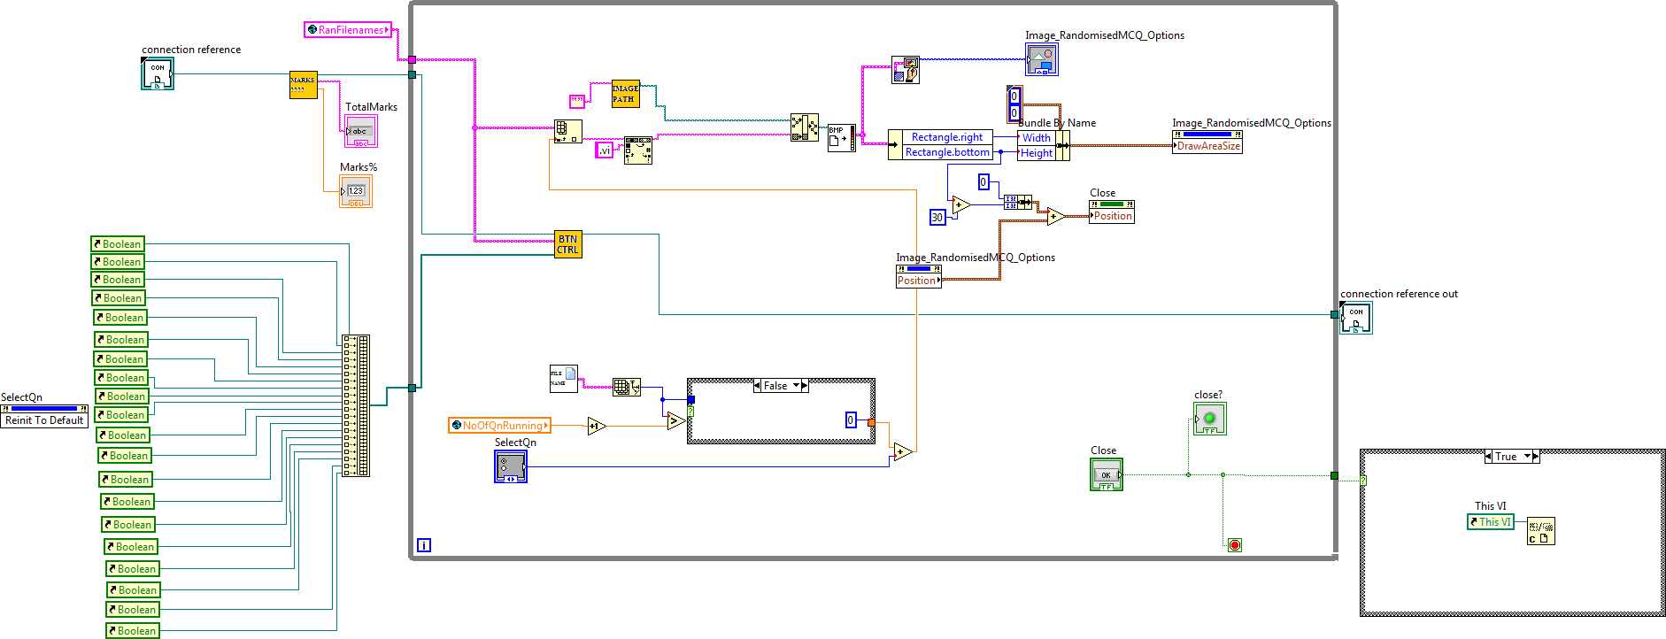

Figure 6.6.2.2 Block Diagram of “ReviewQnsPaper2(SubVI).vi”

The function of this VI is to review the questions as well as showing the results and answers. This VI uses three subVIs; “GetMarks(SubVI).vi”, ‘BtnCtrl_Review(SubVI).vi” and “ImagePath(SubVI).vi”. Other than the functions of these subVI described earlier, this VI displays the image file saved previously with “SaveImage(SubVI).vi”. The image file displayed corresponds with the button selected.

## 6.7 Administration panel

Figure 6.7.0.1 Front Panel of “AdminLogin(SubVI).vi”

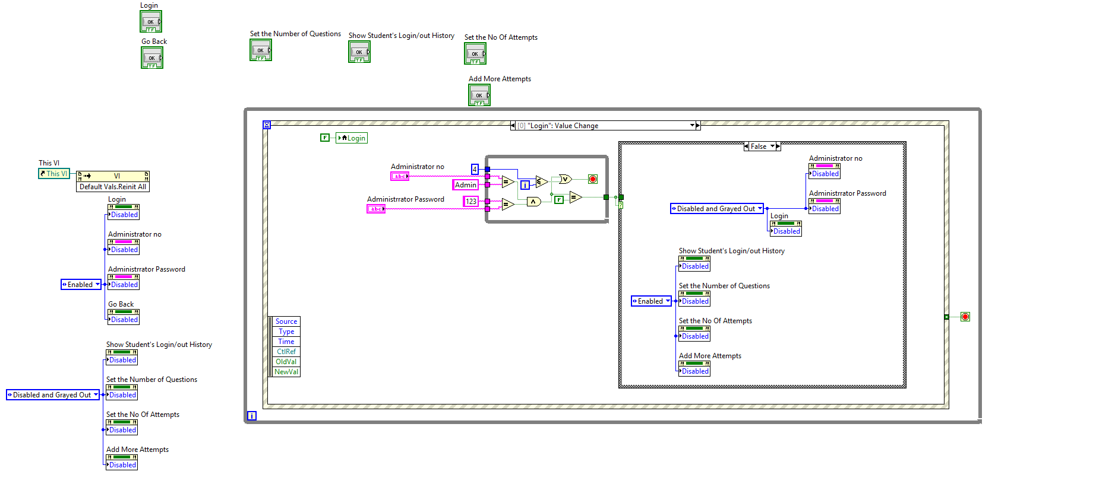

Figure 6.7.0.2 Block Diagram of “AdminLogin(SubVI).vi”

This admin panel is to let the administrator to see the student’s Login/Logout History, set the number of question running for each paper, set and add more attempts for one specific student.

However, the administrators need to enter the correct Username and Password first. The Username will be “Admin”, and the Password will be “123”. This can be changed inside the block diagram.

After the administrator entered the correct username and password, four buttons will be enabled to let the administrator to choose which function he/she want to access.

## 6.7.1 See Login/Logout History

## 6.7.1.1 Front panel

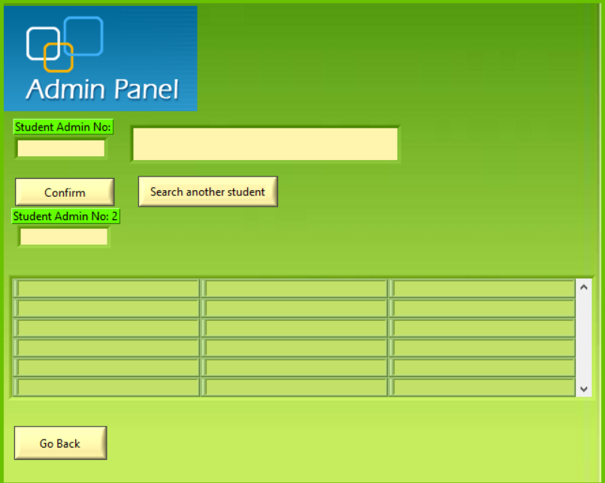

Figure 6.7.1.1 Front Panel of “AdminLogin(SubVI).vi”

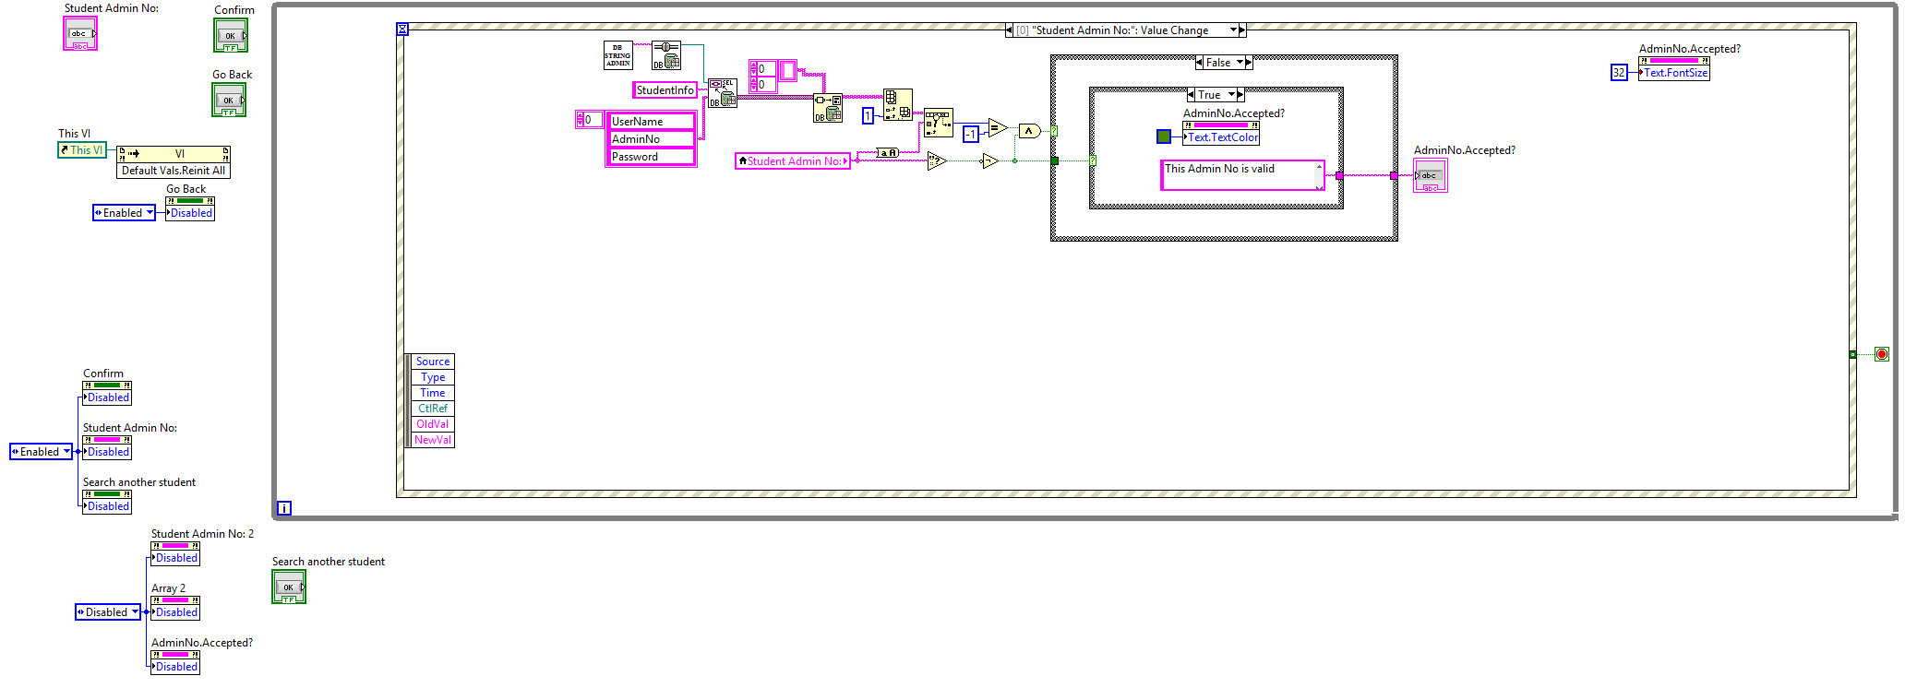

Figure 6.7.1.2 Block Diagram of “AdminLogin(SubVI).vi”

The administrator needs to enter the student’s admin number, if the admin number is valid, green-coloured font “Admin No is valid” will appear in the box beside “Student Admin No:”. If not, the red-coloured font “Admin No is invalid” will appear in the box.

After the administrator enter the valid admin number, the history will appear in the table at the bottom. All the data will be taken from the database “LogInOut” table.

## 6.7.2 Set Number of question running

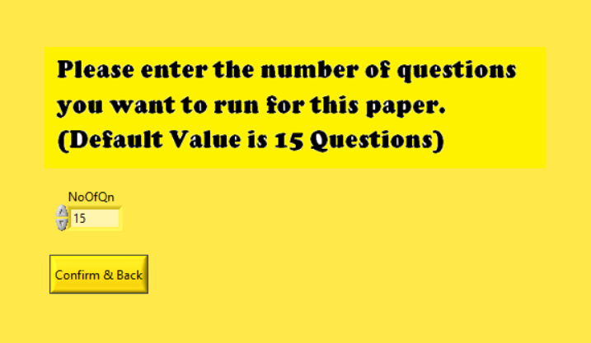

Figure 6.7.2.1 Front Panel of “SetNoOfQuestion(SubVI).vi”

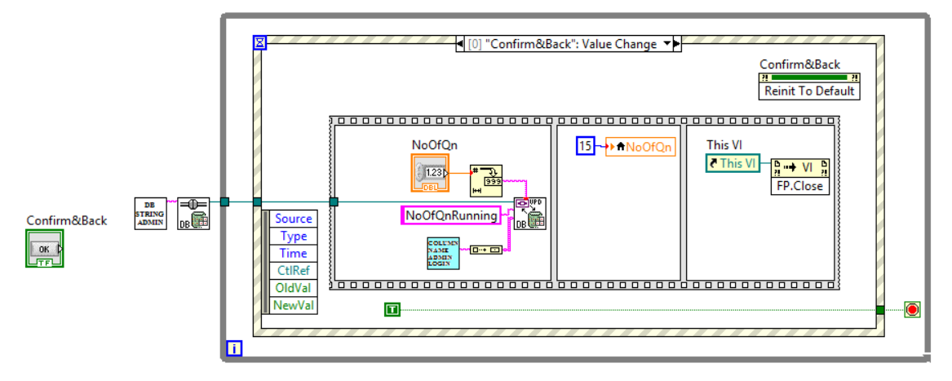 Figure 6.7.2.2 Block Diagram of “SetNoOfQuestion(SubVI).vi”

This is to set the number of question running for each paper. In short, the program will update the number which entered by the administrator to database “NoOfQnRunning” Table. And every time before the program start one new attempt, it will go to the database to check the number of question running question variable. And the program will get the number of question running based on the value inside the database.

## 6.7.3 Set Number of Attempts

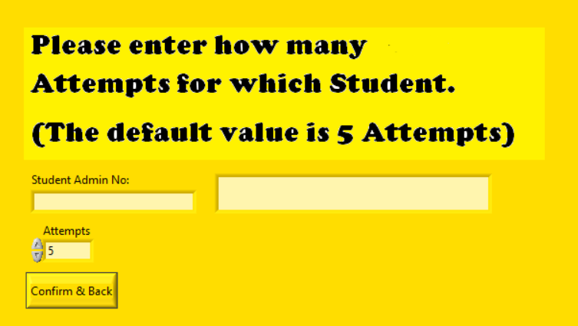

Figure 6.7.3.1 Front Panel of “SetNoOfAttempts(SubVI).vi”

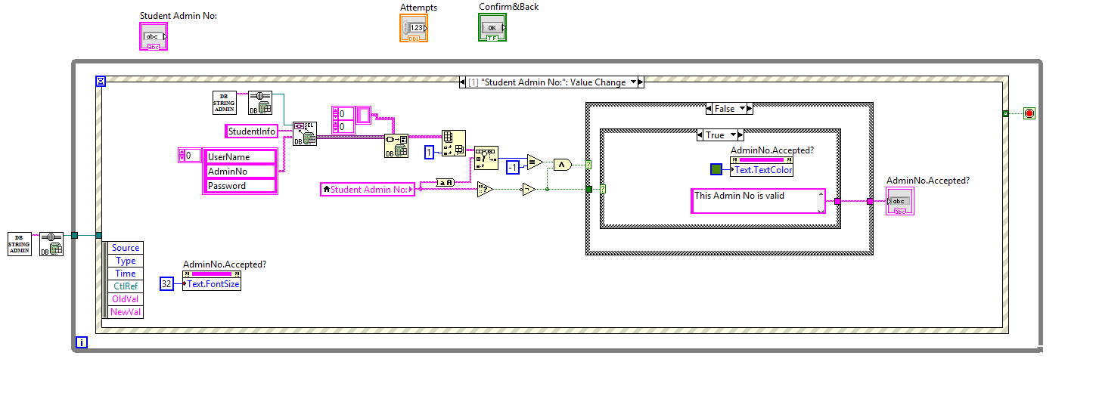

Figure 6.7.3.2 Block Diagram of “SetNoOfAttempts(SubVI).vi”

This is to set the number of attempts for each student. In short, the program will update the number which entered by the administrator to database “NoOfAttempts” Table. And every time before the program start one new attempt, it will go to the database to check the number of attempts. And the program will get the number of question running based on the value inside the database. If the number is larger than 0, the program will run the “RunQn(SubVI).vi” and at the same time, the program will deduct 1 from the original value. After that, it will update the new value to the database. However, if the value inside database is “0”, then the program will pop up a windows (Figure 6.7.3.3) and ask the student to approach to his/her teacher to add more attempts for him/her.

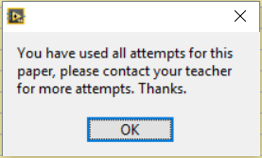

Figure 6.7.3.3 MessageBox of “SetNoOfAttempts(SubVI).vi”

## 6.7.4 Add more attempts

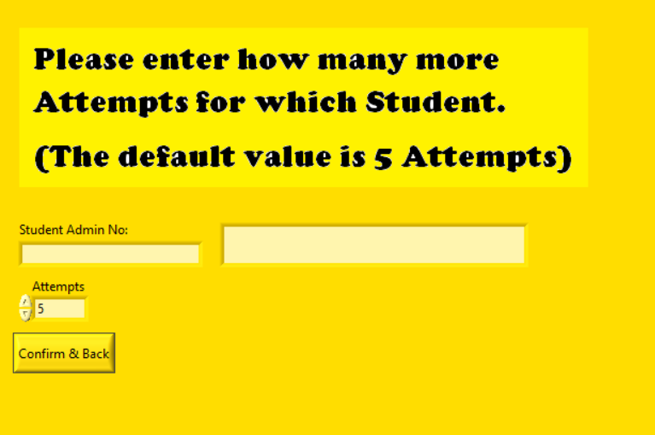

Figure 6.7.4.1 Front Panel of “AddMoreAttempts(SubVI).vi”

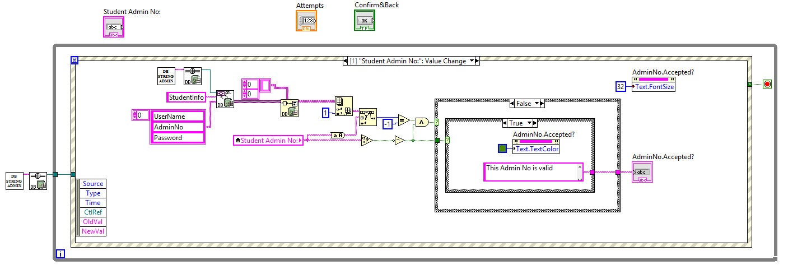

Figure 6.7.4.2 Block Diagram of “AddMoreAttempts(SubVI).vi”

This function let the administrator be able to add more attempts for the student after they used up all their attempts.

# 7 Building the Executable (Application)

Not everyone will have LabVIEW installed on their computer. These people are not able to run the program with the .vi files. Hence, building the program into an executable is a crucial step to allow people who do not have full LabVIEW installed to use the application. However, users have to run the installer before the application could be used *(see section 8 Building the Installer).*

1. Open the project file (*.lvproj).

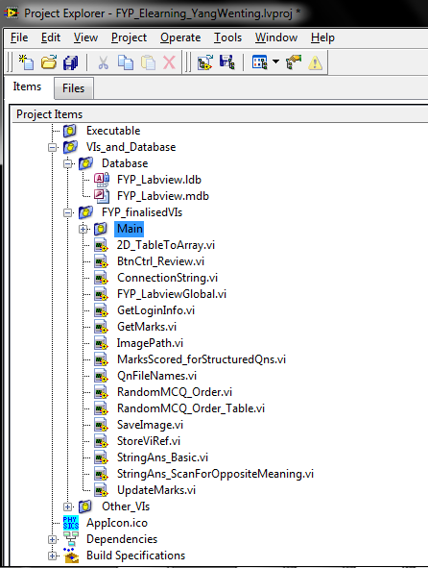

Figure 7.1

1. Go to “Build Specifications”

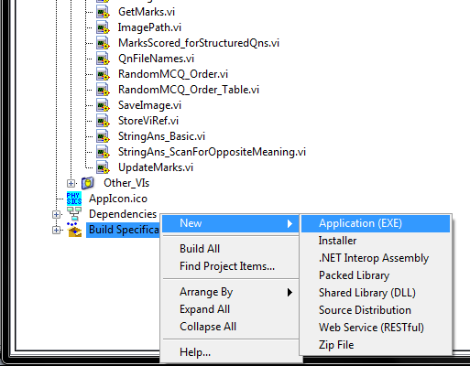

Figure 7.2

1. A message will pop up. Click “OK”.

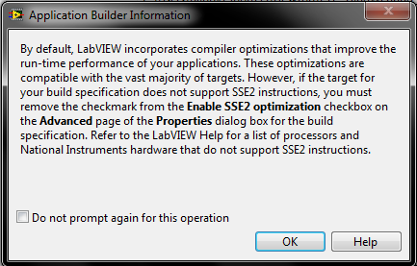

Figure 7.3

1. After you click “OK”, the specification box will appear.

Change the “Build Specification name”, “Target filename” and the “Destination directory”.

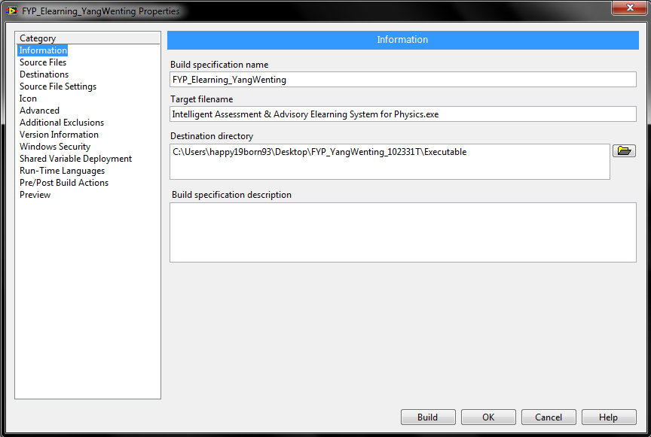

Figure 7.4

1. Go to “Source Files” from the tab control on the left. Place the necessary files to the “Always Included” box and the main VI to the “Startup VIs” box.

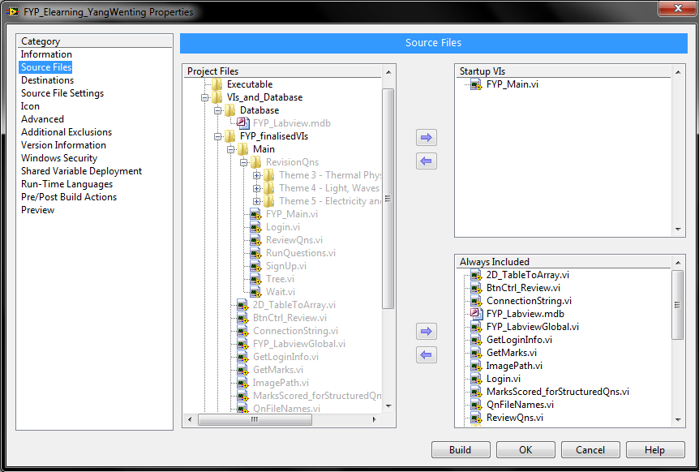

Figure 7.5

1. Go to “Icon”. You can change the icon of your completed program here

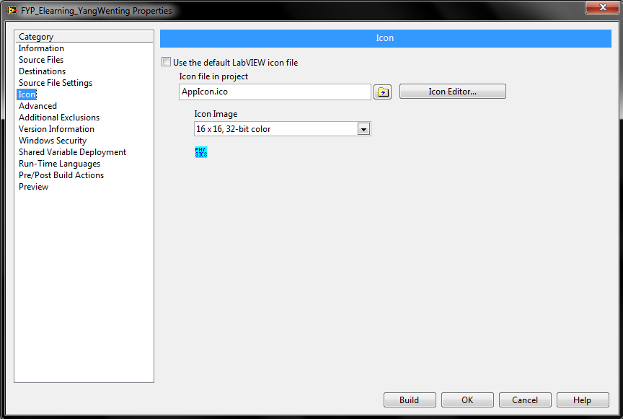

Figure 7.6

1. After everything is done, click on “Build”.

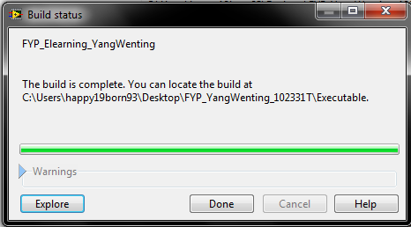

Figure 7.7

1. You are ready to use your program.

# 8 Building the Installer

1. Go to “Build Specifications” in your project file(*.lvproj).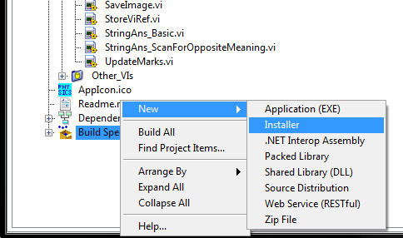
2. The specification box appears.

Change the “Build Specification name”, “Product name” and the “Installer destination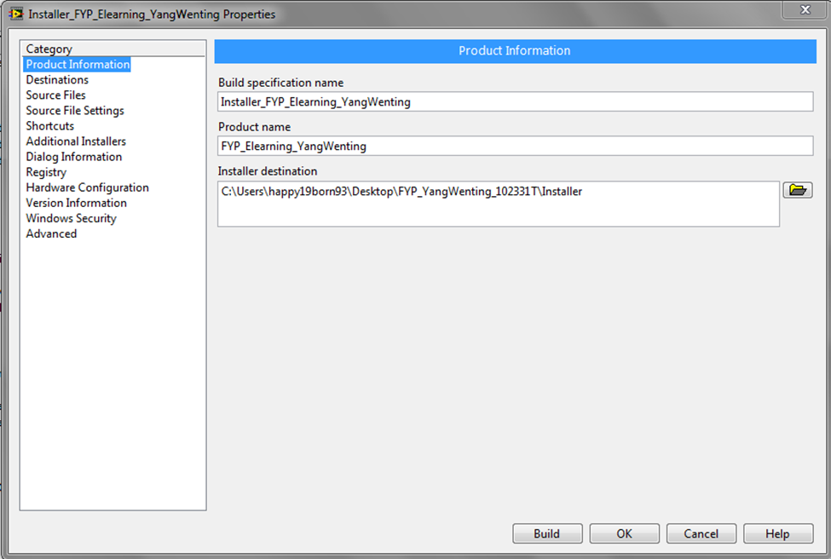

1. Go to “Source Files” from the tab control on the left. Make sure the necessary files, including the *.exe file created just now, are included in the “Destination View” on the right.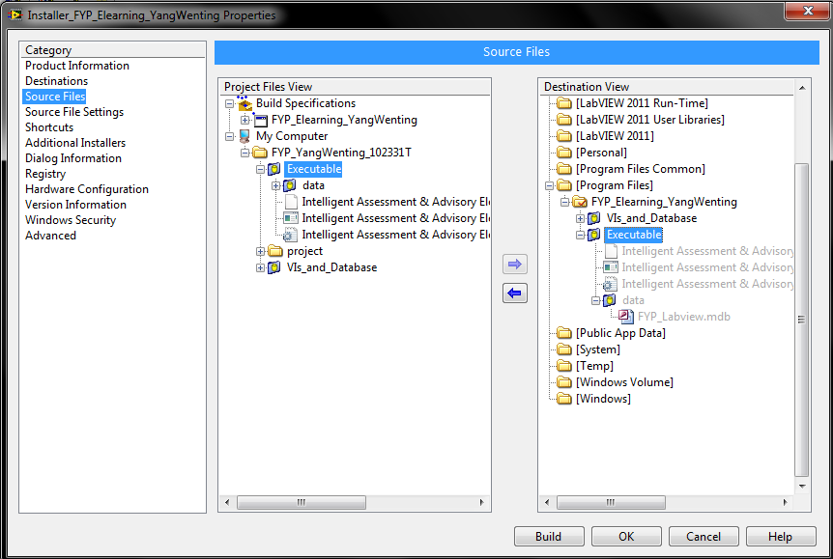
2. Go to “Shortcuts”. You can choose to create shortcuts to the application after the users installs the application. Choose the directory of the shortcut(s) from the dropdown list. 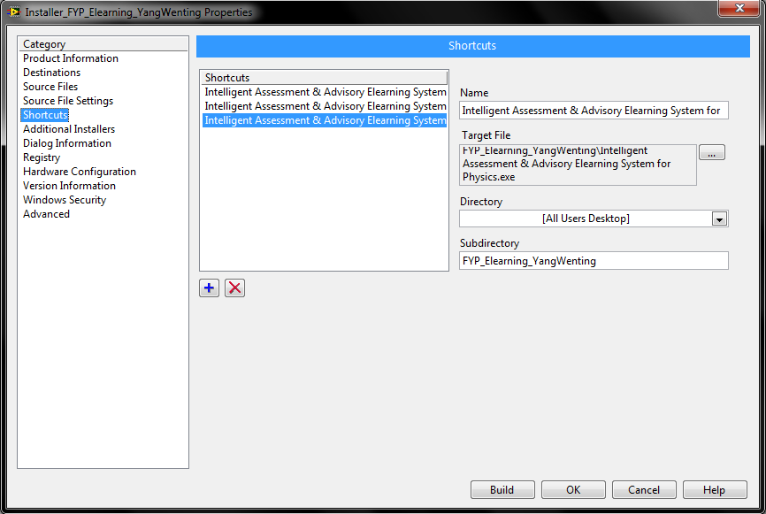
3. Go to “Additional Installers”. Select “NI VC 2008 MSMs”. This component is needed for users without LabVIEW development system to run the application.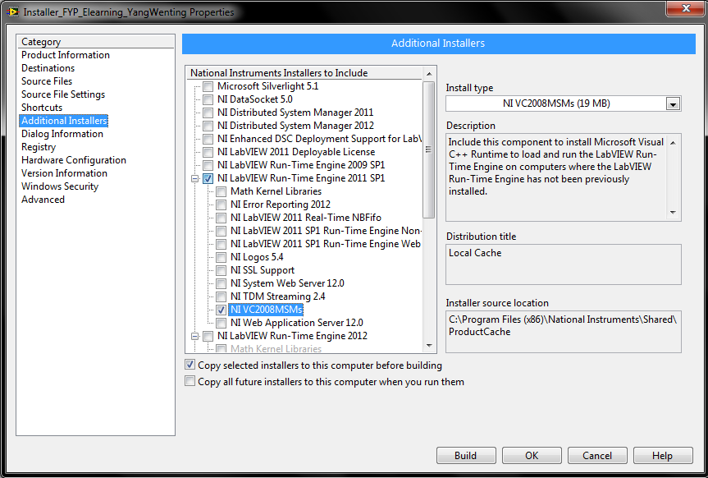
4. Go to “Dialog Information”. You can customize the welcome title and message here. You can also include optional files.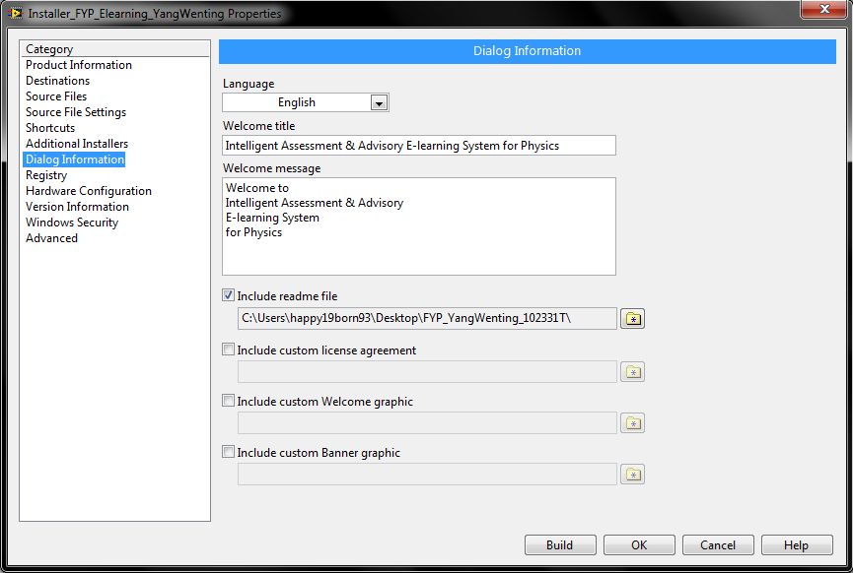
5. Go to “Advance”. You can choose to run the executable right after the users finished the installation. After that, click “Build”. 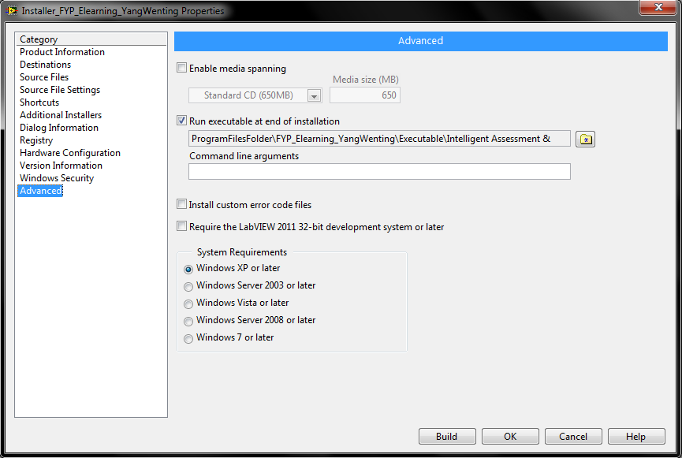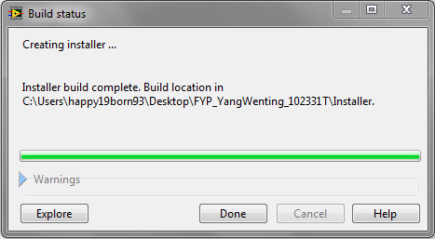
6. The installer is completed. Now, the application is able to run on other computers without LabVIEW development system after running the installer.

# 7 Building the Executable (Application)

Not everyone will have LabVIEW installed on their computer. These people are not able to run the program with the .vi files. Hence, building the program into an executable is a crucial step to allow people who do not have full LabVIEW installed to use the application. However, users have to run the installer before the application could be used *(see section 8 Building the Installer).*

1. Open the project file (*.lvproj).



Figure 7.1

1. Go to “Build Specifications”



Figure 7.2

1. A message will pop up. Click “OK”.



Figure 7.3

1. After you click “OK”, the specification box will appear.

Change the “Build Specification name”, “Target filename” and the “Destination directory”.



Figure 7.4

1. Go to “Source Files” from the tab control on the left. Place the necessary files to the “Always Included” box and the main VI to the “Startup VIs” box.



Figure 7.5

1. Go to “Icon”. You can change the icon of your completed program here



Figure 7.6

1. After everything is done, click on “Build”.



Figure 7.7

1. You are ready to use your program.

# 8 Building the Installer

1. Go to “Build Specifications” in your project file(*.lvproj).
2. The specification box appears.

Change the “Build Specification name”, “Product name” and the “Installer destination

1. Go to “Source Files” from the tab control on the left. Make sure the necessary files, including the *.exe file created just now, are included in the “Destination View” on the right.
2. Go to “Shortcuts”. You can choose to create shortcuts to the application after the users installs the application. Choose the directory of the shortcut(s) from the dropdown list. 
3. Go to “Additional Installers”. Select “NI VC 2008 MSMs”. This component is needed for users without LabVIEW development system to run the application.
4. Go to “Dialog Information”. You can customize the welcome title and message here. You can also include optional files.
5. Go to “Advance”. You can choose to run the executable right after the users finished the installation. After that, click “Build”. 
6. The installer is completed. Now, the application is able to run on other computers without LabVIEW development system after running the installer.

# 9 Problems Encountered

## 9.1 Database (writing SQL statements)

**Problem Faced:**

This is my first time dealing with database and I have to start from scratch. I do not have any prior knowledge on writing SQL statements. I encountered quite a number of errors due to syntax errors in the SQL statements.

**Solution:**

Fortunately, the need to write SQL statements is minimal in LabVIEW. It is only needed when there is a need to specify the conditions of the statement. After doing a research, I had found useful books like “Access 2010: The missing manual” and “Access 2010 Step by Step”. The books have guided me step by step on creating database and make first timer like me easier to learn using Access 2010.

## 9.2 Open and execute subVIs can on the same page

**Problem Faced:**

Initially, I do not know how to open and execute subVIs on the same page.

**Solution:**

I managed to overcome this problem after researching for the solution. The solution is to use subpanel control, where the front panel of other VIs could be displayed. Examples that uses subpanel could be found by selecting **Help> Find Examples...**

## 9.3 Interactively control which subVI to show on the subpanel and the behaviour of subVI

**Problem Faced:**

Clicking on the “Next” or “Previous” buttons from “RunQuestions(SubVI).vi” does not stop the VIs of individual questions and proceed to the next or previous question.

**Solution:**

After intensive research, I found a way to solve this problem [23](<http://zone.ni.com/reference/en-XX/help/371361F-01/lvhowto/loading_panel_in_subpanel/>). This problem was solved by using refnum controls *(see section 4.2 Refnum Controls)*.

## 9.4 Structures questions

**Problem Faced:**

Difficulties in identifying if users’ answers to questions that require string answers are correct. This is because there are many words that have the same meaning. Users may also phrase the answers differently from the modal answers, even though they mean the same. The users’ answers may also be partially correct and partial marks have to be rewarded.

**Solutions:**

Changed long answers to “close passage” format where users just have to fill in the blanks. By doing so, users are directed to answer in a fixed way and limit them from phrasing the answers differently from the modal answers.

“StringAns_Basic(SubVI).vi” *(see Figure 6.4.23 in section 6.4.2 Structured Questions)*, is created to manipulate the users’ answers. It searches the answers users keyed in for specific keywords. The output is the number of matched keywords. This output is then wired to “MarksScored_forStructuredQns(SubVI).vi”.

MarksScored_forStructuredQns(SubVI).vi” *(see Figure 6.4.24 in section 6.4.2 Structured Questions)* is created to calculate the marks scored according to the number of matched keywords, marks per answer part correct and total marks of the question.

## 9.5 Select Topics to Work on

**Problem Faced:**

Initially, users have to do all the questions once they start assessment. They are unable to choose the topics of the questions they want to focus on. Some of the users may already know to topics they are weaker in and needs to focus on them. This is very impractical for an e-learning system as the purpose of an e-learning system is to enhance and support the traditional learning system and make the learning process more efficient.

**Solutions:**

A Tree control is used to solve this problem. With this control, users are able to choose the topics of the questions they want to focus on. Examples of using tree control could be found by selecting **Help> Find Examples...**

## 9.6 Error Running Executable on Other Computers without LabVIEW

**Problem Faced:**

*“The LabVIEW Run-Time Engine must be installed on any computer on which users run the application or shared library” (“Building a Stand-Alone Application”, LabVIEW Help, National Instruments)*. This means that executable built with LabVIEW development system cannot run on computers without LabVIEW Run-Time Engine since LabVIEW version 8.x.

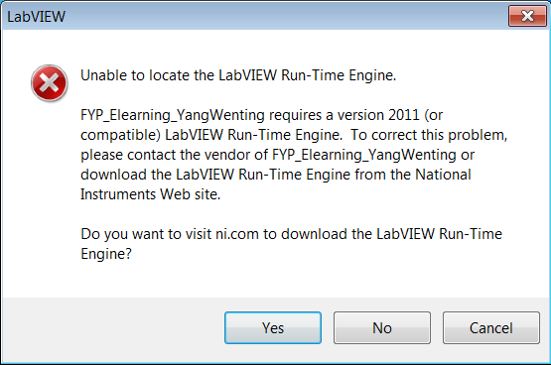

Figure 9.6.1 Error message when trying to run exe file created by LabVIEW on computers without LabVIEW Run-Time Engine

**Solution:**

After intensive research, I had found that creating an installer to be the only solution. Users will have to run the installer which installs both the LabVIEW Run-Time Engine and the e-learning application itself on their computers.

## 9.7 Relinking the .udl file was needed every time the application is distributed to other computers

**Problem Faced:**

Every user had to go through the steps of linking the .udl file to the database after installation. This is very inconvenient for the users. It is also very impractical for a e-learning system software to require users to link the data link file to themselves.

**Solution:**

After much researching, I had found out about DSN-less database connection could be used to solve this problem. DSN-less database connection could be created by passing as the connection string instead of the UDL file path during runtime *(*[*http://digital.ni.com/public.nsf/allkb/852559036FB6447380256ADF007C3964?OpenDocument*](http://digital.ni.com/public.nsf/allkb/852559036FB6447380256ADF007C3964?OpenDocument) *)*.

## 9.8 SubVI cannot Pop-up when click it

**Problem faced:**

If the programmer just put the SubVI inside the Top-level SubVI or VI, this SubVI will not be able to auto pop-up. The programmer need to set its properties.  
**Solution:**

Go to the Block Diagram, move the cursor to and right click the SubVI which the programmer want it to pop up when the user click it. Choose “SubVI Node Setup…” Then tick the “Show Front Panel when called” and “Close afterwards if originally closed” boxes.

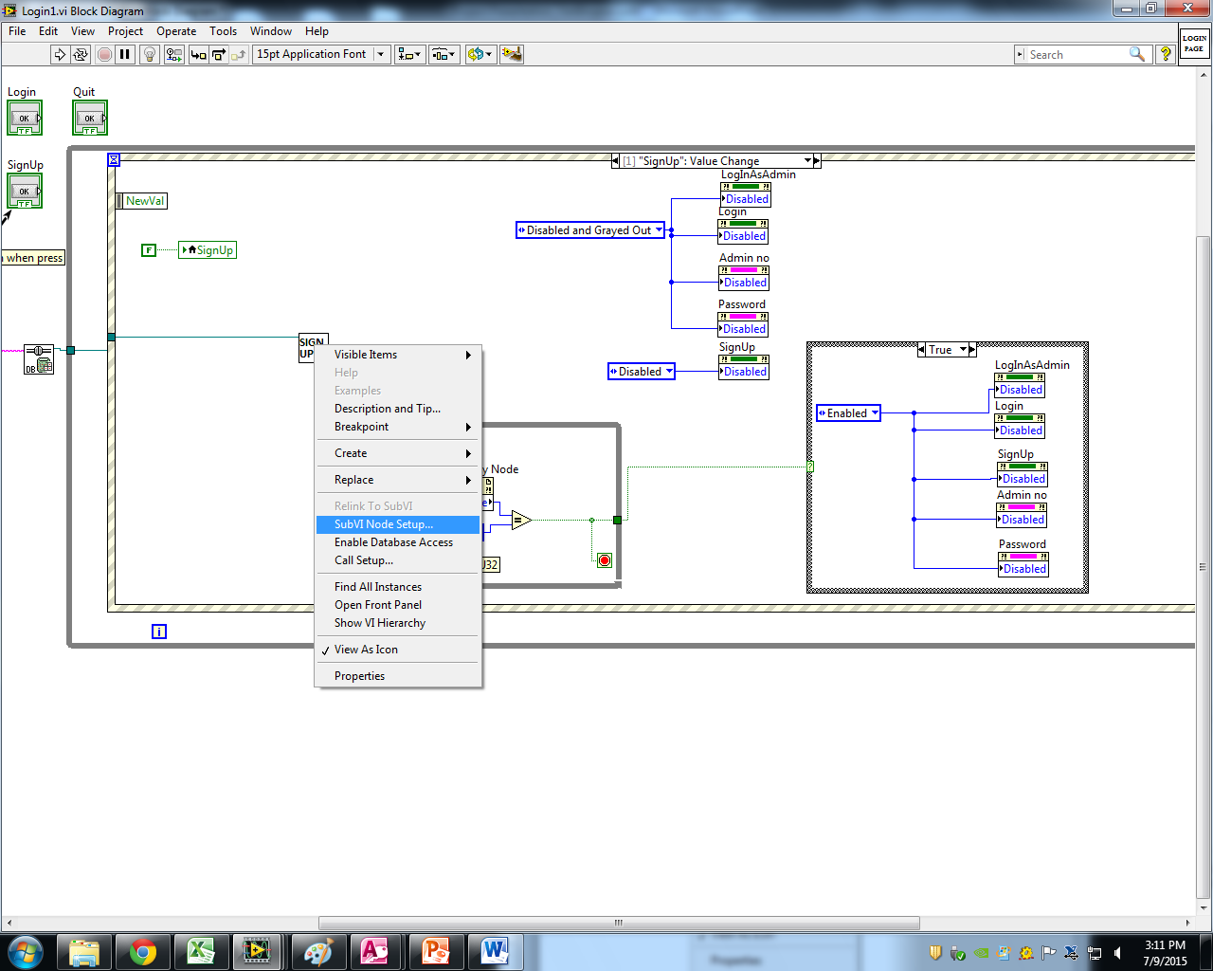

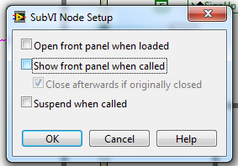

Figure 9.8.1 Example solution for 9.8.1

## 9.9 Mismatching VI Reference Type

**Problem faced:**

The warning window will show “VI Reference type does not match VI connector pane”. And inside the block diagram, the warning will be at “Open VI Reference”

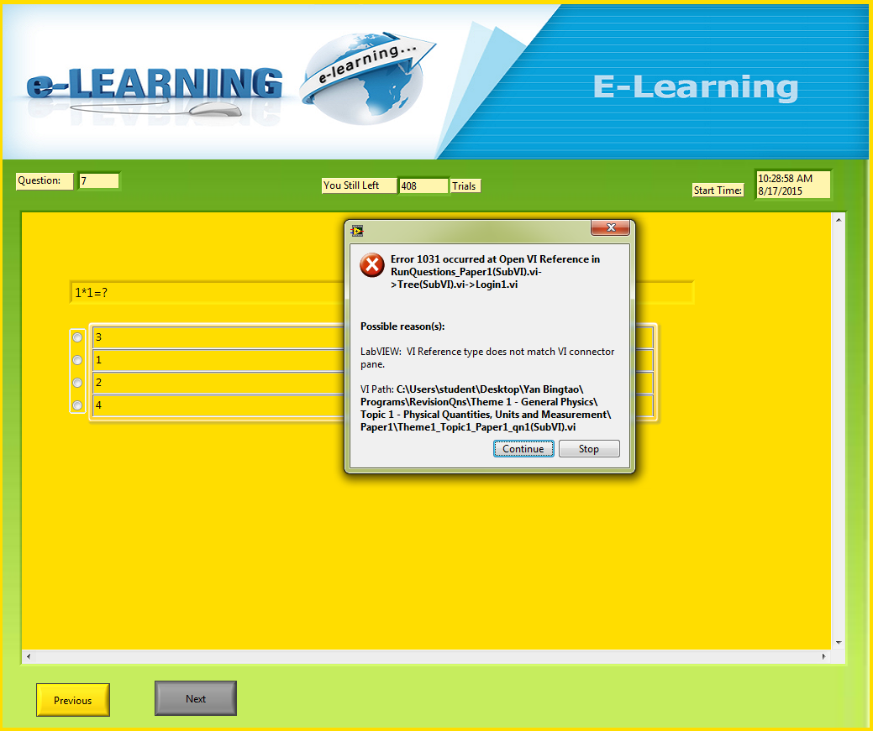

Figure 9.9.1 Example problem for 9.9.1

**Solution:**

Go to the SubVI and double check the Patter of the SubVI. If the pattern is mismatching with the upper level SubVI or VI, then change the pattern to be the same as the upper level one.

# 10 Future Enhancement

## 10.1 Provide Analyses of Mastery Level of Each Topic

Analyses of mastery level of each topic could be provided to users so that users know their level of understanding for each topic.

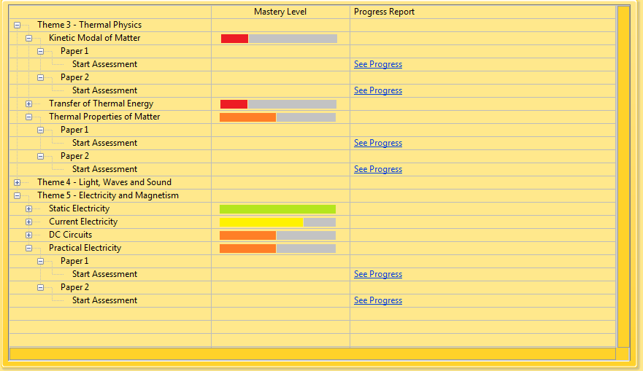

Figure 10.1 Proposed Display for Tracking of Mastery Level

## 10.2 Provide Personalized Tracking of Results

Users can track their results for each attempt on every topic. Graph could be used to show their progress.

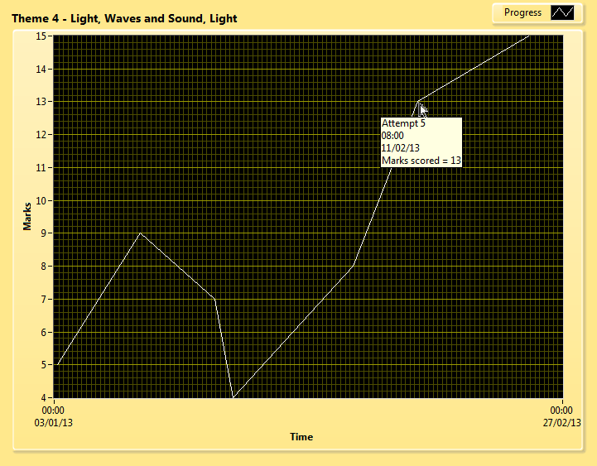

Figure 10.2 Proposed Display for Graph that shows progress

## 10.3 Timer

Adding a timer to allow users to limit the amount they can take for any topics. Reminder alarm could be set so that at X minutes before time is up, where X is the alarm time set by users, users will be notified.

## 10.4 Teaching Guides

Create teaching guides for every topic and link them to the tree control.

## 10.5 Web Enabling this Application

Web enabled applications are hosted on a server connected through internet. This means that anyone with a web browser and internet connection from any location can access the application. If this application is web enabled, there is no need for installation. Hence, software compatibility issues can be eliminated.

# 11 Conclusion

Throughout the 12 weeks of the Final Year Project, we have learnt more about LabVIEW and Microsoft Access. Using LabVIEW to program and Access were a challenge initially as we had never used LabVIEW and Access before. There are numerous challenges encountered during the course of this project. We have to do intensive research and troubleshooting to overcome these challenges. This made us gain more knowledge and programming skill. We had also learnt to be more independent.

Lastly, we would like to thank my project supervisor, Mr Cheong Chee Keng, for his patience and giving us suggestions on how to improve on the program, and our presentation assessor, Mr Loh Kock Keong, for his time, patience and advice for my presentation and project.

# 12 Gantt Chart

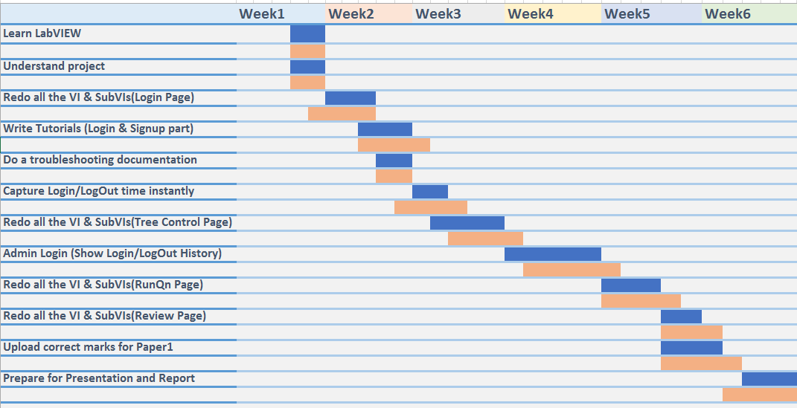

Figure 12.1 Gantt chart of Week 1 to Week 6 _ Yan Bingtao

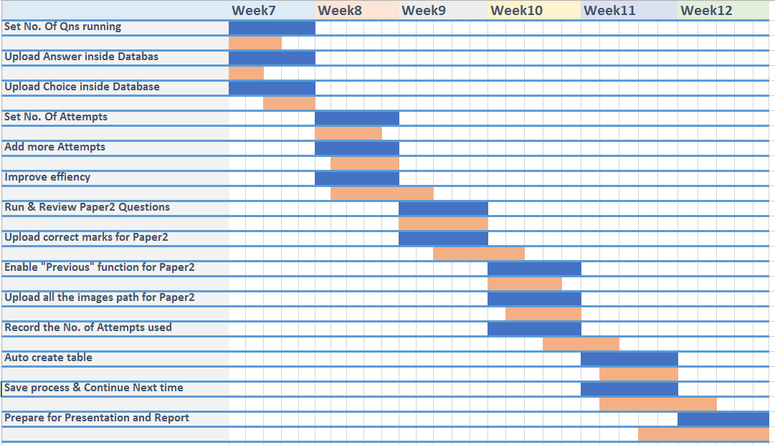

Figure 12.2 Gantt chart of Week 7 to Week 12 _ Yan Bingtao

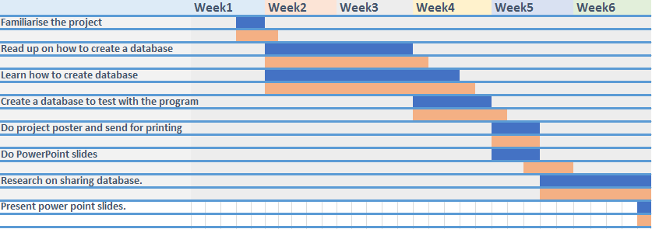

Figure 12.3 Gantt chart of Week 1 to Week 6 _ Pang Jun Qing

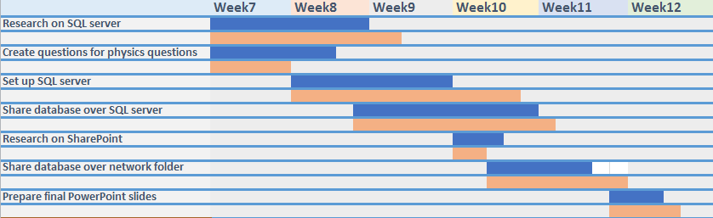

Figure 12.2 Gantt chart of Week 7 to Week 12_ Pang Jun Qing

# 13 References

1. Robin Pang M. Eng, 2008, “O-level Science Physics Guide”, Educational Publishing House Pte Ltd.
2. Tavangarian D., Leypold M., Nölting K., Röser M., 2004, “Is e-learning the Solution for Individual Learning? Journal of e-learning”.
3. Simon Hogg, 2010, “What Is LabVIEW?”, <http://zone.ni.com/devzone/cda/pub/p/id/1141>
4. “Chapter 1. Using a VI as a SubVI”, [www.csun.edu/~rd436460/Labview/SubVI.pdf](http://www.csun.edu/~rd436460/Labview/SubVI.pdf)
5. “Types of Refnum Controls”, LabVIEW Help, National Instruments
6. “Refnum Controls”, LabVIEW Help, National Instruments
7. “Property Node”, LabVIEW Help, National Instruments
8. “Local Variable”, LabVIEW Help, National Instruments
9. “Global Variable”, LabVIEW Help, National Instruments
10. “Start Asynchronous Call”, LabVIEW Help, National Instruments
11. “Call By Reference”, LabVIEW Help, National Instruments
12. “NI LabVIEW Database Connectivity Toolkit”, National Instruments, <http://sine.ni.com/nips/cds/view/p/lang/en/nid/209060>
13. “Value (signalling)”, LabVIEW Help, National Instruments
14. “Get System Directory VI”, LabVIEW Help, National Instruments
15. “Check if File or Folder Exists VI”, LabVIEW Help, National Instruments
16. “Flat Sequence Structure”, LabVIEW Help, National Instruments
17. “Closing References in LabVIEW”, National Instruments, <http://www.ni.com/white-paper/14393/en>
18. “Match Pattern Function”, LabVIEW Help, National Instruments
19. “Search 1D Array Function”, LabVIEW Help, National Instruments
20. “Open VI Reference Function”, LabVIEW Help, National Instruments
21. “SQL Tutorial”, w3Schools, <http://www.w3schools.com/sql/default.asp>
22. “Loading a Front Panel in a Subpanel Control”, LabVIEW Help, National Instruments, <http://zone.ni.com/reference/en-XX/help/371361F-01/lvhowto/loading_panel_in_subpanel/>
23. “Building a Stand-Alone Application”, LabVIEW Help, National Instruments

# Tutorial

**Tutorial**

**Contents:**

1. VI Server Reference
2. Property Node
3. Case Structure
4. Current VI’s Path
5. Strip Path
6. Build Path
7. String Constant
8. Path To String
9. Concatenate Strings
10. Enum Constant
11. While Loop
12. Array Constant
13. Database Variant To Data Function
14. Index Array Function
15. Search 1D Array Function
16. DB Tools Open Connection VI  
    & DB Tools Select Data VI  
    & DB Tools Insert Data VI  
    & DB Tools Close Connection VI
17. Event Structure
18. True/False Constant
19. Get Date/Time In Seconds Function
20. Format Date/Time String Function
21. To Upper Case Function
22. Array Size Function
23. Decrement Function
24. Less Or Equal? Function
25. Equal? Function
26. And Function
27. Or Function
28. Display Message to User Express VI
29. Empty String Constant
30. Static VI Reference Function
31. Local variable
32. Connection reference
33. Compound Arithmetic Function
34. Empty String/Path?
35. Bundle Function
36. Not Function
37. Flat Sequence Structure
38. **VI Server Reference**
    1. Overview:   
       VI Server Reference returns a reference to the current VI or application, to a control or indicator in the VI, or to a pane. You can use this reference to access the properties and methods for the associated VI, application, control, indicator, or pane.

In short, VI Server Reference will be able to give a path to show where the current VI or Application saved.

Differences between VI and Application:  
VI means running in the LabVIEW development environment. In development environment, programmers are able to edit the program easily.

Application means building the VI into an executable. LabVIEW wraps all Vis associated with a stand-alone application into an extra layer, which is actually the executable itself. Executable means the final version, and programmers are not able to make any changes in executable file.

In section 1 “ConnectionString(SubVI).vi”, we will use VI Server Reference as a reference to the application.

* 1. Examples of icons:

For VI:

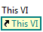   
  
For Application:  
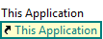

* 1. Example:  
     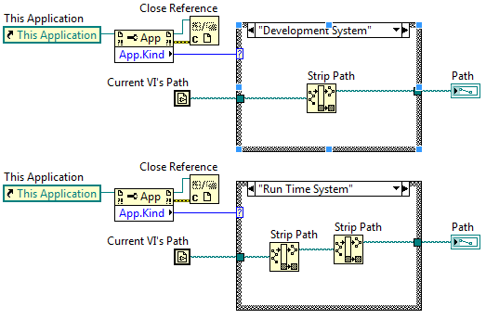

This example shows how to use VI Server Reference.   
  
This program will be able to print out the path of current VI’s path. Then we can see “This Application” is the VI Server Reference, and it gives a reference that can refer to. Otherwise, there will be no way to call this SubVI/Application itself to track the path of it.

* 1. Find in library:
     1. Right click inside the Block Diagram.  
        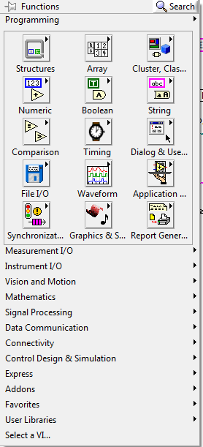
     2. Click “Search” at the top right corner.  
        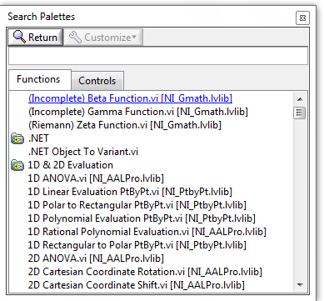
     3. Type “VI Server Reference”.  
        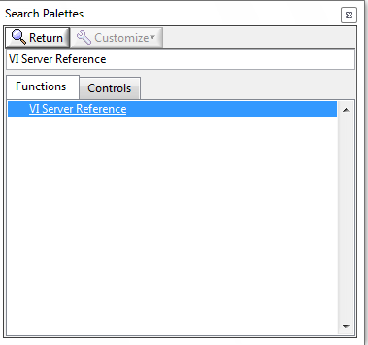
     4. Drag “VI Server Reference” to the Block Diagram.  
        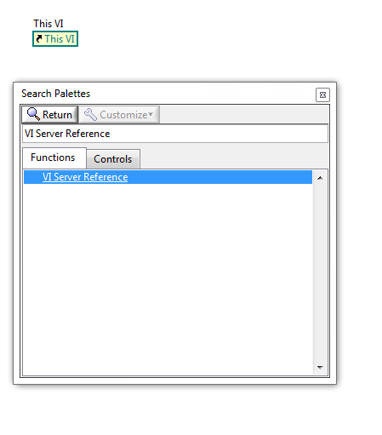
     5. (*If need to link to “This Application”, instead of linking to “This VI”. Then follow these two steps)

Right click the icon. Move the cursor to “Link to”. Then select “This Application”  
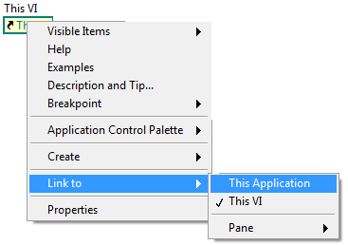

* + 1. Now, it will return the reference to current application, and the icon will change to:  
       

1. **Property Node**
   1. Overview:   
      Property Node reads(gets) and/or writes(sets) properties of a reference.  
      Moreover, the Property Node automatically adapts to the class of the object that you reference.
   2. Examples of icons:  
      Reading mode:  
      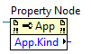  
      Writing mode:  
      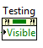
   3. Example:   
      Front Panel:

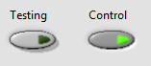 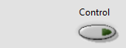   
  
Block Diagram:  
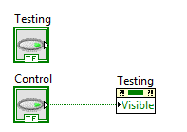  
  
This example shows how to use the property node to control a button’s property.   
  
If let this simple program run, button “Testing” will be controlled by button “Control”. If the user switch on button “Control”, then button “Testing” will appear and vise versa.   
  
There are many properties for a button (showed in the following image).  
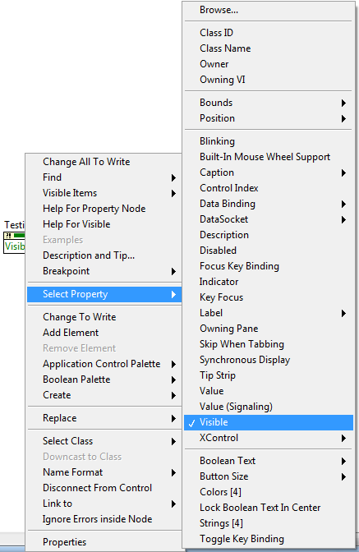  
  
The programmer can choose to set or read the property of a reference, such as a button, through property node.

**Property Node of Button “Testing”**

* 1. Find in library:
     1. Search “property node” in library  
        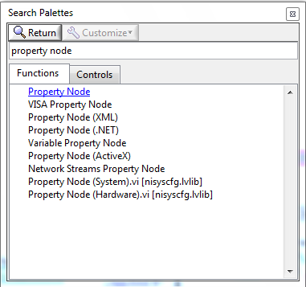
     2. Drag “property node” to the Block Diagram.  
        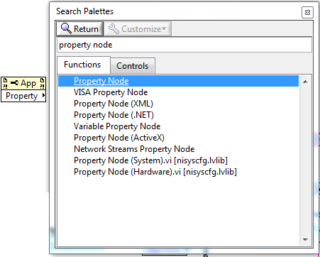
     3. (Optional)Connect (wire) to the reference.  
        (For example, connect to an application)  
        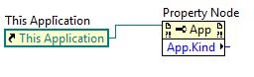
     4. (Optional)Select the property needed.  
        (For example, get the “Application🡺Kind” property of this application)  
          
        Click the bottom box 🡺 Application 🡺 Kind  
        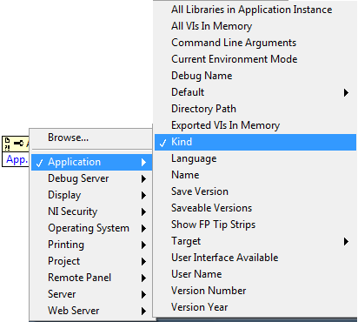
     5. (Optional)Use the output.  
        (For example, use the output to control a case structure)  
        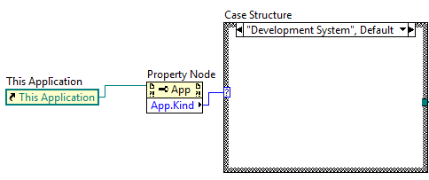

1. **Case Structure** 
   1. Overview

Case structure contains one or more cases. The value connected to the selector terminal determines which case to execute.  
  
Case structure is similar to the traditional programming “if else” and “case” method. The case to execute depends on the case condition wire to the boxed “?”.

* 1. Example:   
     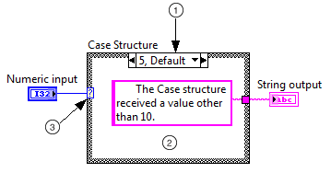  
     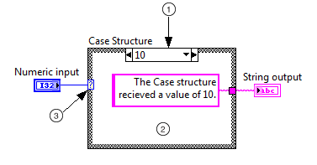

This example shows how the case structure works.

The blue part is the input. In the example, it’s a numeric input. The block in the middle is case structure. The output is at the right of the case structure.

①Case selector label—Displays the value(s) for which the associated case executes.

②Subdiagram(case)—Contains the code that executes when the value wired to the case selector terminal matches the value that appears in the case selector label.

③Case Selector terminal—Selects which case to execute based on the value of the input data. The input data can be a Boolean, string, integer, enumerated type or error cluster.   
  
In the example, if the numeric input is “10”. Then the case structure will execute the image2, whose case selector label is “10” also. As a result, the string output will be “The Case structure received a value of 10”.

* 1. Examples of icons:  
     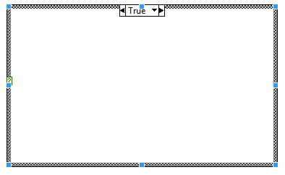
  2. Find in library
     1. Search “case structure” in library  
        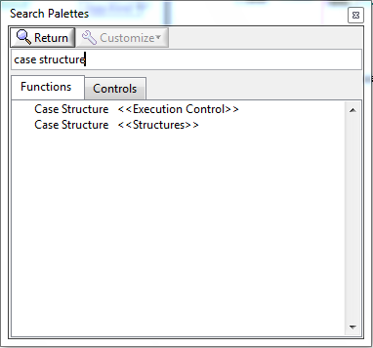
     2. Choose “Case Structure <<Structure>>” or “Case Structure <<Execution Control>>” and draw inside the Block Diagram.  
        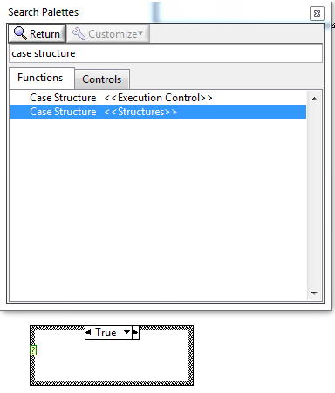
     3. (Optional) If you need to add new cases or delete cases, you can right click “Case Selector Label”, then choose whether adding new cases or deleting the case.  
        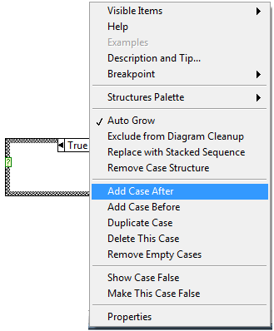

1. **Current VI’s Path**
   1. Overview  
      Returns the path to the file of the current VI. If the VI never has been saved, this function returns <Not A Path>.

This function always returns the current location of the VI. If you move the VI, the value returned changes.

* 1. Examples of icons  
     
  2. Example:  
     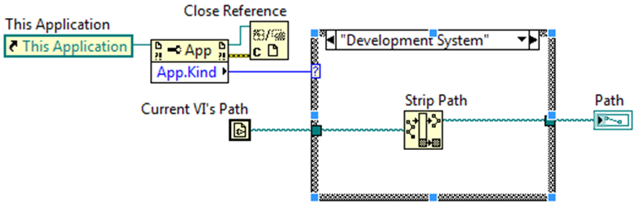  
     This example shows how to use the Current VI’s Path. The Current VI’s Path here allows the program to get the Path of this VI. If users move this VI to another location, the path returned by the Current VI’s Path will change automatically.
  3. Find in library
     1. Search “current vi’s path” in library  
        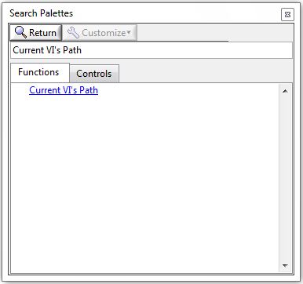
     2. Drag “Current VI’s Path” inside the Block  
        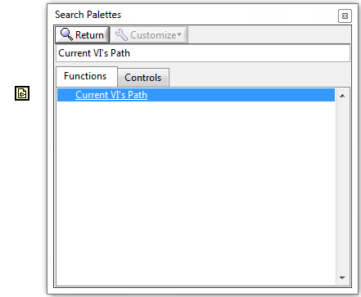

1. **Strip Path**
   1. Overview  
        
        
      The “Path” is the input. The “stripped path” and “name” are the outputs.  
        
      It returns the name of the last component of a path and the stripped path that leads to that component.  
        
      For example, the path “C:\Users\student\Desktop \Database\DB.mdb” has 6 components.   
      They are :  
      1)”c:”  
      2)”\Users”

3)”\student”

4)”\Desktop”  
5)”\Database”  
6)”\DB.mdb”  
  
If the programmer uses “Strip Path” once, then the output of “stripped path” will be “C:\Users\student\Desktop\Database”; meanwhile the output of “name” will be “\DB.mdb”.

* 1. Examples of icons   
     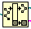
  2. Find in library
     1. Search “Strip path” in library  
        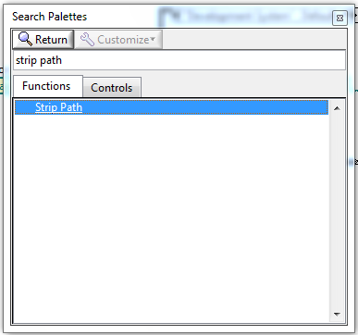
     2. Drag “Strip path” to the Block Diagram.  
        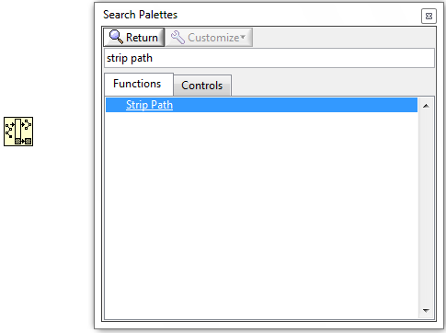

1. **Build Path**
   1. Overview  
      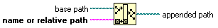

The “base path” and “name or relative path” are inputs. The “appended path” is the outputs.  
  
It creates a new path by appending a name (or relative path) to an existing path.  
  
For example, the path “C:\Users\student\Desktop \Database” has 5 components.   
They are :  
1)”c:”  
2)”\Users”

3)”\student”

4)”\Desktop”  
5)”\Database”  
  
If the programmer uses “Build Path” once, putting the current path ” C:\Users\student\Desktop \Database” as “base path”, and put “\DB.mdb” as “relative path”, then the output of “appended path” will be “C:\Users\student\Desktop \Database\DB.mdb” .

In short, “Build Path” is to combine two paths together.

* 1. Examples of icons  
     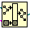
  2. Find in library
     1. Search “build path” in library  
        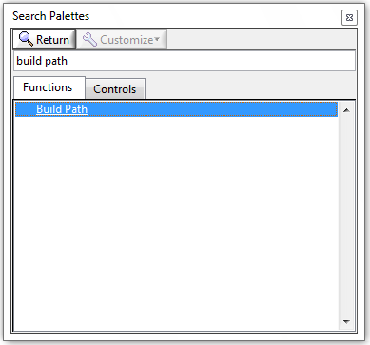
     2. Drag “Build Path” to the Block Diagram.  
        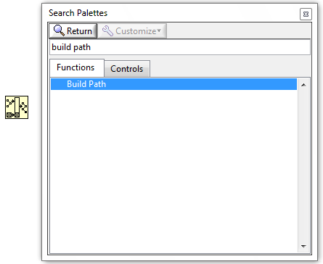

1. **String Constant** 
   1. Overview  
      Use this constant to supply a constant text string to the block diagram.
   2. Example of icons  
       **or** 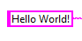
   3. Example:  
      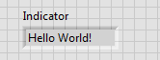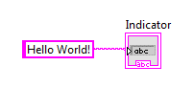  
      This example shows how String Constant works.   
        
      In the example, we used the string constant to write a string inside the indicator. Therefore, when the user run the program, “Hello World!” will appear inside the indicator. Therefore, output will be whatever the programmer wrote inside the String Constant, and it’s a string.
   4. Find in library
      1. Search “string constant” in library  
         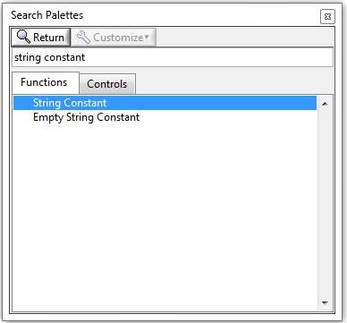
      2. Drag “String Constant” to the Block Diagram.  
         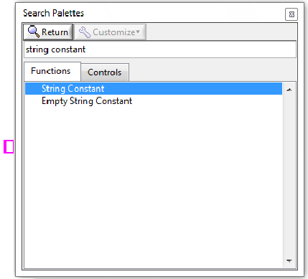
      3. Type the string inside the String Constant  
         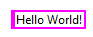
2. **Path To String**
   1. Overview  
      Converts path into a string describing a path in the standard format of the platform.
   2. Examples of icons  
      
   3. Example:  
      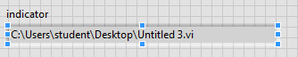  
      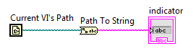  
        
      This example shows how to use the Path To String function.

In the example, “Path To String” convert the “Current VI’s Path” into string format and write into the indicator. As a result, the indicator will show the current VI’s path when the user run the program.

* 1. Find in library
     1. Search “path to string” in library  
        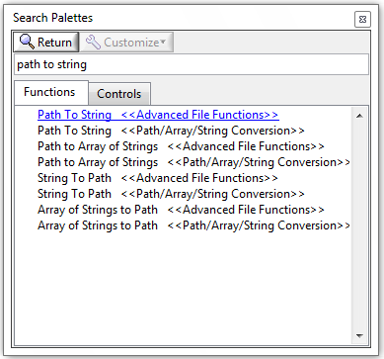
     2. Drag “Path To String<<Path/Array/String Conversion>>” to the Block Diagram.  
        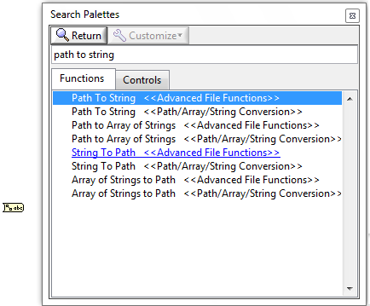

1. **Concatenate Strings**
   1. OverviewConcatenates input strings and 1D arrays of strings into a single output string. For array inputs, this function concatenates each element of the array.

In short, “Concatenate Strings” is to combine 2 or more strings together into a single output string.

* 1. Examples of icons  
     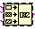

Example:  
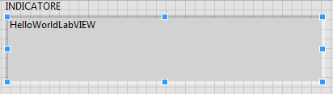  
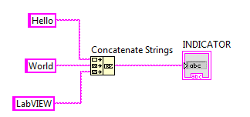   
This example shows how “Concatenate Strings” works.   
  
The 3 inputs are “Hello”, ”World” and “LabVIEW”. After “Concatenate Strings”, 3 of them combine into only one output string, which is “HelloWorldLabVIEW”. And pass this string to the indicator. Therefore, the user will be able to see the “HelloWorldLabVIEW” when they run the program.

* 1. Find in library
     1. Search “Concatenate Strings” in library  
        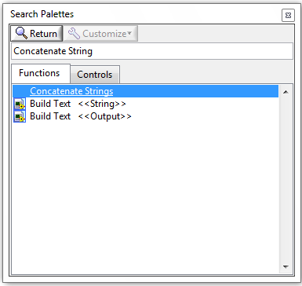
     2. Drag “Concatenate Strings” to the Block Diagram.  
        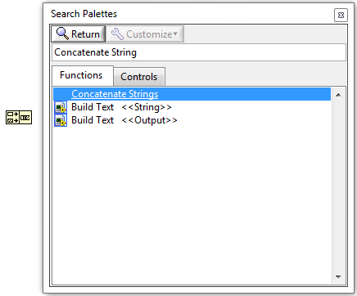

1. **Enum Constant** 
   1. Overview:  
      Use the enumerated constant to create a list of string labels with corresponding integer values you can select on the block diagram.  
        
        
      The numeric value is always an integer from zero to n – 1, where n is the number of values in the enumerated constant.  
      The image below is one example. For example, if the value is 0, the the output will be “Enabled”. If the value is 1, then the output will be “Disabled”.  
      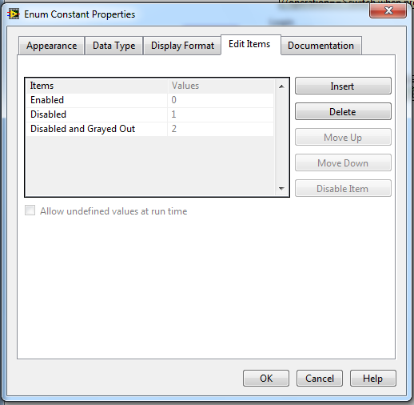
   2. Examples of icons:  
       **OR** 
   3. Example:  
      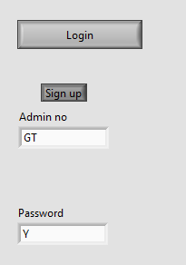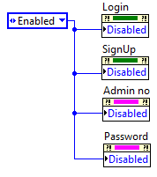  
      In the example above, the “Enum constant” are controlling the properties of 2 buttons(“Login” & “ Sign Up”) and 2 string controls (“Admin no” & “Password”). The moment the programmer selected the “Enum constant” to Enabled”. While users running the program, he can click the buttons and type words inside the string controls.   
        
      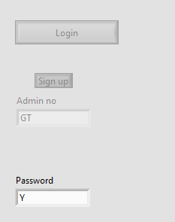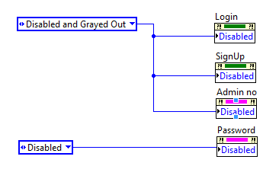  
      In the example above, the “Enum constant” are controlling the properties of 2 buttons(“Login” & “ Sign Up”) and 2 string controls (“Admin no” & “Password”). The moment the programmer set the “Enum constant” of “Login”, “SignUp” and “Admin no” to “Disabled and Grayed Out”. While the users running the program, “Login”, “SignUp” and “Admin no” will be disabled and grayed out.   
        
      Moreover, the moment the programmer set the “Enum constant” of “Password” to “Disabled”. While users running the program, “Password” will be disabled. Users will not be able to change the value inside “Password”.
   4. Find in library:
      1. Search “enum constant” in library  
         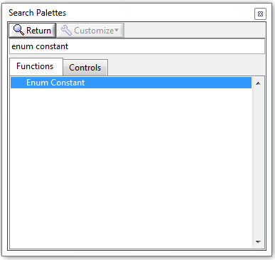
      2. Drag “Enum Constant” inside the Block  
         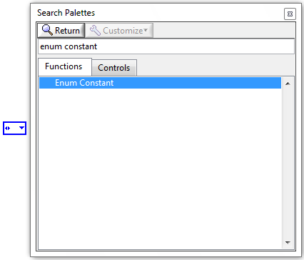
   5. Add, Remove and Edit items:
      1. Right click the icon, then choose “Edit Items”:  
         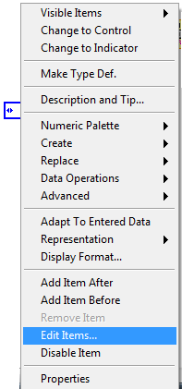
      2. Click insert:  
         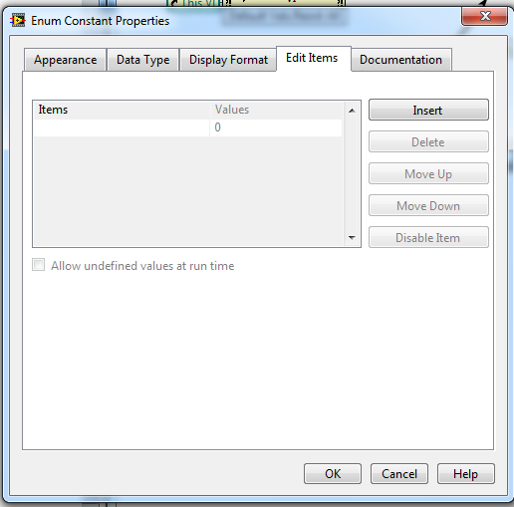
      3. Then add the items you want.
2. **While Loop**
   1. Overview:  
      Repeats the code within its subdiagram until a specific condition occurs. A While Loop always executes at least one time.

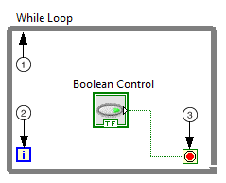  
  
①Subdiagram—Contains code that the while loop executes once per iteration

②Iteration Terminal (i) – Provides the current loop iteration count. The loop count always starts at zero for the first iteration.  
③Conditional Terminal – Evaluates a Boolean input value to determine whether to continue executing the while loop.

* 1. Examples of icons:  
     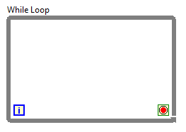
  2. Example:  
     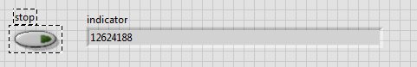  
     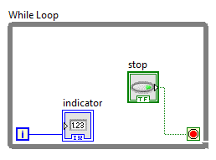  
     This example shows how while loop works. The stop button is to stop the while loop. While the indicator shows how many times the while loop executed from start until the user pressed the button stop.
  3. Find in library:
     1. Search “while loop” in library  
        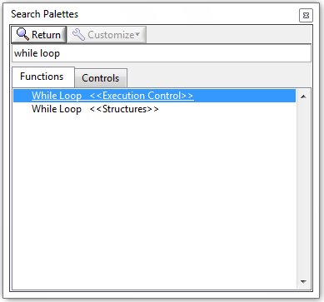
     2. Choose “While Loop <<Structure>>” or “While Loop <<Execution Control>>” and draw inside the Block Diagram.  
        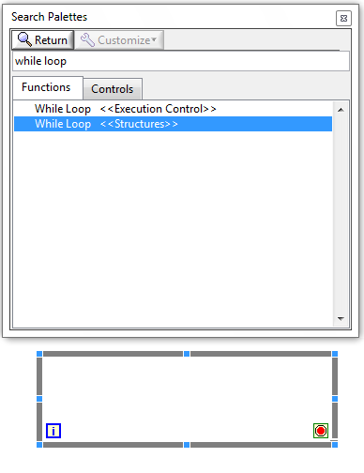

1. **Array Constant**
   1. Overview:  
      Use this constant to supply a constant array value to the block diagram.  
        
      Define the type of the array constant by selecting any scalar constant (eg. String Constant, numeric constant and so on) from the Functions palette and placing it inside the array constant.  
        
      For example, if the programmer want to use the 2D String-type Array Constant.   
      **Step1)** Create a “**Array Constant**” first**(more details in 12.4):**   
        
      **Step2)** Place a “**String constant**” inside the “**Array Constant**”  
      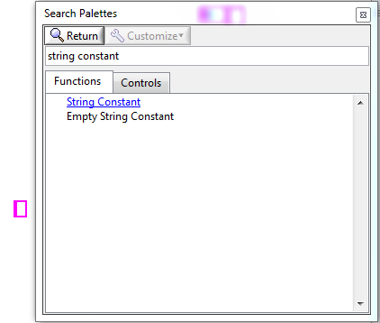  
      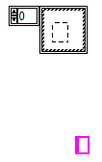  
        
      **Step3)** Drag the box at left side down until can see 1 more boxes.  
        
      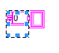  
      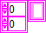
   2. Examples of icons:  
      Undefined Type:  
        
      String Type:   
      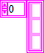  
      Numeric Type:

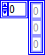

* 1. Example:  
     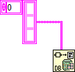  
     Normally, “Array Constant” will use with “Database Variant To Data Function”.  
       
     For more details, please see **13.3.**
  2. Find in library:
     1. Search “array constant” in library  
        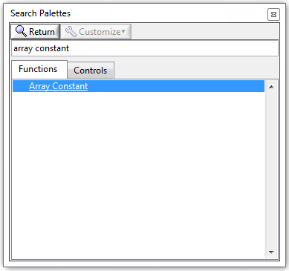
     2. Drag “Array Constant” to the Block Diagram.  
        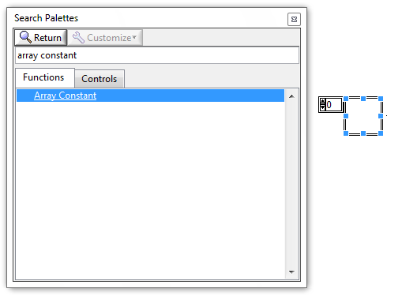

1. **Database Variant To Data Function** 
   1. Overview:  
      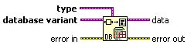  
      Converts a database variant to the LabVIEW data type specified in type so you can use the data in another function or VI.
   2. Examples of icons:  
      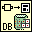
   3. Example:  
      Database:  
      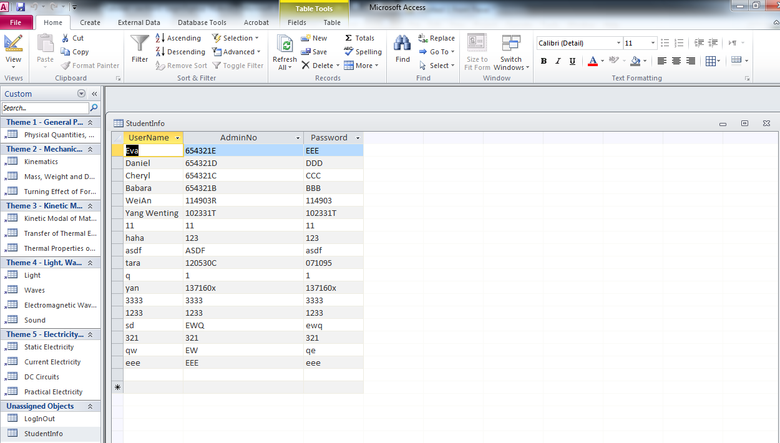  
        
        
        
        
      Front panel:  
      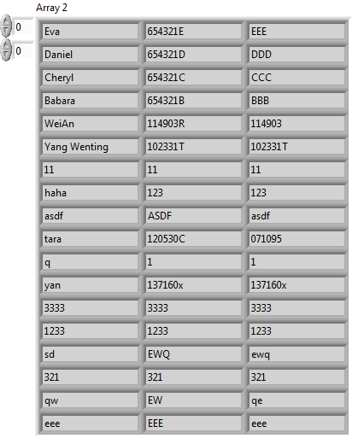  
        
      Block diagra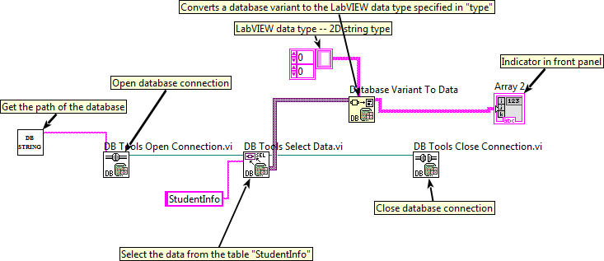  
      This example shows how to access to Database and get the data from the Database.   
        
      Firstly, need to get the path of the Database. So the program will be able to find the database.   
      Then, if the programmer wants to access to database by using LabVIEW, need to open database connection by using “**DB Tools Open Connection VI**”.  
      If need to get data from the database, need to use “**DB Tools Select Data VI**”.  
      After take out the data, the programmer need to close database connection by using “**DB Tools Close Connection.vi**” and reformate the data to the LabVIEW data type by using “**Data Variant To Data Function**”.
   4. Find in library:
      1. Search “Database Variant To Data” in library  
         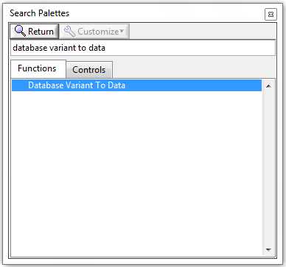
      2. Drag “Database Variant To Data” to the Block Diagram.

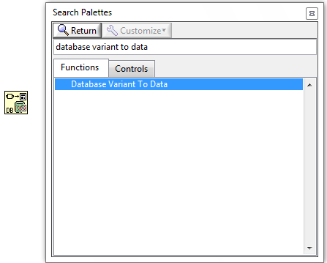

1. **Index Array Function** 
   1. Overview:  
      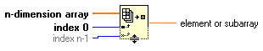  
      Returns the element or subarray of n-dimension array at index.  
        
      For example, if the programmer want to get the data in 3rd row. He can assign a numeric “2” to the index (Index starts from 0. Thus, 3rd row = numeric 2). Then the output will be a 1D array. There will be only 3rd row data of the data base inside the output.  
      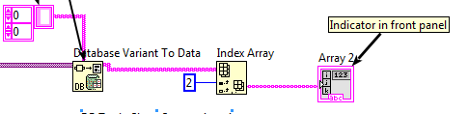
   2. Examples of icons:  
      
   3. Example:  
      Database:  
        
      Front Panel:  
      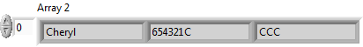  
        
      Block Diagram:  
        
      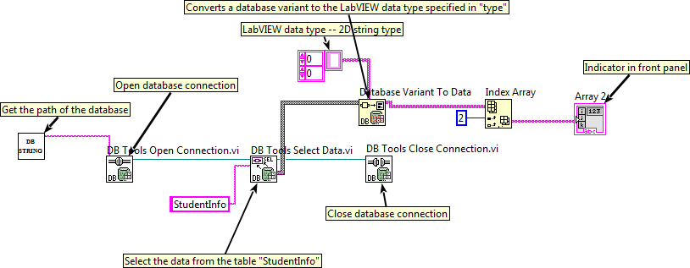  
        
      This example shows how to access to Database, get the data in 3rd row from table “StudentInfo” and filter out the rest.  
        
      Firstly, need to get the path of the Database. So the program will be able to find the database.   
      Then, if the programmer wants to access to database by using LabVIEW, need to open database connection by using “**DB Tools Open Connection VI**”.  
      If need to get data from the database, need to use “**DB Tools Select Data VI**”.  
      After take out the data, the programmer need to close database connection by using “**DB Tools Close Connection.vi**” and reformate the data to the LabVIEW data type by using “**Data Variant To Data Function**”.  
      After reformat to LabVIEW data type, then the whole data will pass to “**Index Array**” to filter out those which are unwanted, and pass the only 3rd row data inside the “StudentInfo” database to the output. Therefore, the indicator will only show 3rd row data, instead of the whole table.
   4. Find in library:
      1. Search “Index Array” in library  
         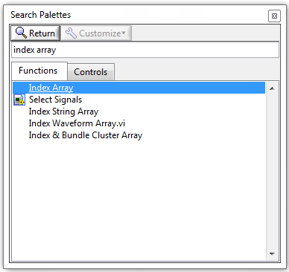
      2. Drag “Index Array” to the Block Diagram.

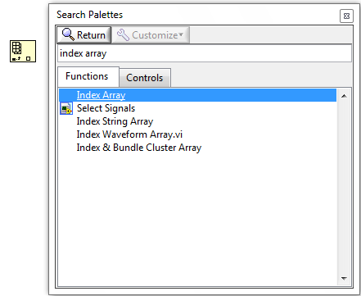

1. **Search 1D Array Function** 
   1. Overview:  
      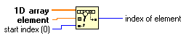  
      Searches for an element in a 1D array starting at start index.  
        
      The **element** is the value to search for in the input array.   
      The **index of element** is the index where element is found. If the function does not find element, index of element is -1.
   2. Examples of icons:  
      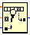
   3. Example:  
      Database:  
        
      Front Panel:  
      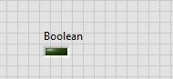  
      Block diagram:  
      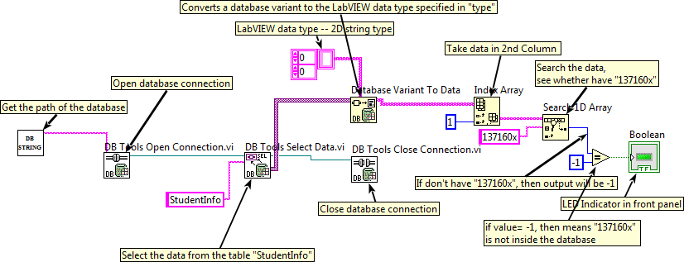

This example shows how to access to Database, get the data in 3rd row from table “StudentInfo” and filter out the rest.  
  
Firstly, need to get the path of the Database. So the program will be able to find the database.   
Then, if the programmer wants to access to database by using LabVIEW, need to open database connection by using “**DB Tools Open Connection VI**”.  
If need to get data from the database, need to use “**DB Tools Select Data VI**”.  
After take out the data, the programmer need to close database connection by using “**DB Tools Close Connection.vi**” and reformate the data to the LabVIEW data type by using “**Data Variant To Data Function**”.  
After reformat to LabVIEW data type, then the whole data will pass to “**Index Array**” to filter out those which are unwanted, and pass the only 3rd row data inside the “StudentInfo” database to the output. Therefore, the indicator will only show 3rd data, instead of the whole table.  
Then the output will pass to **Search 1D Array** to search the array to see whether got any elements is “137160x”. If there is, then the LED indicator will not light up. Otherwise, LED indicator will light up.

* 1. Find in library:
     1. Search “Search 1D Array” in library  
        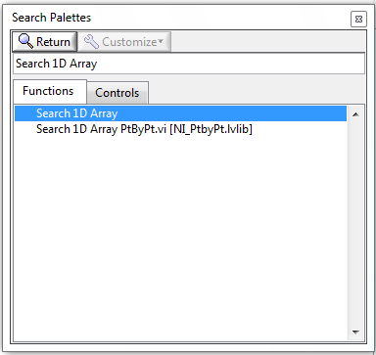
     2. Drag “Search 1D Array” to the Block Diagram.  
        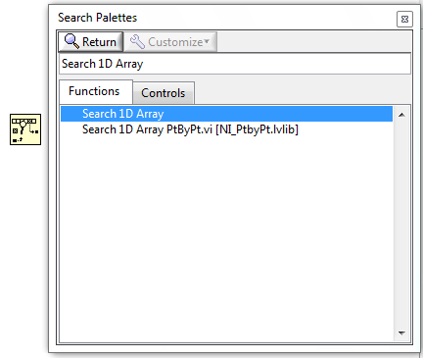

1. **DB Tools Open Connection VI  
   & DB Tools Select Data VI  
   & DB Tools Insert Data VI  
   & DB Tools Close Connection VI**
   1. Overview:  
      DB Tools Open Connection VI:  
      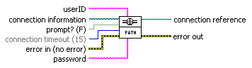  
      “DB Tools Open Connection VI” is to open a database connection using the connection information path and returns a connection reference.   
        
      “Connection information” is the absolute path of the file that stores the connection information.  
        
      DB Tools Select Data VI:  
      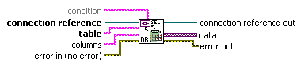  
      “DB Tools Open Connection VI” is to select data from the table in the database identified by connection reference.  
        
      “Table” is the name of the table in the database from which to select data.  
        
      DB Tools Insert Data VI:  
      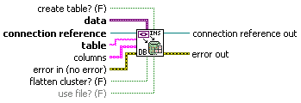  
      “DB Tools Insert Data VI” inserts a new row into the table in the database identified by the connection reference.  
        
      “Data” specifies the data you want to insert in the database.  
      “Table” specifies the name of the table in the database in which to insert data.   
      “Columns” is the column in the table to insert data into.

DB Tools Close Connection VI:  
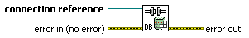  
“DB Tools Close Connection VI” is to close a database connection

* 1. Examples of icons:  
     DB Tools Open Connection VI:  
     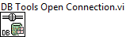  
     DB Tools Select Data VI:  
     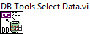  
     DB Tools Insert Data VI:  
     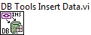  
     DB Tools Close Connection VI:  
     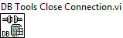
  2. Example:  
     Database:  
       
       
       
       
       
     Front panel:  
       
       
     Block diagram  
     This example shows how to access to Database and get the data from the Database.   
       
     Firstly, need to get the path of the Database. So the program will be able to find the database.   
     Then, if the programmer wants to access to database by using LabVIEW, need to open database connection by using “**DB Tools Open Connection VI**”.  
     If need to get data from the database, need to use “**DB Tools Select Data VI**”.  
     After take out the data, the programmer need to close database connection by using “**DB Tools Close Connection.vi**” and reformate the data to the LabVIEW data type by using “**Data Variant To Data Function**”.
  3. Find in library:
     1. Search “**DB Tools Open Connection VI**” or **“ DB Tools Select Data VI**” or “ **DB Tools Insert Data VI**” or “**DB Tools Close Connection VI**” in library (Take “DB Tools Open Connection VI” for example):  
        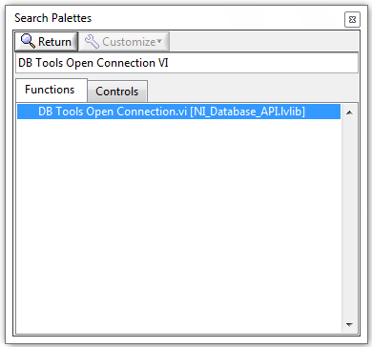
     2. Drag “**DB Tools Open Connection VI**” or **“ DB Tools Select Data VI**” or “ **DB Tools Insert Data VI**” or “**DB Tools Close Connection VI**” to the Block Diagram (Take “DB Tools Open Connection VI” for example):.

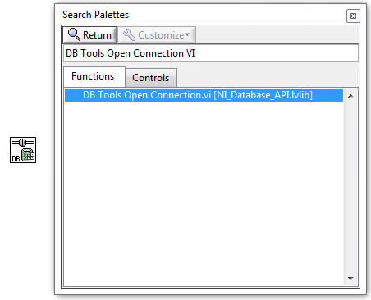

1. **Event Structure**
   1. Overview:  
      Events are caused by actions the user performs. For example, clicking the mouse generates a mouse event, pressing a key on the keyboard generates a keyboard event, clicking a button generates a button event, and so on.  
        
      Event Structure waits until an event occurs, then executes the appropriate case to handle that event. The Event structure has one or more event cases. This structure can time out while waiting for notification of an event. Wire a value to the Timeout terminal at the top left of the Event structure to specify the number of milliseconds the Event structure waits for an event. The default is -1, which indicates never to time out.  
        
      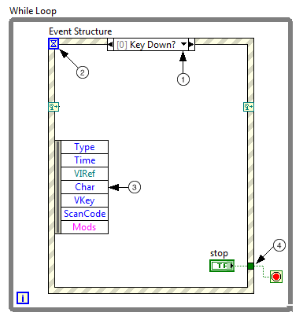  
      ①The event selector label – specifies which events cause the currently displayed case to execute. To view other event cases, click the down arrow next to the case name. To edit or add events, right click the event selector label, and then click “Edit Events Handled by This Case…”  
      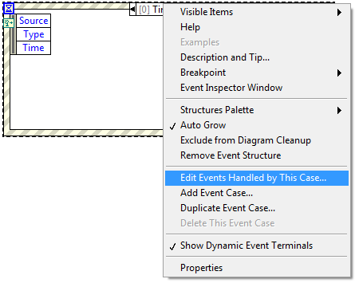

②The timeout terminal – specifies the number of milliseconds to wait for an event before timing out. If you wire a value to the Timeout terminal, you must provide a Timeout event case to avoid an error.

③The Event Data Node – identifies the data LabVIEW returns when an event occurs. For example, you can use the Event Data Node to access event data elements, such as Type and Time, which are common to all events.

* 1. Example:  
     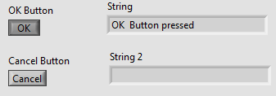  
       
     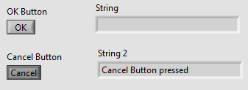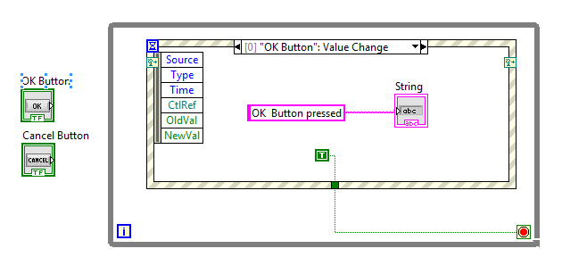  
     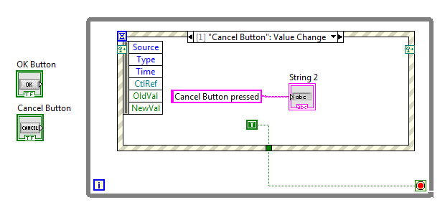  
       
     This example shows how case structure works. In the example, when the user presses the OK Button, then “String” will show “OK Button pressed”. If the user press the Cancel Button, then “String 2” will show ”Cancel Button pressed”.   
       
     More specifically, if the user presses the OK Button, then “OK Button” value will change, therefore, the case structure will execute the case [0]. In other words, “OK Button pressed” will print as output to indicator “String”.  
       
      If user presses the Cancel Button, then “Cancel Button” value will change, as a result, the case structure will execute case [1]. “Cancel Button pressed” will print to indicator “String 2”.
  2. Find in library:
     1. Search “event structure” in library  
        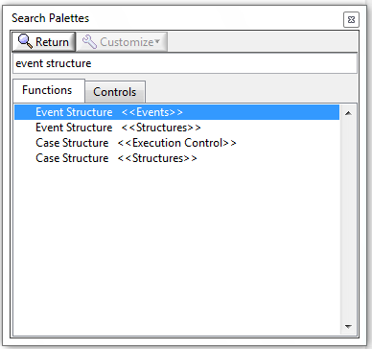
     2. Choose “Event Structure <<Events>>” or “Event Structure <<Structures>>” and draw inside the Block  
        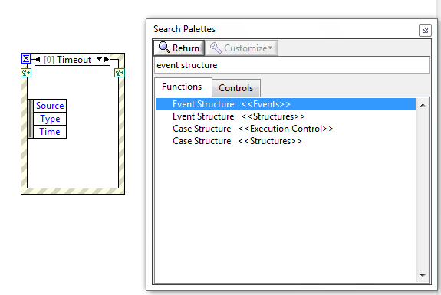

1. **True/False Constant**
   1. Overview:
      1. True constant  
         Use this constant to provide a value of TRUE to the block diagram.
      2. False Constant   
         Use this constant to provide a value of FALSE to the block diagram.
   2. Examples of icons:  
      True Constant:    
      False Constant: 
   3. Example:  
      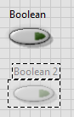 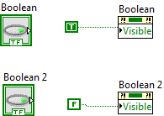

In the example, button “Boolean2” cannot be seen, as we set its visible property to FALSE. And we are able to see the button “Boolean”, since we set its visible property to TRUE.

* 1. Find in library:
     1. Right click in the block diagram, then go to “Boolean”;  
        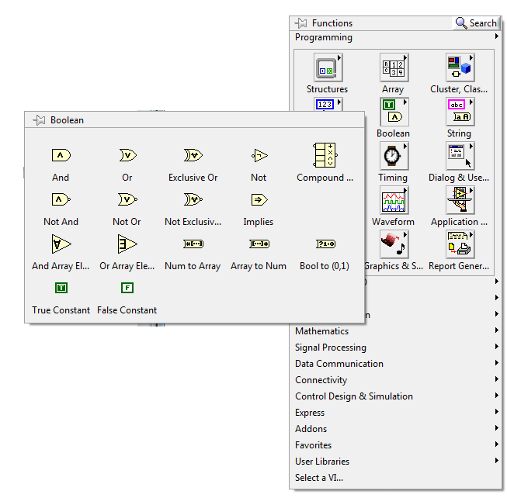
     2. Then drag True Constant OR False Constant to the block diagram.  
        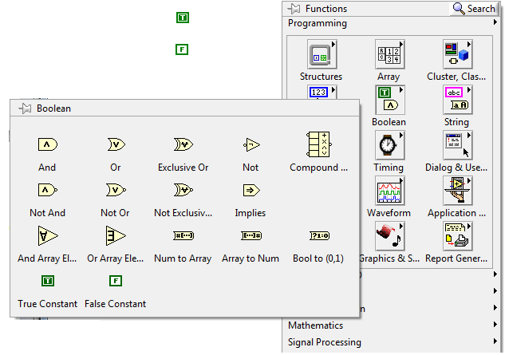

1. **Get Date/Time In Seconds Function**
   1. Overview:  
      Returns a timestamp of the current time.
   2. Examples of icons:  
      
   3. Example:  
      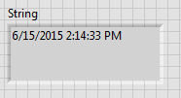  
      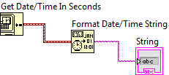

In the example, the “Get Date/Time In Seconds” is to get the current time from the system. Then pass to “Format Date/Time String” to convert to string format. Then pass to the indicator “String”. Therefore, when users run the program, the current time will be shown inside the indicator “String”.

* 1. Find in library:
     1. Search “get date/time in seconds” in library  
        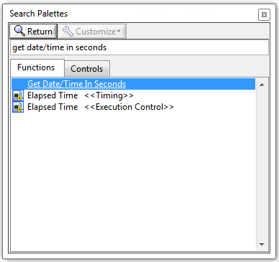
     2. Drag “Get Date/Time In Seconds” to the Block Diagram.  
        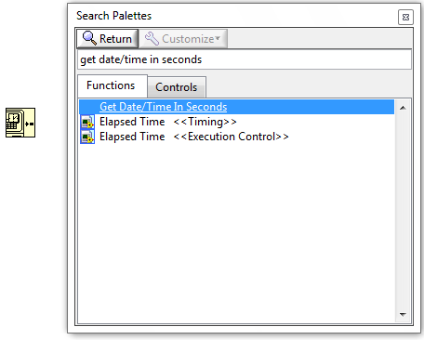

1. **Format Date/Time String Function**
   1. Overview:  
      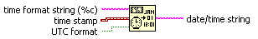  
      Displays a timestamp value or a numeric value as time in the format you specify using time format codes.   
        
      “Time stamp” is the input. It always connects to “Get Date/Time In Seconds” to get the time.  
        
      “UTC format” specifies if the output string is in Universal Time. (Will not use in the program)  
        
      “Time format string(%c)” specifies the format of the output string. For example, if the programmer want the output string is in “hh/mm/ss/AM(PM) dd/mm/yyyy” form. Then based on time format codes, the programmer can assign “%I:%M:%S:%p %d/%m/%Y”. (For more details, refer to Time Format Codes list below)  
        
      Time Format Codes list:   
      %c displays locale-specific date/time  
      %X (locale-specific time)  
        
      %H (hour, 24-hour clock)  
      %I (hour, 12-hour clock)  
      %M (minute)  
       %S (second)  
      %<digit>u (fractional seconds with <digit> precision)  
      %p (a.m./p.m. flag)  
        
      %x (locale-specific date)  
       %y (year within century)  
      %Y (year including century)  
      %m (month number)  
      %b (abbreviated month name)  
      %d (day of month)  
      %a (abbreviated weekday name)

* 1. Examples of icons:  
     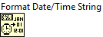
  2. Example:  
     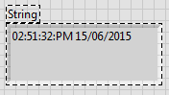  
     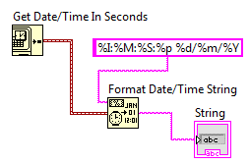

In the example, the “Get Date/Time In Seconds” is to get the current time from the system. Then pass the “Format Date/Time String”.   
  
As the “time format string(%c)” is “%I:%M:%S:%p %d/%m/%Y”, the output will be in “hh/mm/ss/AM(PM) dd/mm/yyyy” form.   
  
Then the output will pass the indicator “String”. Therefore, the user will be able to see the current time and date in the indicator ”String”. And it’s in “hh/mm/ss/AM(PM) dd/mm/yyyy” form.

* 1. Find in library:
     1. Search “Format Date/Time String” in library  
        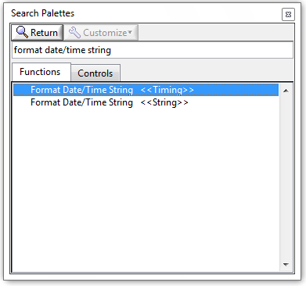
     2. Drag either “Format Date/Time String<<Timing>>” or “Format Date/Time String<<String>>” to the Block Diagram.  
        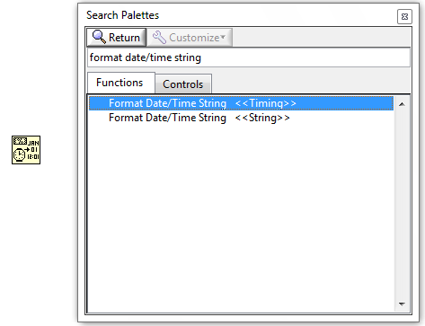

1. **To Upper Case Function**
   1. Overview:  
      Converts all alphabetic characters in string to uppercase characters.
   2. Examples of icons:  
      
   3. Example:  
      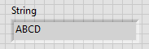  
      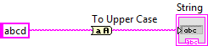  
        
      in the example, the input string is “abcd”. Then pass to “To Upper Case”. After “To Upper Case”, all characters will convert to uppercase. Then pass to the indicator “String”.

* 1. Find in library:
     1. Search “To Upper Case” in library  
        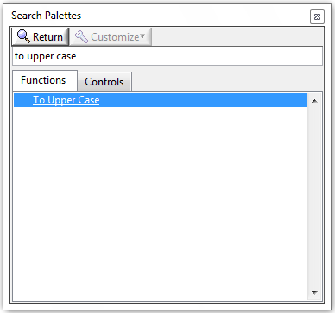
     2. Drag “To Upper Case” to the Block Diagram.

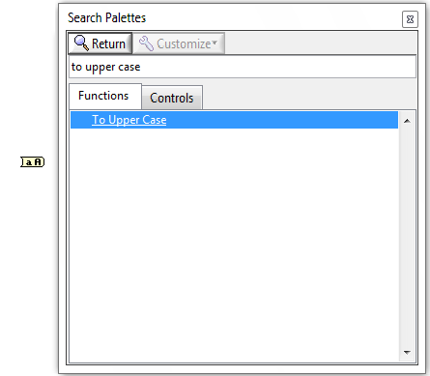

1. **Array Size Function**
   1. Overview:  
      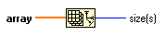  
      “Array Size Function” returns the number if elements in each dimension of array.  
        
      The output “size” will be a 32-bit integer if array is one-dimension. If array is multidimensional, the returned value is a 1D array in which each element is a 32-bit integer that represents the number of elements in the corresponding dimension of array.
   2. Examples of icons:  
      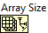
      1. Example:  
         Database:  
         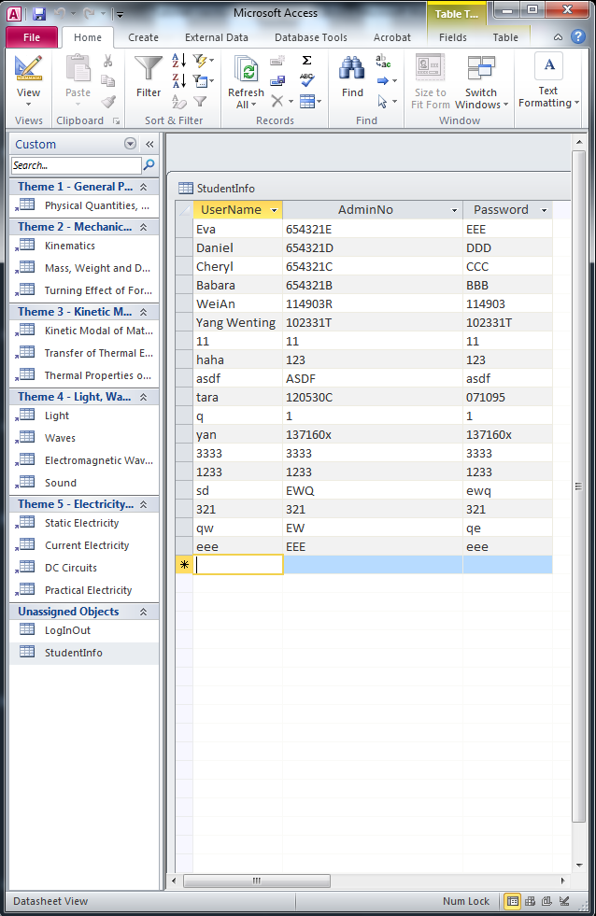  
         Front panel:  
         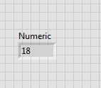  
         Block diagram:  
         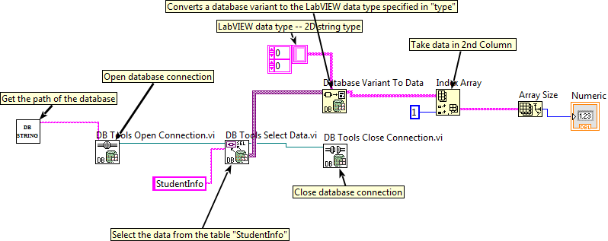

This example shows how to count the number of elements inside the Database – “StudentInfo”.  
  
Firstly, need to get the path of the Database. So the program will be able to find the database.   
Then, if the programmer wants to access to database by using LabVIEW, need to open database connection by using “**DB Tools Open Connection VI**”.  
If need to get data from the database, need to use “**DB Tools Select Data VI**”.  
After take out the data, the programmer need to close database connection by using “**DB Tools Close Connection.vi**” and reformate the data to the LabVIEW data type by using “**Data Variant To Data Function**”.  
After reformat to LabVIEW data type, then the whole data will pass to “**Index Array**” to filter out those which are unwanted, and pass the only 2nd column data inside the “StudentInfo” database to the output. Therefore, the indicator will only show 2ndcolumn data, instead of the whole table.  
Then pass to “**Array Size**”. It will count how many elements inside the array, which is the column “AdminNo” inside the table “StudentInfo”.   
The numeric output will pass to the indicator. Once the user run the program, indicator will show “18”, as there are 18 elements in the array.

* 1. Find in library:
     1. Search “array size” in library  
        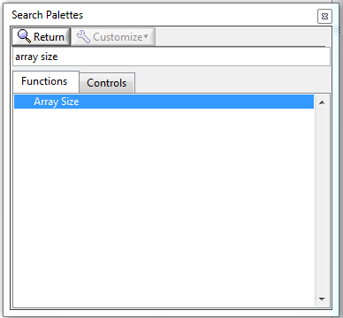
     2. Drag “Array Size” to the Block Diagram.  
        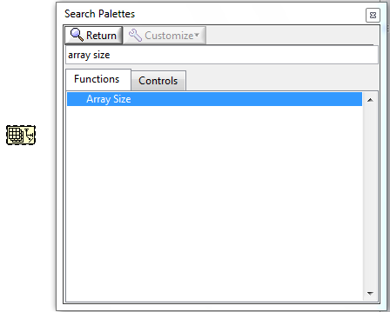

1. **Decrement Function**
   1. Overview:  
      Subtracts 1 from the input value.
   2. Examples of icons:  
      
   3. Example:  
      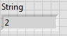  
      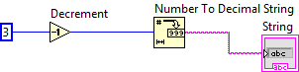  
      In the example, the input number is “3”. Then pass to “Decrement” Function. Then the output will be “2”. And then, the output will be passed to “Number To Decimal String” to convert to string format. Finally, string “2” will be passed to the indicator “String”.
   4. Find in library:
      1. Search “decrement” in library  
         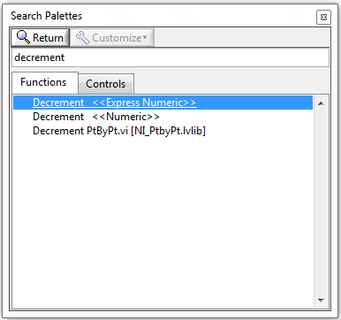
      2. Drag either “Decrement<<Express Numeric>>” or “Decrement<<Numeric>>” to the Block Diagram.  
         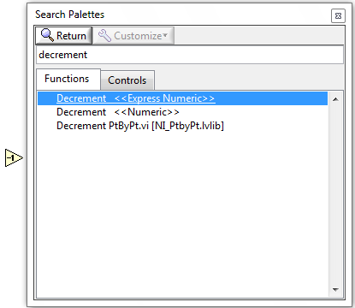
2. **Less Or Equal? Function**
   1. Overview:  
      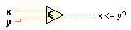  
      Returns TRUE if x is less than or equal to y. Otherwise, this function returns FALSE.
   2. Examples of icons:  
      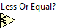
   3. Example:  
      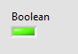 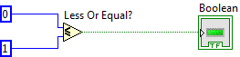  
      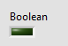 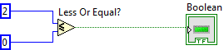  
        
      In the example, if input x is “0” and input y is “1” (x<y). Then the output will be TRUE. Therefore, the LED indicator will light up.

However, if the input x is “2” and input y is “0” (x>y). Then the output will be FALSE. Therefore, the LED indicator will light off.

* 1. Find in library:
     1. Search “Less Or Equal?” in library  
        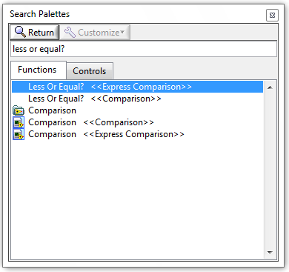
     2. Drag either “Less Or Equal?<<Express Comparison>>” or “Less Or Equal?<<Comparison>>” to the Block Diagram.  
        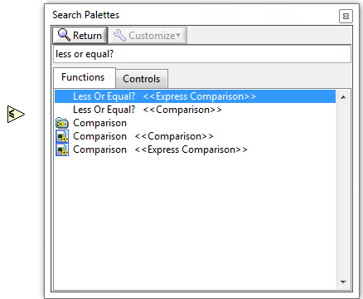

1. **Equal? Function**
   1. Overview:  
      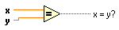  
      Returns TRUE if x is equal to y. Otherwise, this function returns FALSE.
   2. Examples of icons:  
      
   3. Example:  
       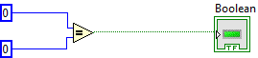  
       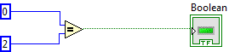  
        
      In the example, if input x is “0” and input y is “0” (x=y). Then the output will be TRUE. Therefore, the LED indicator will light up.

However, if the input x is “0” and input y is “2” (x≠y). Then the output will be FALSE. Therefore, the LED indicator will light off.

* 1. Find in library:
     1. Search “Equal?” in library  
        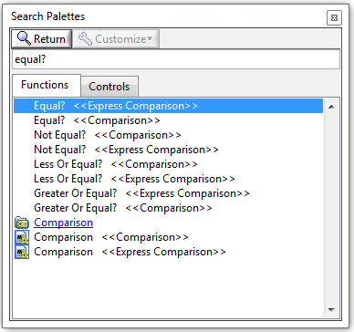
     2. Drag either “Equal?<<Express Comparison>>” or “Equal?<<Comparison>>” to the Block Diagram.  
        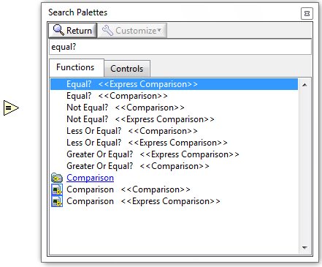

1. **And Function**
   1. Overview:  
      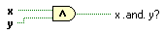  
      Computes the logical AND of the inputs. Both inputs must be Boolean values, numeric values, or error clusters. If both inputs are TRUE, the function returns TRUE. Otherwise, it returns FALSE.
   2. Examples of icons:  
      
   3. Example:  
       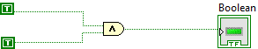  
        
       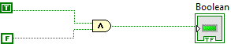

In 1st example, the two inputs are TRUE. Thus, the output is TRUE. Then the LED indicator “Boolean” will light up.  
  
in 2nd example, the two inputs are TRUE and FALSE. Thus, the output is FALSE. Then the LED indicator “Boolean” will not light up.

* 1. Find in library:
     1. Search “and” in library  
        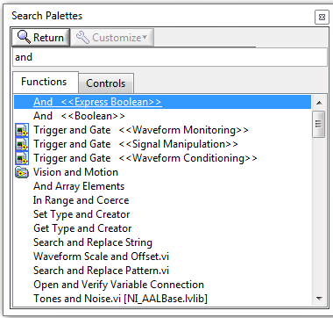
     2. Drag either “And<<Express Boolean>>” or “And<<Boolean>>” to the Block Diagram.  
        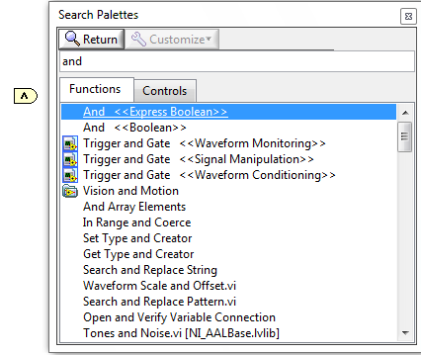

1. **Or Function**
   1. Overview:  
      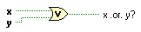  
      Computes the logical OR of the inputs. Both inputs must be Boolean values, numeric values, or error clusters. If both inputs are FALSE, the function returns FALSE. Otherwise, it returns TRUE.
   2. Examples of icons:  
      
   3. Example:  
       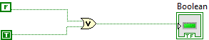  
       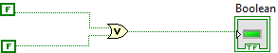
   4. Find in library:
      1. Search “or” in library  
         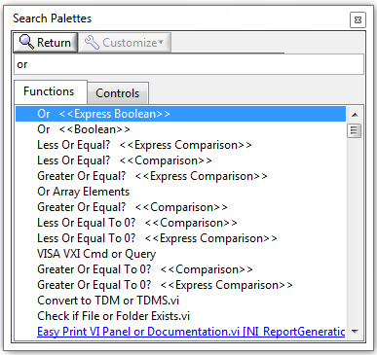
      2. Drag either “Or<<Express Boolean>>” or “Or<<Boolean>>” to the Block Diagram.  
         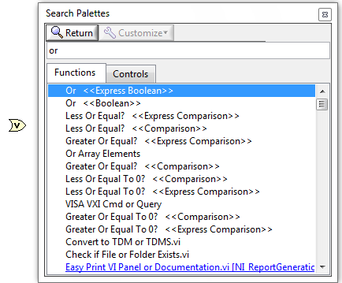
2. **Display Message to User Express VI**
   1. Overview:  
      Displays a standard dialog box that contains a message for users.
   2. Examples of icons:   
      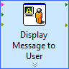  
      
   3. Example:  
      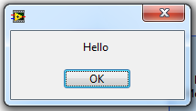  
      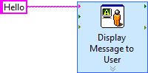  
      In the example, the message contained in the box is “Hello”. Once the user run the program, the dialog window will pop-up automatically, and it will show the content which is written by programmer.
   4. Find in library:
      1. Search “Display Message to User” in library  
         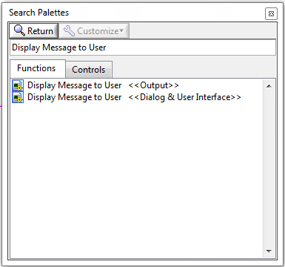
      2. Drag either “Display Message to User<<Output>>” or “Display Message to User<<Dialog & User Interface>>” to the Block Diagram. And click “Cancel”.  
         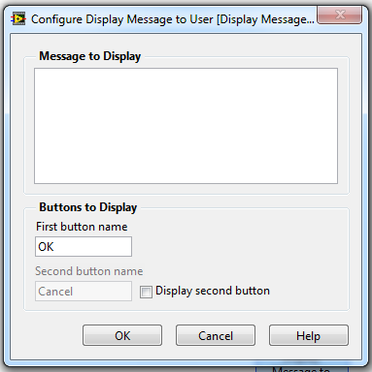  
         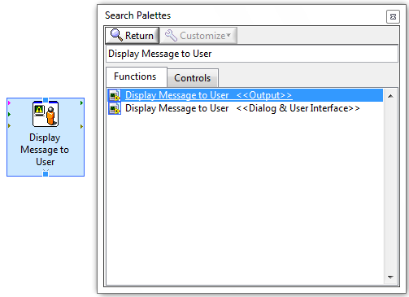
3. **Empty String Constant**
   1. Overview:  
      Consists of a constant string that is empty (length zero).
   2. Examples of icons:  
      
   3. Example:  
      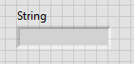  
      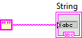  
      In the example, the “Empty String Constant” will pass to the indicator. Therefore, there are nothing inside the indicator.
   4. Find in library:
      1. Search “Empty String Constant” in library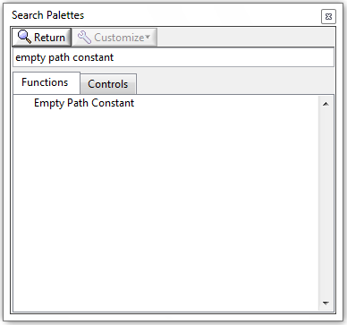
      2. Drag “Empty String Constant” to the Block Diagram.  
         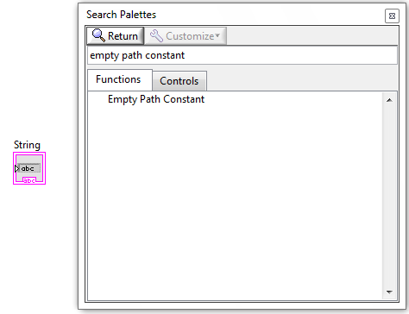
4. **Static VI Reference Function**
   1. Overview:  
      The Static VI Reference function acts as a subVI and appears in the VI hierarchy of the top-level VI. By default, the output is a generic VI reference.  
        
      For example, if we set “**Static VI Reference function**” as a reference to the SubVI – “LoginInfo(SubVI).vi”. Then we need to double click the icon, and then choose the subVI we needed.  
      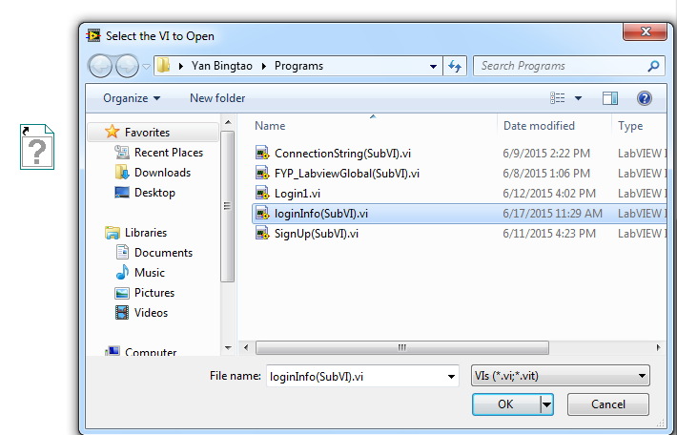  
      
   2. Examples of icons:  
      
   3. Example:  
      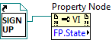  
        
      For example, the programmer can use the “**Static VI Reference function**” as a reference to get its property.
   4. Find in library:
      1. Search “Static VI Reference” in library   
         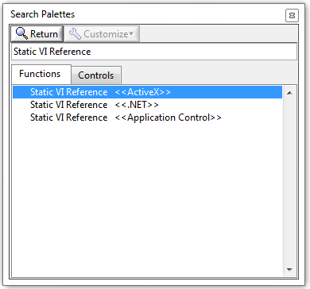
      2. Drag “Static VI Reference” to the Block Diagram.  
         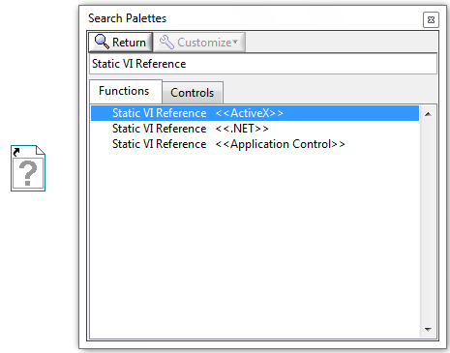
5. **Local variable**
   1. Overview:  
      Use local variables to read or write to one of the controls or indicators on the front panel of a VI.
   2. Examples of icons:  
        
      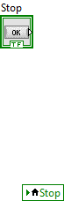  
      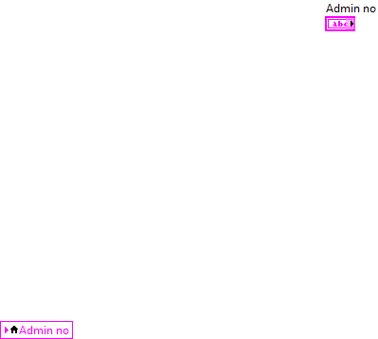
   3. Example:  
      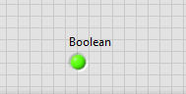  
        
      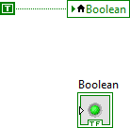  
        
      In the example, the local variable “Boolean” is the reference of the LED indicator “Boolean”. So setting the local variable “Boolean” as TRUE is same as setting the LED indicator “Boolean” as TRUE.
   4. Find in library:
      1. Right click the icon of the indicator/Control, choose “Create” 🡺 “Local Variable”:  
         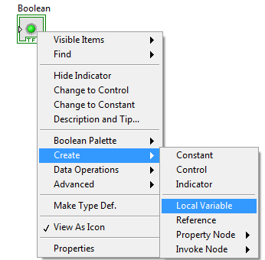
      2. Place the “Local Variable” to Block Diagram:  
         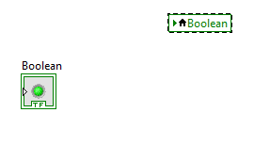
6. **Connection reference**
   1. Overview:  
      Use **connection reference** to give a reference to one of the wiring part on top-level VI.  
        
      Connection reference can separate to “Connection reference in” and “Connection reference out”.
   2. Examples of icons:
   3. Example:  
      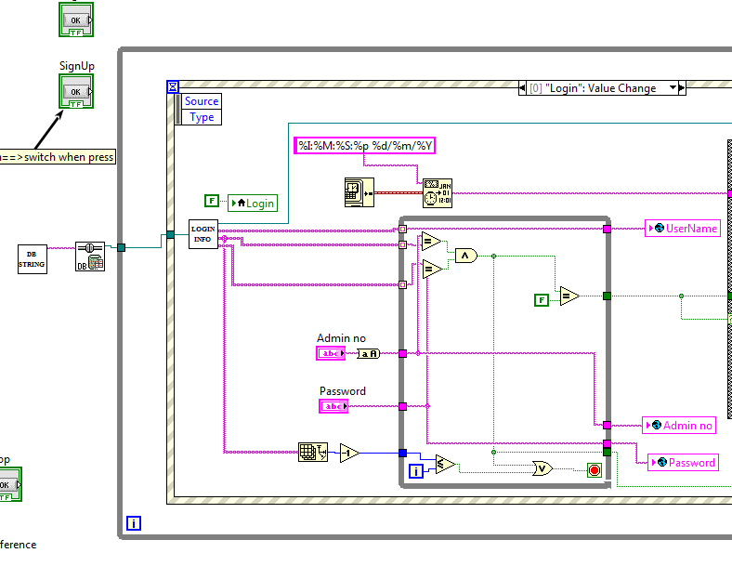   
      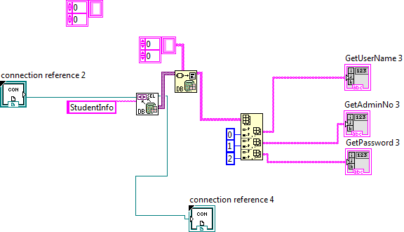  
        
        
      The first image is an example of top-level VI. Second image showed the subVI “LOGIN INFO”. It’s like we use the small box “LOGIN INFO” TO replace the whole thing inside the 2nd image. For subVI “LOGIN INFO”, it needs to know where the reference is in the top-level VI. Therefore, the subVI needs the connection reference to tell itself where its location in the top-level VI.   
        
      For example, the “Connection Reference 2” is “Connection reference in”. The “Connection Reference 4” is “Connection reference out”  
        
      The “Connection Reference 2” is to tell the subVI that its connection in the top-level VI is at the wire before the box “LOGIN INFO”. The “Connection Reference 4” is to tell the subVI that its connection in the top-level VI is at the wire after the box “LOGIN INFO”. (Can see the 2 images above)
   4. Find in library:  
      Create “Connection reference in”
      1. Select and right click the wire where the programmer wants to set as input for the subVI . Then Click “Create” 🡺 “Control”.  
         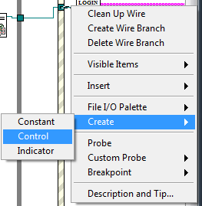
      2. Place the icon in the Block Diagram:  
         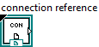
      3. Select and right click the wire where the programmer wants to set as output for the subVI . Then Click “Create” 🡺 “Indicator”.  
         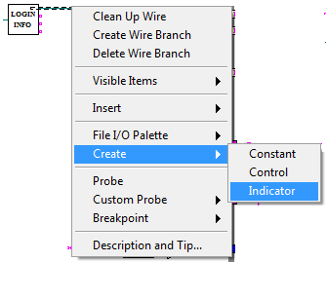
      4. Place the icon in the Block Diagram:  
         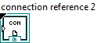
      5. Copy these two icons (“controller”  & “indicator” ) to the subVI diagram.  
         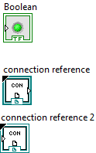
      6. The “Controller” is the “Connection reference in”.  
         The “Indicator” is the “Connection reference out”.
7. **Compound Arithmetic Function**
   1. Overview:  
      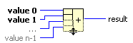  
      Bundle Function performs arithmetic on one or more numeric, array, cluster, or Boolean inputs.   
        
      To select the operation (Add, Multiply, AND, OR, or XOR), right-click the function and select Change Mode from the shortcut menu.  
      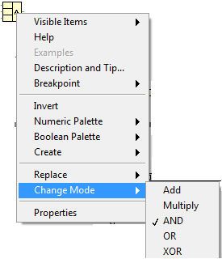
   2. Examples of icons:  
      OR Function:  
        
      AND Function:  
      
   3. Example:  
      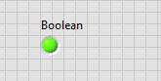  
      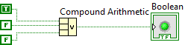  
        
      In the example, the “**Compound Arithmetic**” acts as OR Function. Therefore, through there is only one TRUE input, the output still is TRUE. As a result, the LED indicator “Boolean” will light up.
   4. Find in library:
      1. Search “Compound Arithmetic” in library  
         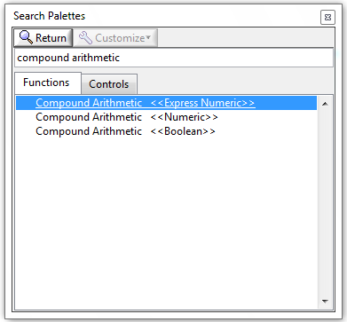
      2. Drag either “Compound Arithmetic<<Express Numeric>>”, “Compound Arithmetic<<Numeric>>” or “Compound Arithmetic<<Boolean>>” inside the Block  
         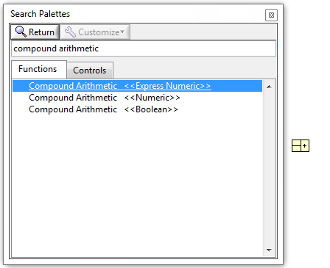
8. **Empty String/Path?**
   1. Overview:  
      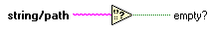  
      Returns TRUE if string/path is an empty string or an empty path. Otherwise, this function returns FALSE.
   2. Examples of icons:  
      
   3. Example:  
        
      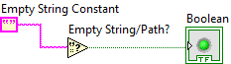  
        
      In the example, the “Empty String Constant” is the input. Then pass to “Empty String/Path?”. As the input is empty, the output of the “Empty String/Path?” is TRUE. Therefore, the LED “Boolean” will light up.
   4. Find in library:
      1. Search “Empty String/Path?” in library  
         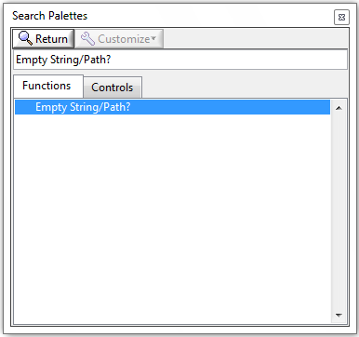
      2. Drag “Empty String/Path?” inside the Block  
         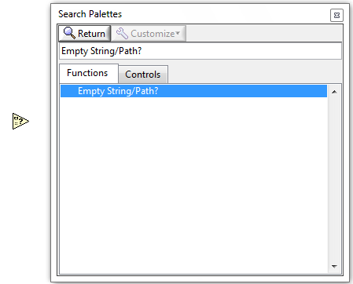
9. **Bundle Function**
   1. Overview:  
      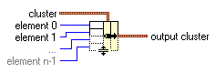  
      Assembles a cluster from individual elements.

“**Element 0...n-1**” -- accepts any data type.

“**Output cluster**” -- is the resulting cluster.

* 1. Examples of icons:  
     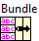
  2. Example:  
     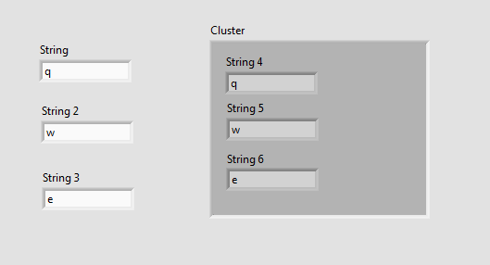  
     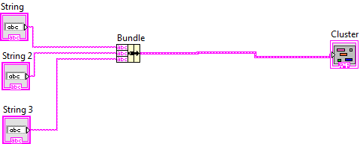  
       
     In the example, the inputs are “**String**”,”**String2**” and “**String3**”. Then pass to “**Bundle**” Function to assemble all the inputs to a cluster. Then pass to output “**Cluster**”.  
       
     Therefore, the user can type anything into “**String**”,”**String2**” and “**String3**”. Then the “**Cluster**” will display whatever the user typed.
  3. Find in library:
     1. Search “bundle” in library   
        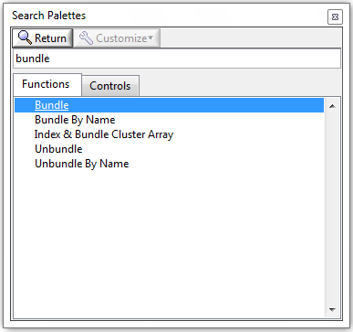
     2. Drag either “Bundle” inside the Block  
        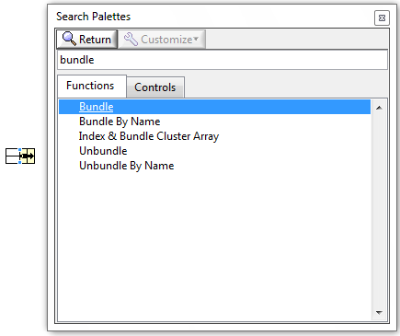

1. **Not Function**
   1. Overview:  
        
      Computes the logical negation of the input. If x is FALSE, the function returns TRUE. If x is TRUE, the function returns FALSE.
   2. Examples of icons:  
      
   3. Example:  
        
      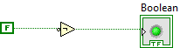  
      In the example, the input of “NOT Function” is FALSE. Then pass to “NOT”. The output will be TRUE. Therefore, the LED “Boolean” will light up.
   4. Find in library:
      1. Search “NOT” in library  
         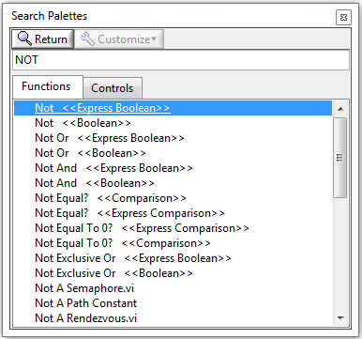
      2. Drag either “Not<<Express Boolean>>” or “Not<<Boolean>>” inside the Block  
         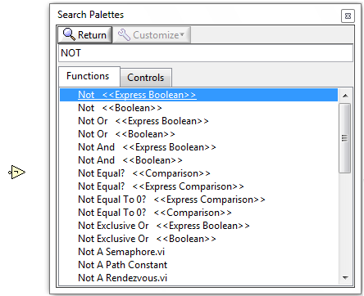
2. **Flat Sequence Structure**
   1. Overview:  
      Consists of one or more subdiagrams, or frames, that execute sequentially. Use the Flat Sequence structure to ensure that a subdiagram executes before or after another subdiagram.

If the programmer want to add Subdiagram(Frame) after/before current Subdiagram(Frame), right click the current Subdiagram(Frame), then choose “Add Frame After”/”Add Frame Before”.  
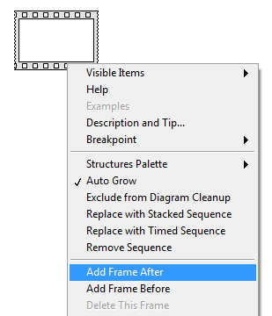

* 1. Examples of icons:  
     One Subdiagram:  
       
     Two Subdiagram:  
     
  2. Example:  
     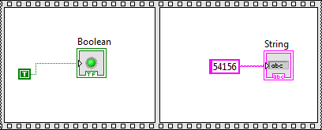  
       
     In the example, the program will execute first Subdiagram(Frame), and execute second Subdiagram(Frame) after that.
  3. Find in library:
     1. Search “Flat Sequence Structure” in library  
        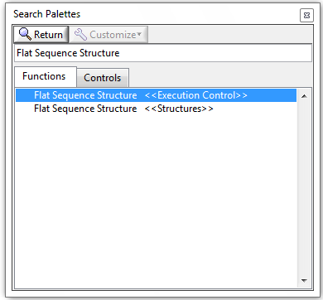
     2. Select and draw either “Flat Sequence Structure<<Execution Control>>” or “Flat Sequence Structure<< Structures >>” inside the Block  
        